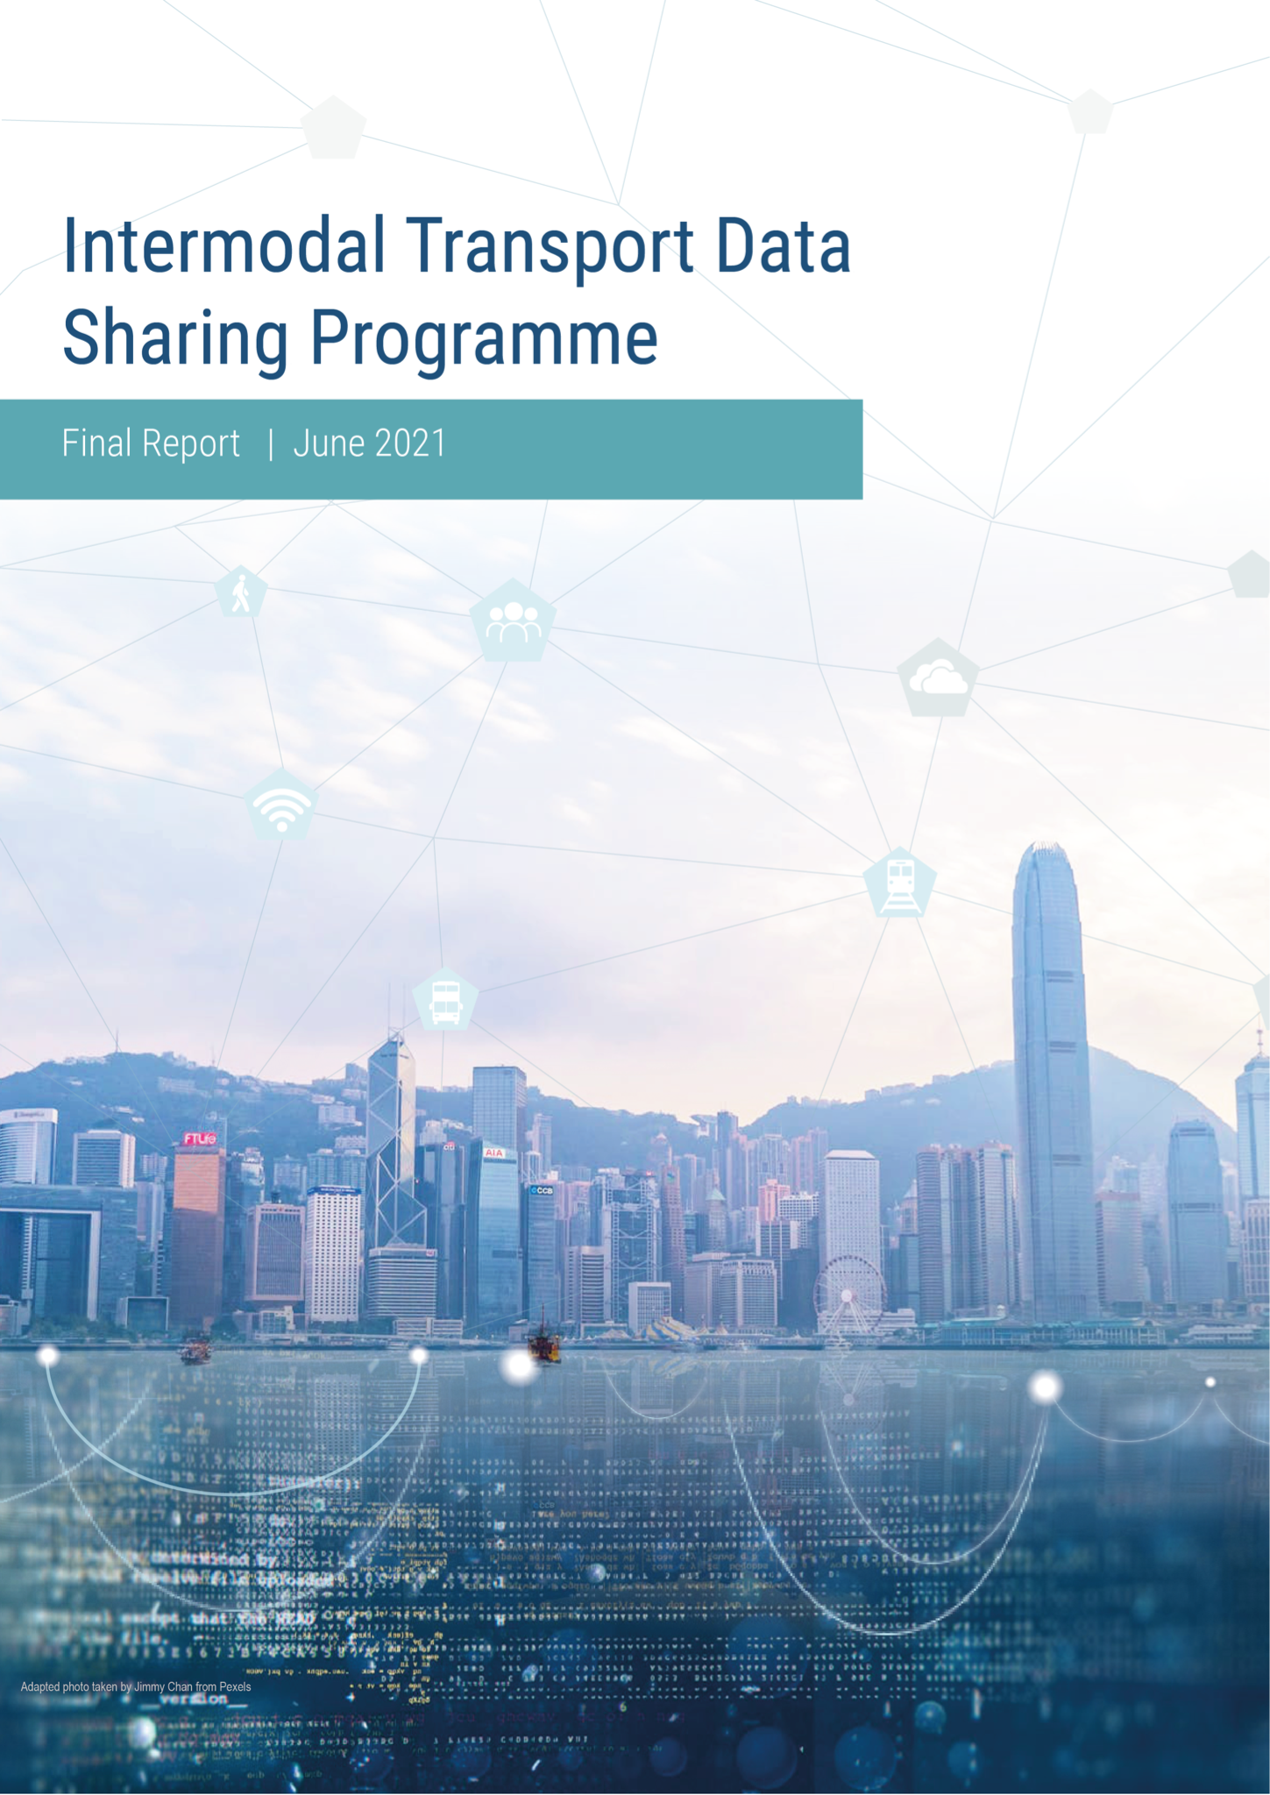

Table of Contents

Acknowledgment 2
Introduction to the Inter-Modal Transport Data-Sharing Programme 3
Chapter 1 – The Data Trust as a Trusted Third Party 6
A: Implementation 13
B: Analytics 14
C: Overview of Datasets by Public Transport Operator 15
C.1 Bus data analysis 16
C.1.1 Daily Variation in Bus Passenger Boarding of Selected Routes 17
C.1.2 Hourly Variation in Bus Passenger Boarding near Exchange Square 20
C.1.3 Origins and Destinations of Bus Passengers on Selected Routes to/from Exchange Square Vicinity 21
C.2 Rail data analysis 23
C.2.1 Daily Variation in MTR Ridership at MTR Central and Hong Kong Stations 24
C.2.2 Hourly Variation in MTR Ridership at MTR Central and Hong Kong Stations 26
D: Inter-modal Analysis 28
D.1 Interchange (rail and bus) analysis 28
D.1.1 Rail-to-bus Interchanges 29
D.1.2 Bus-to-rail Interchanges 31
D.2 Opportunities for future research 35
E: Summary & Conclusions 36
Chapter 2 – Smart City Data, Policies & Regulations for Integrated Transport Systems 38
A: Hong Kong’s Smart City Initiatives 38
B: Data Transport and Mobility Policies and Regulations in Hong Kong 43
Annex: Examples of Public Engagement from Global Cities Research 47
Chapter 3 – Demand Responsive Transport and Flexible Regulation in Hong Kong 48
Modes and their Differences 51
Chapter 4 – Decarbonising Public Transport in Hong Kong 63
A: Taxis, Trams and Ferries 63
B: PLBs and Franchised Single/Double Decker Buses 66
C: Walking and Cycling 69
Annex: Examples of Public Transport and the Environment from Global Cities Research 72
Chapter 5 – Global Cities Research Extracts 75
Copenhagen 75
London 78
Paris 80
Sydney NSW 82
Seoul 90
Shenzhen 91
Chicago 94
Chapter 6 – Conclusion 97
Annex 1 - Use Cases Developed in Workshops during 2019 99
Annex 2 – Demonstration Projects 101

Acknowledgment
We wish to thank the Innovation and Technology Fund (ITF) and the sponsors for supporting the Intermodal Transport Data-sharing Programme.

Funding Organisation of the Programme


Sponsors:
 |  |  | 

Disclaimer
Any opinions, findings, conclusions or recommendations expressed in the draft Report do not reflect the views of the Government of the Hong Kong Special Administrative Region, the Innovation and Technology Commission or the General Support Programme Vetting Committee of the Innovation and Technology Fund, and the sponsors. Nor are they meant to represent the views of the University of Hong Kong (HKU). They solely represent the work of Dr Zhou at the Data Trust and of the members of the Hong Kong Team employed as research consultants by HKU.

Introduction to the Inter-Modal Transport Data-Sharing Programme

This is the Draft Report of the inter-modal transport data-sharing programme and was followed by a Final Report (version 1) at the end of January 2021. The programme’s idea was initiated by Dr John Ure, then director of the Technology Research Project (TRP) at the University of Hong Kong (HKU), to address the lack of data-sharing between transport operators in Hong Kong where data-sharing is seen as being vital to Hong Kong’s journey towards achieving integrated smart city transport policies. The programme officially started in July 2020 after collaboration with the HK Team (Ir. Andrew Pickford, Ms. Waltraut Ritter, Mr. Terence Graham and Dr. Jenny Wan) and Drs Jiangping Zhou, Weifeng Li and Xing-Jian Liu of the Department of Urban Planning and Design, Faculty of Architecture, HKU. A research proposal drafted by the programme team has been financed by a grant to HKU from the Innovation and Technology Commission’s Innovation and Technology Fund (ITF), with supporting sponsorship from the MTR, Thales and Via. The programme would not have been possible without the support of Professor Chris Webster, Dean of the Faculty of Architecture and of many supporting staff at HKU and with the additional support and participation of Mr. Clement Ho and his colleagues at Arup who made available Arup’s algorithm for further data analysis.
The Draft Report is broken down into six short chapters and two annexes. In some cases, these chapters are Executive Summaries of longer papers, and each represents the output of one of the four informal Interest Groups: Data Trust Interest Group (IG), Policy & Regulation IG, Demand-Responsive IG and the Environmental IG together with the fifth chapter on extracts from the Global Cities Research programme (below). Chapter six draws conclusions. The IGs themselves are a sub-set of the five categories of stakeholders who have been engaged with the programme since its inception: transport operators, vendors, government agencies, independent researchers and civil society organisations. During 2019 three forums were held with these different groups of stakeholders and two workshops, out of which came a focus on use-cases [see Annex 1] to be tested and analysed as a Proof-of-Concept (POC) by creating a Data Trust at the HKU under the supervision of Dr Jiangping Zhou of the Department of Urban Planning and Design, Faculty of Architecture, HKU aided by four research assistants and working closely with the HKU’s Information Technology Services (ITS) unit.
In parallel with the Data Trust POC, a Global Cities Research (GCR) programme was undertaken to examine how the issues of smart city planning for integrated transport, demand-responsive transport operations and environmental clean-air policies have been managed and what could be the lessons for Hong Kong. Weekly research meetings were held to review the progress of this work aided by two research assistants and the results are chapters 2-5 below.
In addition to these research activities, the programme reached out to vendors who had solutions to challenges such as Mobility-as-a-Service, the use of blockchain in integrated transport payment systems and others to offer online demonstration projects [see Annex 2]. Also, on a monthly basis, an advisory Working Group of stakeholders were invited to join online a progress report to express their views and offer advice. With the outbreak of COVID-19 earlier in 2020 all physical meetings were replaced by online meetings and forums, including the Opening Conference, hosted by KPMG with only a moderator onsite, and the same was true of the Closing Conference scheduled for 27th January 2021 at which the Final Report (version 1) and its proposals was presented.

The Methodology
The programme is devoted to public policy research using open collaborative methods directly involving five groups of stakeholders – see above. In the preparatory period in 2019 three forums and two workshops were convened culminating in the identification of use cases, starting with the Exchange Square Public Transport Interchange (PTI) Proof-of-Concept for the creation of the Data Trust at HKU.
Following the online Opening Conference in July 2020 an Advisory Working Group of stakeholders was set up which met monthly until January 2021; three Interest Groups of stakeholders were created as outlined above; and each month two online demonstration projects were presented by interested parties - see https://trpc.biz/trp/data-sharing-program/ .

Participation from the international community includes the GCR (see above), the demo projects and speakers at the Opening Conference and Closing Conference (27th January 2021). Several presentations by members of the HK Team have been a means of reaching out to the wider community.

This Final Report is the summation of the above activities. It will be presented to the Innovation & Technology Fund as the completion of the programme, and shared with the data controllers before being released publicly to guarantee prior commitments on data confidentiality. The Report will reside with the University of Hong Kong. All raw data gathered for the purposes of deriving these results will be destroyed in line with privacy requirements.

Programme Matrix and Staff
The themes running through the Data Trust and research programme are invariably cross-cutting and can be summarised as ‘evidence-based research issues’ and illustrated as follows:
Evidence | Data Trust | PRIG | DRIG | EIG | Report
Data-sharing | MOUs between HKU and Data Controllers | Data governance issues | Measuring demand | Lack of data on walking and cycling | Draft Report Dec 2020  Final Report Jan 2021
Use-cases and POC | Data analytics | Role of OGCIO | Lessons from GCR | Health costs versus zero emissions | Draft Report Dec 2020  Final Report Jan 2021
Data and smart city planning | Outcomes of analytics | Siloes versus holistic planning | Data practices relevant to DR transport | Prioritising clean air with integrated modes of mobility | Draft Report Dec 2020  Final Report Jan 2021
Note: Interest Groups (IG): PRIG (Policy & Regulation); DRIG (Demand Responsive); EIG (Environmental)

Staffing
Name | Role
Dr Jiangping Zhou  Dr Weifeng Li  Dr Xing-Jian Liu  Dr John Ure  Dr Jenny Wan  Mr Terence Graham  Ir Andrew Pickford  Ms Marina Huynh  Ms Waltraut Ritter  Dr Frank Fan Xue  Mr Sam Kiu Sang Ho  Mr Tommy Chan Ho Yin  Ms Leslie Lei Shuyu  Ms Valerie Pang Chor Kiu  Mr Clement Ho  Mr Henry Yeung | PI for the ITF grant & Supervisor of the Data Trust, Associate Prof, HKU  Co-I for the ITF grant, Associate Prof, HKU  Co-I for the ITF grant, Associate Prof, HKU  Programme Director, EIG, research consultant, HKU  Communications Director, EIG, research consultant, HKU  Data Trust advisor, DRIG, research consultant, HKU  Data Trust Research Consultant, HKU, in a personal capacity  Data Trust Research Consultant in a personal capacity  GCR, Demo Projects Manager, PRIG, research consultant, HKU  Data Trust Technical Advisor, Assistant Professor, HKU  Data Trust Research Assistant, HKU  Data Trust Research Assistant, HKU  GCR Research Assistant, HKU  GCR Research Assistant, HKU  Transport Data Analytics Service Provider, Arup  Transport Data Analytics Service Provider, Arup
Note: other names to be added, subject to permissions

The Aims and Objectives
The aim of the programme is to support the use of evidenced-based policymaking in Hong Kong, initially with regards to integrated transport policies, building upon the principles of data-sharing as one of many types of open data policies, and promoting an understanding of smart city planning as including but reaching beyond technologies towards a full engagement of citizens as crucial to a shift from predominantly supply-driven to more demand-driven policies.
The objectives are to create a Data Trust Proof-of-Concept as a trusted third-party legacy for future use by all interested parties, and identify policies that can promote smart city planning in the sense outlined above through revisiting policies, regulations and planning practices, that can support demand-responsive integrated transport options and that can meet environmental targets for clean air and carbon reductions by redesigning Hong Kong’s transport infrastructure, everything from electric vehicles to enhanced walkways systems for pedestrians and cyclists.

Chapter 1 – The Data Trust as a Trusted Third Party

Introduction
Intermodal transport systems have been widely discussed and appreciated by policy makers and practitioners. The concept of intermodality is associated with the increase in economic efficiencies and environmental sustainability that arise from connected, streamlined and coordinated transportation services and it has been a main policy guideline for countries and regions such as European Union, Finland, Copenhagen, and Paris to promote intermodality. However, the typical approaches in Hong Kong for transport planning and policy are mainly focused on each mode as part of a coordinated rather than integrated approach to transport services provision. For instance, there is no specific unit or personnel in the Transport Department responsible for developing policies for multimodal transfers. Also, there is no official platform where intermodality is discussed and promoted across different governmental agencies, potentially highlighting that policy instruments to promote intermodality are not being significantly discussed within the government. In response, this project attempts to conduct evidence-based research that drives the policy discussion on intermodal transport in Hong Kong.
It is seen that the data of different transport modes are siloed and there is limited ‘external innovation’ regarding data sharing. No single organisation or individual is likely to have ownership of the diverse data relevant for intermodal policymaking. Therefore, the framework for evidence-based intermodal transport policy research necessarily depends on a multi-stakeholder partnership. Several key barriers to data sharing between public and private operators have been observed. For the private sector, the key barrier arises from the lack of willingness to share data due to business interests and sensitivity of data disclosure in general, whereas for the public sector, the major barrier comes from privacy obligations. Other influences on the extent to which data is being shared between public and private operators include the differences in the system and format of data, the need to inform users about the use of their data, and the capacity of the organisations to manage data for sharing. This project attempts to overcome these barriers, to (a) establish a platform where different stakeholders can discuss and promote intermodality; (b) to offer feasible protocols and agreed-upon rules by which more and more local stakeholders would be willing to share data in ways that ensure that any personal data within data to be shared is well protected and the process of sharing is compliant with the Personal Data (Privacy) Ordinance (PDPO); and (c) pool and use the sample data shared by stakeholders in evidence-based research to inform intermodal transport policy making.
Requirements
A data trust is broadly defined as an entity established with fiduciary responsibility and technical capacity to manage data usage rights and other digital assets on behalf of beneficiaries who have anticipation for smart city development. A data trust allows interested parties to transfer the data to a trusted institution (e.g. HKU) to use the data in delivering greater insights for different parties. In light of this, the Exchange Square PTI Data Sharing Proof of Concept (“POC”) was established as the focus of a Data Trust to be established at HKU due to it being a microcosm of intermodal transport. This would look to select key stakeholders to contribute to the testing of the viability of data sharing, linking and using mobility-related time and location data to analyse the potential of improving strategic planning; improve the operational efficiencies of transport assets; and demonstrate the potential for closer alignment of transport operations to benefit the users.
Mobility data, which records people’s movements from one location to another, and the mode of transport used will form the input of the Data Trust. A greater range of insight is expected to be gained from the data collected by independent sources, as the sharing of mobility data would enable an understanding of the mode choice of users and its trip purpose, knowledge of the end-to-end total fare, travel time and its variability, etc. The fusing of mobility data from various sources requires the alignment of two or more common variables such as the identification of the means of payment (e.g., Octopus Card ID), the location of a payment event, and static data that describes the transportation infrastructure and the routes applicable to public transport, amongst other factors. Therefore, mobility services at and in the proximity of the Exchange Square Public Transport Interchange (the “PTI”) and its environs are primarily the focus of this study. The PTI and its environs comprise services provided by MTR (and Airport Express), franchised buses, minibus, taxis, trams, long-distance coaches and private vehicles.
According to Creutzig, a data trust is a proven set of trusted frameworks and agreements that will ensure exchanges of data are secure and mutually beneficial by promoting trust in the use of data. As such, HKU, as a trusted party for hosting the Data Trust intends to collect and safeguard transport-related data from various transport operators relating to the PTI to be used for preparing statistics and carrying out research into mobility services and the potential for the improvement of such services, and to provide IT and related security management resources that can securely receive and process data from different parties. The Data Trust fulfils all relevant laws of the Hong Kong Special Administrative Region, in particular, the PDPO which governs the consent to which the data can be provided and transferred to HKU in a secured manner.
The overarching purpose of the Data Trust is therefore to establish the principles and mechanisms of data sharing for transport services in Hong Kong, as applied to data that relates to user behaviour and the transport infrastructure at the Exchange Square PTI. Proving the viability of a Data Trust for the Exchange Square PTI within the programme was also considered to be critical to enable the use of the Data Trust throughout Hong Kong beyond the programme.
Roles
There are three major roles for the establishment of the Data Trust, namely the Data Controller (i.e., data provider), the Data Processor/Administrator (i.e., HKU) and the Transport Data Analytics Service Provider (“TDASP”), their respective roles and functions are described in the following Table 1. It is emphasised that the names of entities listed are examples only and does not confirm participation in the programme.
Table 1. Roles and Functions of Participants for the Data Trust
Organisation (examples only) | Roles and Functions
HKU | Data Processor/Administrator and Receiver of processed and aggregated data, with the permission of the respective Data Controllers
Payment Services Providers (PSPs) such as:  Octopus Cards Limited (OCL) | Data Controller (e.g., payment-related events and related metadata)
Transport Service Providers (TSPs) such as:  MTR Corporation Ltd. (MTR);  Kowloon Motor Bus Ltd. (KMB); and  Citybus and New World First Bus (NWFB)  Non-TSPs such as:  Hongkong Land (HK Land) | Data Controllers, similar contributions as PSPs
Analytics and advisory service providers such as:  Ove Arup & Partners Hong Kong Limited*  Thales Transport & Security (Hong Kong) Ltd | TDASP – Provider of data analytics (including nominated analysts)
* Ove Arup & Partners Hong Kong Limited (“Arup”) confirmed its commitment to the programme and has been an active participant with the prior permission of other Data Controllers.
Each Data Controller is responsible to provide relevant data with regards to the mobility events that either originate and/or terminate at or near Exchange Square PTI. For instance, the data includes the location of the payment event, either tap-in and/or tap-out of the route. For vehicle-based events, the location will be an estimate based on the use of GPS (or similar). Based on public data of Hong Kong Tramways operations, vehicle-based events could be based on odometer-based interpolation between known fixed locations marked by RFID tags, as implemented in 2012.
The MTR maintains a database of logical relationships between the ID of each gate at each station and its physical location, with reference to the nearest station exit(s). For bus operators, location data will be generated periodically and independently of the payment event record which would mean that time-based interpolation for each route as recorded by in-vehicle telematics systems would be required to estimate the location of the payment event. Similarly, Data provided by a PSP may include the time and location of the event but would not include information such as the expenditure amount or category of consumption. A TDASP, on the other hand, will be providing data processing algorithms and directly related support services to the Data Processor (i.e., HKU) and support HKU to analyse the Aggregated Data, whilst ensuring compliance with the PDPO.

Approaches
Illustrated in Table 2 below are the approaches to data gathering, relevant access rights of different parties, as well as the types and sources of data. There are two types of data: ‘Data’ provided by a Data Controller to the Data Processor (including extracts of such data) and ‘Aggregated Data’ that is data prepared by the Data Processor based on the fusion and aggregation of all or a part of Data provided by Data Controller(s) with data from other sources. It is emphasised that HKU is the only Data Processor responsible to receive data from individual Data Controllers before aggregating the data (into Aggregated Data) to be formulated by HKU in its role as host of the Data Trust.
Table 2: Access Rights for the Data Trust
 |  | Data Access
 |  | Data A | Data B | Aggregated Data
Party | Data Processor (HKU) | Yes | Yes | Yes, via HKU
Party | Data Controller A (Data A) | Yes | No | Yes, via HKU
Party | Data Controller B (Data B) | No | Yes | Yes, via HKU
Party | TDASP | No | No | Yes, via HKU
Party | Third (3rd) party | No | No | Yes, via HKU

To further elaborate, Data provided by a Data Controller to HKU will not be shared with any other party (including another Data Controller). From the perspective of a Data Controller and Data Processor, everyone else is a third party – including a TDASP.
It is emphasised that HKU is the gatekeeper to all third-party data access requests to Aggregated Data. Also, although a TDASP will not access the Data, it will provide analytics expertise (i.e., coding scripts, visualisation tools, advisory support etc.) and train its algorithm(s) based on a sample of Aggregated Data made available by HKU to a TDASP. This means that a TDASP will not be able to access the Data and will not take a copy of this Data but instead, its role is to assist HKU in processing Aggregated Data and supporting the use of a TDASP’s algorithm(s).
The data will mainly be depending on any payment related data such as data from a PSP for the consolidation of the Aggregated Data. For example, for the MTR network, the PSP is OCL and events generated by physical Octopus cards or mobile phone-based emulations could include tap-in/tap-out data from MTR stations (i.e., at both ends of a trip, originating or terminating at Central Station or Hong Kong Station, or transiting between them) and from tap-in event reports captured on franchised buses or GMB for boarding events at or in proximity to the Exchange Square PTI.
Any Data generated from the use of an Octopus Card would be defined as Octopus Transaction Data, as shown below.
Table 3: Data Statistics
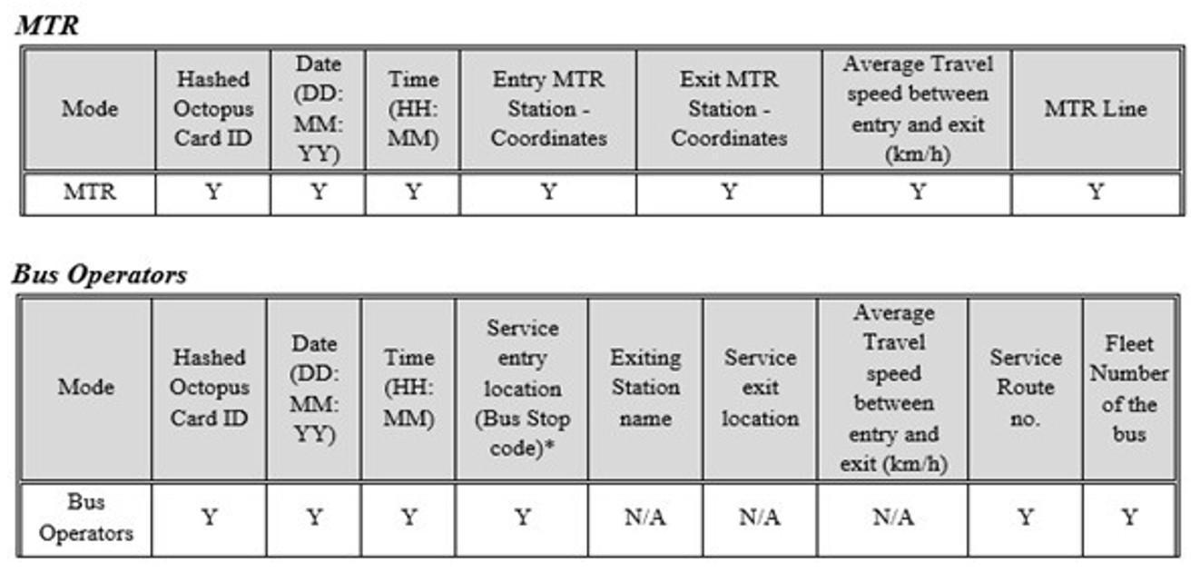
Note: (i) Service entry location refers to a bus stop at which the bus is located at the time that the tap-in event is made; (ii) Since passengers do not need to tap-out when alighting on buses, Bus Operators will not provide exiting bus stop name, exit location coordinate and average travel speed of each transaction, but it is hoped that Bus Operators will provide occupancy estimates also.

However, it should be noted that data gathering is subject to time and geographical limitations. Firstly, the survey period is from 1 May 2019 00:00:00 to 31 May 2019 23:59:59.
It was proposed by HKU that this period is the most recent complete month where travel patterns would be regarded as normal without being affected by school holidays, adverse weather events, the Hong Kong anti-extradition protests and travel restrictions due to COVID-19. Clearly, a longer period would provide additional data points for analysis and this would be considered for any potential extension of the Data Trust beyond the research period. Secondly, the data will only pertain to journeys originating from and terminating at Exchange Square PTI.
Static data included the site plan, pedestrian flow counts, and programme mix of blocks relating to Exchange Square and its catchment area that falls within the area of the site plan. The static data sets also include details on MTR trips originating or ending at Central/Hong Kong Station. Assuming that the Data Trust has access to MTR data, then for each trip, information would include the MTR station code, its name, its coordinates in WGS-84 format; the hourly average duration of the total journey time of the passenger between MTR stations and dwell time at Central/Hong Kong Station within the survey period; and the hourly estimation (based on manual count data from comparable times and days) of the total number of boarding and alighting passengers at each trip related to Central/Hong Kong Station, and the number of trips operated in that hour from MTR; and the route number and list of bus stops on the routes that originating or ending at bus stops within a 200m radius of the Exchange Square PTI.
Figure 1. Technical Architecture of the Data Trust
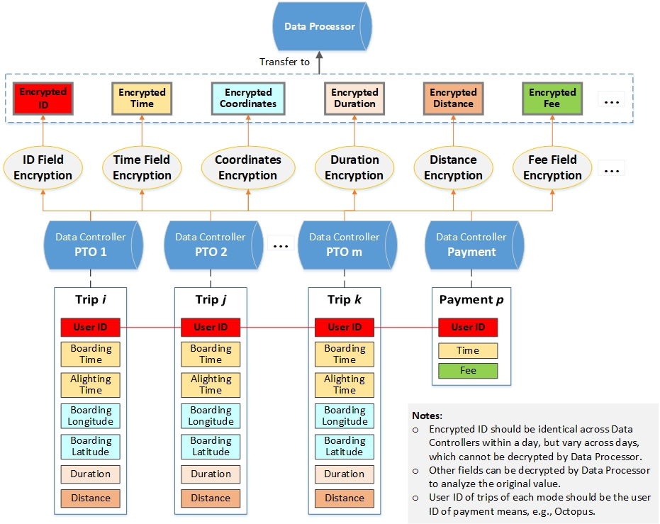

For each bus stop, information would include the bus stop code, name and coordinate of the bus stop location in WGS-84 format; the hourly average duration of the journey time for passengers between bus stops and the dwell time at each bus stop on target routes within the survey period; and the hourly estimation (based on manual count data from comparable times and days) of the total number of boarding and alighting passengers at each stop on target routes, and the number of trips operated in that hour from bus operators. Based on the above, the overall technical architecture of the data trust is summarised in Figure 1.

The Framework
Two types of Memorandum of Understanding (“MOU”) were developed to govern the use and collection of data between participating parties, one relating to the relationship between a Data Controller and Data Processor and the other between the Data Processor and TDASP. The Code of Conduct sets expectations on the role of all parties. Prior to the transfer of data, it is stated in the Data Controller-Data Processor MOU that all Data Controllers shall apply a hashing algorithm (as provided by HKU) to personal data that is included in the data (as defined by the PDPO) and then encrypt such data before transfer to HKU for ingress into the Data Trust. The approach to hashing and encryption as stated in the MOU is to ensure a common hashing approach by all Data Controllers.
Each Data Controller shall ensure that the data fields provided include sufficient overlap with the data fields (i.e., common keys) from another source. This not only requires agreement amongst Data Controllers and the Data Processor but also a common process to protect the Data during its transfer, processing and use in compliance with the PDPO. To ensure sufficient overlap, TSPs may elect to provide hashed Octopus Card ID (User ID) as a common data field (Figure 1 refers). By use of the same MOU template, each Data Controller that participates in the programme would be required to use a common approach to hashing its data that includes a minimum number of data points. The hashed and encrypted data (known as Data) provided by each Data Controller is transferred to the Data Processor and recombined with the data sets provided by other Data Controllers to generate aggregated and anonymised data (known as Aggregated Data).
The process aimed to exceed the usual definition of ‘personal data’ in Hong Kong to ensure that any ‘personally identifiable data’ could not be extracted to reveal individual identities. The hashing algorithm applied to all Data Controllers strictly follows the Secure Hash Algorithms standard and was provided by HKU to individual Data Controllers to prepare the Data before transferring it to HKU. The hashing codes provided by HKU, once executed by the Data Controller regardless of whether they apply to daily or monthly data, generate new anonymous card IDs that are for all practical purposes irreversible. The hashing codes, if each was executed on each day in May 2019 (i.e., 31 codes), would generate a different non-reversible ID for the same Card ID every day. But if a single hash was executed once on all 31 days’ as one block of combined calendar data and Card ID, it would also generate different non-reversible IDs that are different on a monthly basis (i.e., the same original ID will also become the same new hashed ID across 31 days). In both cases, it would not be possible to recover the original ID. The Data is then delivered in a secure manner to HKU as agreed between each Data Controllers and the HKU, such as using an encrypted DVD or secure File Transfer Protocol (“FTP”) as setting up by the ITS. The second stage of hashing is performed by the Information Technology Services (“ITS”) of HKU on receipt of the Data, so as to ensure that no personally identifiable data can be retrieved.
For the avoidance of any doubt, it was expressly agreed that an MOU executed with HKU as the host of the Data Trust does not create any legal obligations between the Parties. Instead, the MOU sets out some intended key terms and conditions of an agreement for the Collaboration which will be negotiated in good faith between the Parties following the execution of such. In addition, the Code of Conduct has been published for all MOU signatories and, on request to the Project Team or HKU, will be published to interested third parties. Specifically, the MOUs referenced in the Code are those between (a) each Data Controller and the HKU; and (b) each TDASP and the HKU. For convenience, any reference to an MOU also includes any complementary instruments relating to the participants such as Non-Disclosure Agreement(s) (NDAs) executed between the same parties.
The programme is intended to be collaborative and its success is also dependent upon the proactive participation of MOU signatories and many other parties that use or deliver transport services to the public and business in Hong Kong. It is necessary that the principles of data sharing should be flexible enough to reflect the changing mobility environment in Hong Kong and so updates to the Code may be issued during the execution of the programme. Affected parties should always keep abreast of the provisions of the Code. The Code applies to all stakeholders but not all provisions of the Code apply to all stakeholders. The Code does not apply to third parties. The Code consists of relevant explanatory notes and terms, general principles, provision and use of data, rights of data access, functions of transport data analytics service provider and its algorithm access.
Every participant is invited to submit research questions to determine if the data provided by all participants collectively could answer such questions. To ensure that the Data Trust reaches its full potential, over an 18-month period prior to the ITF-funded programme, multiple ‘use cases’ were developed that describe typical transport activities, mostly from a user perspective that can be used to explore the aggregated data on the Data Trust.
The Transport Department, MTR and all the involved transport operators contributed to the use cases. In particular, a mapping of pedestrian routes and timings, and how these could be affected by changes in the layout of Exchange Square, the bus timetables, the availability of other modes of transport such as on-demand, etc. are some topics to be explored. The Data Trust is therefore a tool to explore solutions for Exchange Square PTI improvement, and to be informed by use cases to investigate the usage of mobility data that meets the public needs. The principles on which the Data Trust was established are equally applicable to other economic zones and corridors in Hong Kong and scalable to the whole of Hong Kong.

A: Implementation
IT resources at HKU
The Data Trust was established with the relevant expertise of the HKU’s Information and Technology Services (ITS) and the Faculty of Architecture (FoA) . ITS offers a comprehensive range of big data management services and in particular, the Data Analytics (DA) platform of ITS is adopted for the establishment of the Data Trust. The data centre containing the DA platform is well equipped with high availability features and is under 24/7 monitoring in a well-controlled physical environment (ITS, 2020). Besides, the ITS provides their expertise in the usage of Logstash of Elastic to parse and transform unstructured data for data pre-processing. It helps ingest data of all shapes, sizes and sources and filters the data regardless of format or compactivity. Overall, their services include data replication, maintenance and regular updates of the platform, and most critically deriving the structure for the hashing of sensitive data (i.e., potentially de-identification of Octopus serial number).

B: Analytics
The use of visualisation platforms such as ArcGIS (one of the most efficient geo-visualisation analytics software available) and Kepler (an open-source web-based platform used for exploratory data analysis and large-scale location data visualisation) enable a range of analysis including but not limited to trip modelling and simulation, strategic transport modelling, agent and Agent Based Modelling (ABM), population synthesis, etc. The use of ArcGIS online also enables different parties to access the aggregated data from the Data Trust in an efficient way, while the latter open-source option can be used to showcase publishable research results to any interested audience who is not bounded by the MOU agreement. In sum, the flow of the process involved in the data trust can refer to below Figure 2.
Figure 2: Flow of Process for the Data Trust


Data Governance
There are four levels of data governance are (1) data storage, (2) access policies, (3) retention and archiving policies and (4) data destruction. Relevant details are extracted from the MOU and Code of Conduct and are listed as follows:
- Data Storage
- The expected date of completion is 31 January 2021, the Data Processor shall confirm that it is no longer in possession of the Data or any part thereof in any media or in any form,
- The Data Processor shall be transparent about the collection, use and disclosure of Data
- The Data Processor is committed to respecting the privacy rights of all applicable individuals granted by privacy laws and to keeping abreast of all applicable data protection/privacy laws of the jurisdictions in which it operates:
(a)The Data Processor shall keep the Data secure and
(b)The Data Processor is aware of the obligations set out in the MOU and shall follow necessary data protection procedures when handling the Data.

- Access Policies
- The Data provided shall not be used for any purpose other than research purpose
- The Data of a particular Data Controller shall not be distributed or transferred in part or in whole and in whatever forms and media to other Data Controllers or a third party
- The Data Processor shall keep the Data confidential
- A Data Controller will not be given or be able to get access or review Data coming from another Data Controller
- Access to the Data will be strictly limited and the Data Processor will implement appropriate physical, technical and organisational measures to ensure security
- The Data Processor will not transfer or process the Data outside the Hong Kong SAR.

- Retention and Archiving Policies
- The Parties (i.e., Data Controller) acknowledge that the Data has not been prepared specifically to meet the Data Processor’s individual requirements and purpose and that the Data Processor will not have any recourse against Data Controllers for any damage or loss it may suffer in any use or attempted use of the Data
- Each Data Controller remains the owner of the Data it provides at all times, HKU shall not copy or otherwise infringe any rights (including without limitation intellectual property rights) that the Data Controllers may have in the Data, whether in whole or in part
- Relevant security procedures are in place and guidance is issued to staffs of the Data Processor explaining its data protection and security obligations.

- Data Destruction
- The Data stored in the computer systems and storage media of the Data Processor shall be destroyed when the research purpose has been fulfilled and no later than on completion of the Collaboration
- At the end of the research period, the Data Processor will destroy all Data received from Data Controller(s) (with evidence provided for its destruction).

C: Overview of Datasets by Public Transport Operator
Independent Octopus Card datasets by public transport operator covering 1-month records (i.e., May 2019) were provided in batches under different sets of hashing codes. Each dataset was firstly cleaned by removing invalid data entries, such as records of negative travelling time, ride times that lasted more than 3 hours, records with missing information, etc. The content and structure of datasets, including the number of distinctive card holders, data records, data field available are summarised in Table 4 below.
Table 4: Summary of Octopus Card Datasets
Octopus Card Dataset | NWFB | KMB | MTR
Number of distinct card holders | 635,500 | 63,600 | 2,041,500
Number of raw records | 2,896,900 | 172,500 | 10,138,700
Number of cleaned records  (% of raw data) | 2,572,800  (88.8%) | 172,500  (100.0%) | 10,128,600  (99.9%)
Data captured | 30 bus routes serving areas in proximity of Exchange Square PTI | 3 bus routes serving areas in proximity of Exchange Square PTI | All station-to-station movements from/to MTR Central/Hong Kong Stations
Data fields available | - Hashed ID  - Entry Time  - Entry Latitude and Longitude  - Bus Route  - Vehicle Number | - Hashed ID  - Entry Time  - Entry Latitude and Longitude  - Bus Route  - Vehicle Fleet Number  - Concession (adult, elderly, student & children) | - Hashed ID  - Card Type (adult, elderly, student, children, disable)  - Entry Time  - Exit Time  - Entry Station  - Exit Station  - Trip Time

In this analysis with Octopus Card datasets for NWFB, KMB and MTR, the passenger’s complete trip may not be fully captured, particularly trips with multiple modes in addition to bus and rail involved (including public light bus, ferry, taxi, etc.), or trips of passengers that did not use Octopus card as the only payment option. It is envisaged that these data would still be very useful and acts as a reliable indicator for passenger’s travel behaviour taking into account the fact that (i) rail and bus are two major public transport modes sharing over 75% of average daily public transport passengers in May 2019 and (ii) Octopus was the dominant e-payment options available at the time.
The following sub-sections details the data analysis by individual mode (NWFB and KMB datasets for bus and MTR dataset for rail). A more complete interpretation of inter-modality (interchange between bus and rail) is provided in Section D. To facilitate the ease of data comparison, figures are usually presented in form of an average weekday and weekend/holiday in May 2019.

C.1 Bus data analysis
Bus routes that served areas in proximity of Exchange Square PTI are listed out in Table 5 and visualised on a map in Figure 3. They were selected as the basis for formulation of NWFB and KMB datasets. Fundamentally speaking, only bus passenger tap-on records could be captured from Octopus Cards. In other words, stop-to-stop data for bus rides were unavailable. Although data availability for bus passenger journeys was limited, attempts had been made for realising the origin and destination of bus passengers (in form of stop-to-stop bus passenger movement) by considering several underlying assumptions derived from individual bus dataset.

The following sub-sections discuss daily and hourly variations of bus passenger boarding of these select bus routes (combined in both NWFB and KMB datasets), followed by the showcase of bus passenger Origin-Destination (OD) analysis.
Table 5 and Figure 3: Selected Bus Routes for Analysis
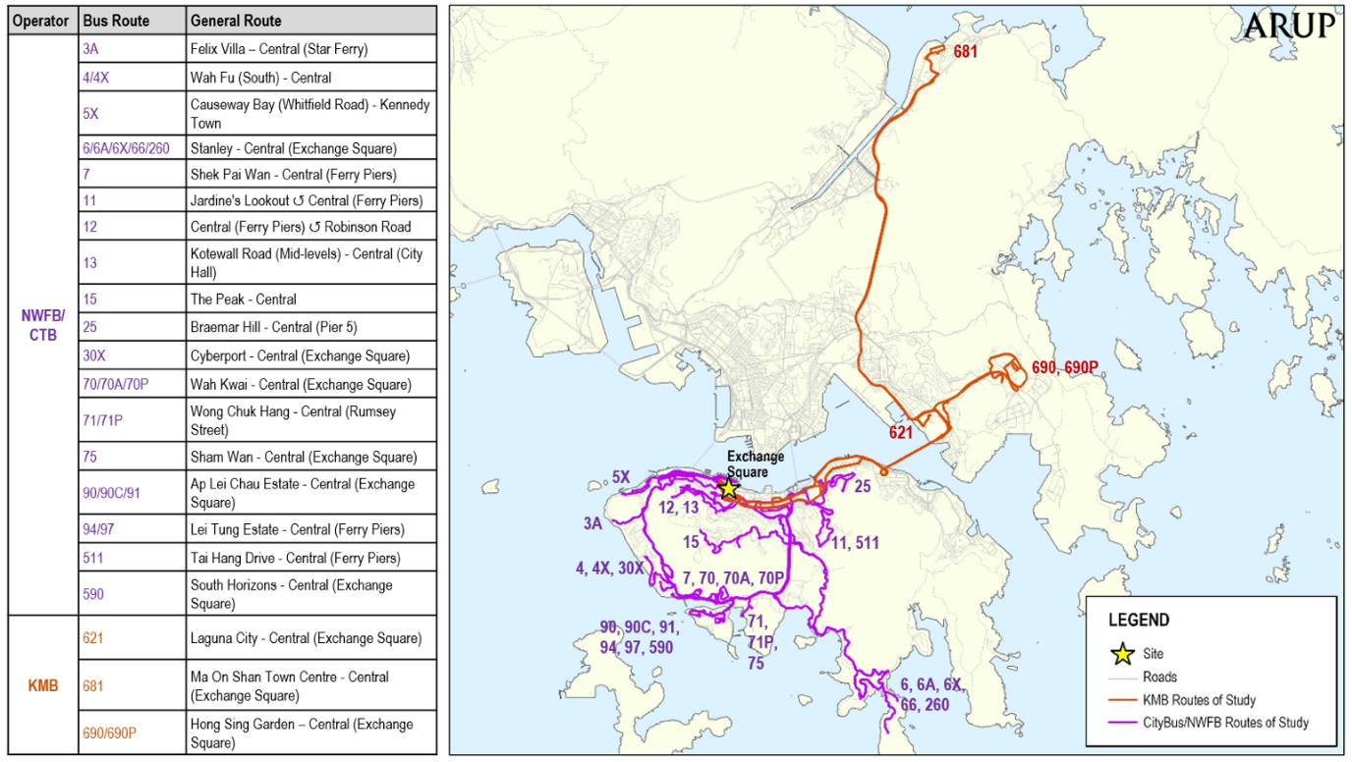

C.1.1 Daily Variation in Bus Passenger Boarding of Selected Routes
Overall, the total daily bus passenger boardings for the selected routes on an average weekday and weekend/holiday in May 2019 are summarised in Table 6. Analysed by day as shown in Figure 4, the total daily bus passenger boardings along with the number of distinct Octopus cards show a consistent weekly pattern over time, with constantly higher ridership on weekdays, followed by lower ridership on weekends, especially on Sundays.

Table 6: Daily Bus Passenger Boardings
 | Average Weekday | Average Weekend/Holiday
Daily Bus Passenger Boarding | 96K | 83K
Figure 4: Daily Bus Ridership and Number of Distinct Octopus Card used on Selected Routes
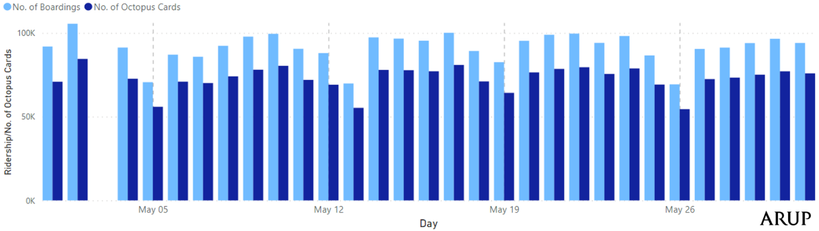
*Bus data absent for 3 May 2019
Figure 4 also shows that the number of Octopus Cards used were not far fewer than the total ridership on the studied bus routes, signifying that few bus passengers made two-way trips in a day by the same mode. The daily itinerary asymmetry can further be proved by enumerating the frequency of daily bus boarding per Octopus Card shown in Figure 5, where more than three-quarters of passengers took the bus only once a day, both on an average weekday and weekend/holiday. Although the major reason is that we are unable to capture all the trips from the small sample of selected bus routes, the existence of one-way trip in transit systems is of particular interest to scholars. We might hypothesize that those trips cannot be captured are either by other modes or out of the study area. It could also be from a behavioural point of view that taking the same trip with the same mode could not create travel experiences that answer higher-order needs such as relatedness, autonomy, and competence, as suggested in a recent academic study . It would be valuable to analyse the behavioural aspect of mode choice when more data from both qualitative (with interview and questionnaire) and quantitative (with more complete travel datasets) methods are therefore warranted. Doing those, however, are far beyond the scope of this grant.

Figure 5: Frequency of Daily Bus Boarding per Octopus Card on Selected Routes
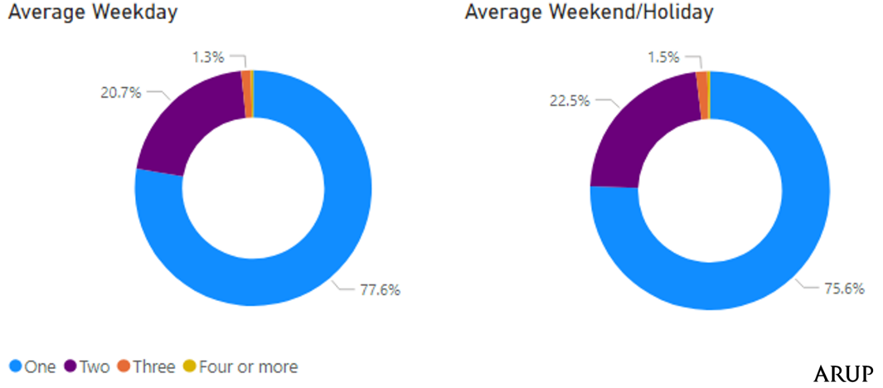
Figure 6 tabulates the total daily bus passenger boardings by routes. Sub-group analysis by daily bus passenger boardings at bus stops within a 200m walking catchment of the Exchange Square PTI (which is also overlayed in this figure) revealed that a majority of bus routes recorded less than 11% of total boardings from Exchange Square on average weekdays, Similarly, most bus routes had less than 15% of total boardings from Exchange Square on average weekends/holidays. There were also notable bus routes that can be revealed as critical to serving those who frequent Exchange Square:
- Express peak-hour bus services with direct access to/from the Exchange Square had higher rates of passengers boarding at Exchange Square (over 30% on an average for weekdays)
- Bus routes serving non-rail catchments such as Stanley and Repulse Bay generated higher bus passenger demand as well as higher rates of boarding passengers from Exchange Square (up to 26% and 32% of all boardings on an average weekday and weekend/holiday respectively)
- Short-haul bus routes from the Mid-levels had relatively high rates of boarding passengers from Exchange Square (between 15% and 20% of all boardings on average weekdays and weekends/holidays). It is attributed to their roles as feeder services for taking mid-level residents to likely interchange to other transport modes at Exchange Square, or work and leisure in Central.

Figure 6: Average Daily Bus Ridership by Selected Route
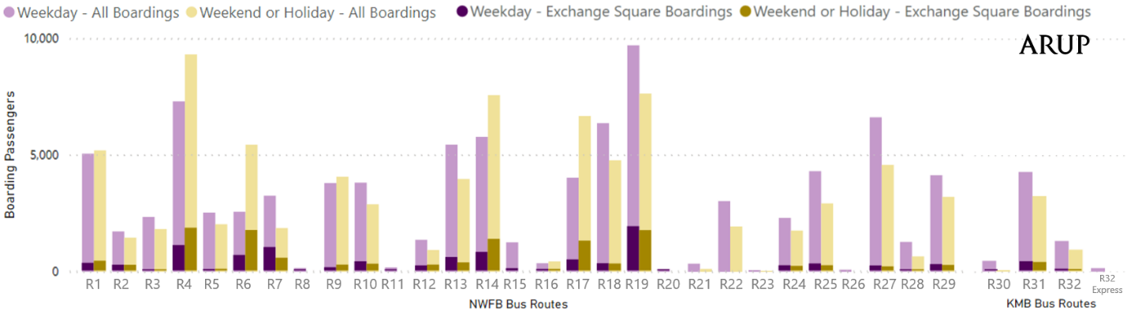

C.1.2 Hourly Variation in Bus Passenger Boarding near Exchange Square
From the hourly variation of bus passenger boarding near Exchange Square as shown in Figure 7, it was observed that there were two commuting peak periods (specifically, 7:10 – 8:58 AM for morning peak period and 5:39-7:19 PM for evening peak period) throughout an average weekday, accounting for about 15% and 19% of the total daily bus passenger boardings near Exchange Square. Weekends/holidays showed a moderate inter-peak period covering approximately 11:00 AM - 7:00 PM, with every hour accounting for about 6-7% of the total daily throughout the day.
Figure 7: Hourly Variation of Selected Bus Routes Ridership near Exchange Square
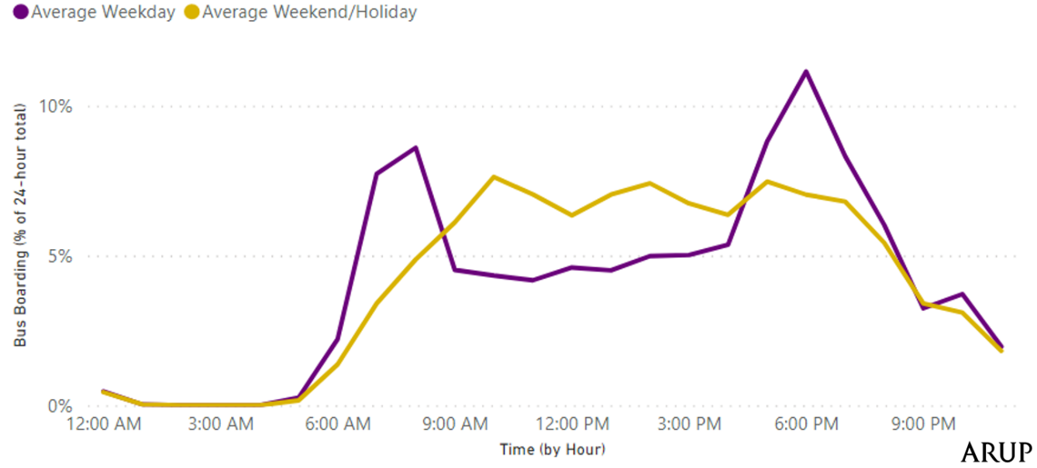

C.1.3 Origins and Destinations of Bus Passengers on Selected Routes to/from Exchange Square Vicinity
Despite the absence of tap-off record it is possible to pair origins with destinations of bus rides, and make assumptions to replicate where “returning” bus passengers going to the Exchange Square came from and vice versa, by considering:
- same card holder had two bus passenger boarding records on the same day
- the card holder boarded only once within the walking catchment of Exchange Square
- these identified bus passengers would follow fixed daily 2-way itineraries with “loyalty” to bus rides.
For example, if an Octopus Card “A” shows bus passenger boarding records at Stanley and Exchange Square on the same day, it is hypothesised that the card holder of Octopus Card “A” would make 2-way bus rides between Stanley and Exchange Square.
Based on the methodology discussed above, origin-destination pairs replicated from the Exchange Square-related bus rides covering areas in southwestern Hong Kong Island are depicted in the map of Figure 8. Southwestern Hong Kong Island, mountainous areas, such as the Peak and the Mid-levels, as well as remote areas in the Southern District, such as Stanley, Repulse Bay were identified as many of origins and destinations.

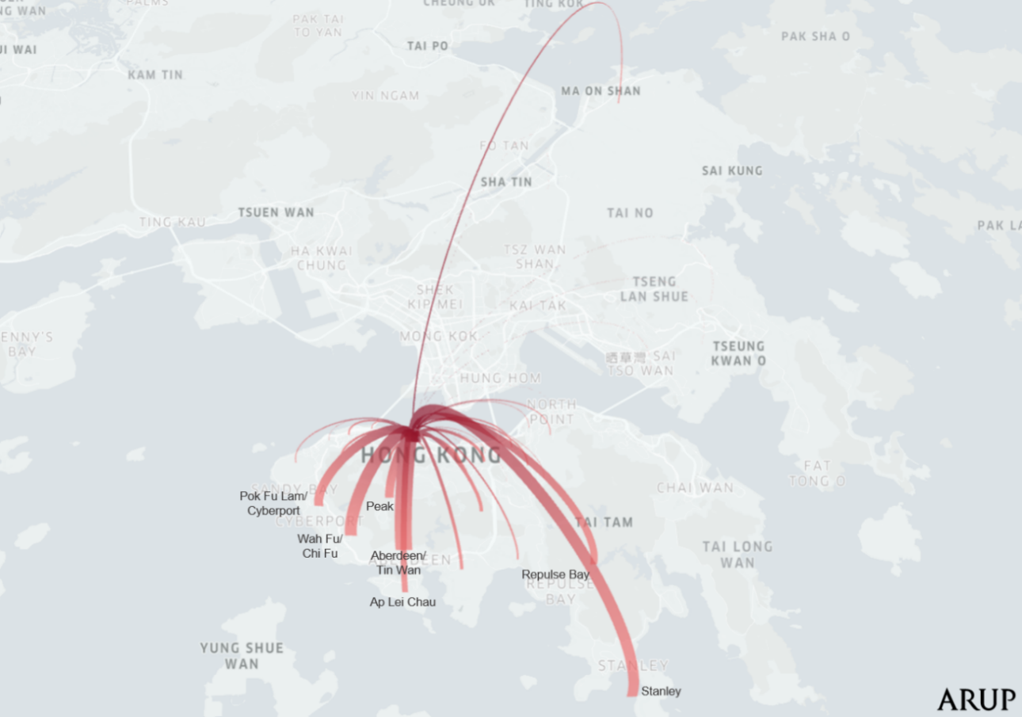
Figure 8: Replicated Origin-Destination of Exchange Square-related Bus Rides on selective routes
Analysed by average weekday and weekend/holidays, Figure 9 indicates the variation in origins and destinations type throughout the week. During weekdays, residential areas such as Aberdeen, Tin Wan, Wah Fu, and the Peak were the dominant bus passenger movements from/to the Exchange Square. In contrast, leisure areas including Stanley, Repulse Bay, and the Peak were popular during weekends/holidays.

Figure 9: Replicated Origin/Destination of Bus Rides from/to Exchange Square
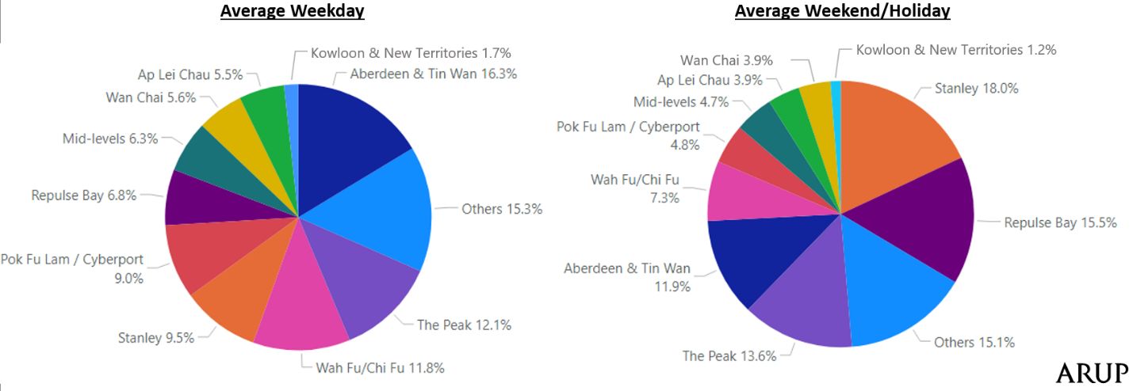

The bus data itself showed some anomalies, especially the lack of many passengers that made two-way bus journey to locations that were most conveniently served by buses. It was very likely that the missing return bus journey could be found in records of other many bus routes within a walkable distance from the Exchange Square, e.g., along bus corridors of Connaught Road or Des Voeux Road (which were not covered in the studied datasets). Moreover, bus patrons were not loyal to a specific route but took the first available bus that stops by their destination. Thus, a comprehensive review on the origin-destination of bus passengers in form of stop-to-stop movement can be performed in the future if all relevant bus routes can be gathered in the dataset.
Certainly, the analysis of origin-destination of bus passengers can further be supplemented with rail data. When both bus and rail data are combined, it will be possible to identify the travel pattern, particularly by looking into bus-rail journeys, the likely location of bus passenger alighting can be determined by matching the rail boarding stations. To unravel this potential, the next sub-sections explore the availability of rail data with showcases.

C.2 Rail data analysis
Rail passenger station tap-in and tap-out records can be captured from Octopus Card. Rail data, as compared to the bus data above, can therefore provide more comprehensive information on the Origin-Destination (OD) of rail passengers. As illustrated in Figure 10 for the rail network in the territory, the MTR dataset offered rail passenger station-to-station movements for all rail lines (except Airport Express Line) coming in and out of MTR Central and Hong Kong Stations (the two closest stations to Exchange Square).
Although the two MTR stations correlated with a large rail passenger demand not fully representing the whole Core Business District, these data acted as a good indicator of passenger travel behaviours at the Exchange Square when combined with other transport datasets, and help confirm scalability of the technical and contractual framework on which the successful implementation of the data trust depended. The following sub-sections discuss daily and hourly variations of rail passenger movements from/to these two stations.
Figure 10: MTR Network (May 2019) and Central and Hong Kong Stations
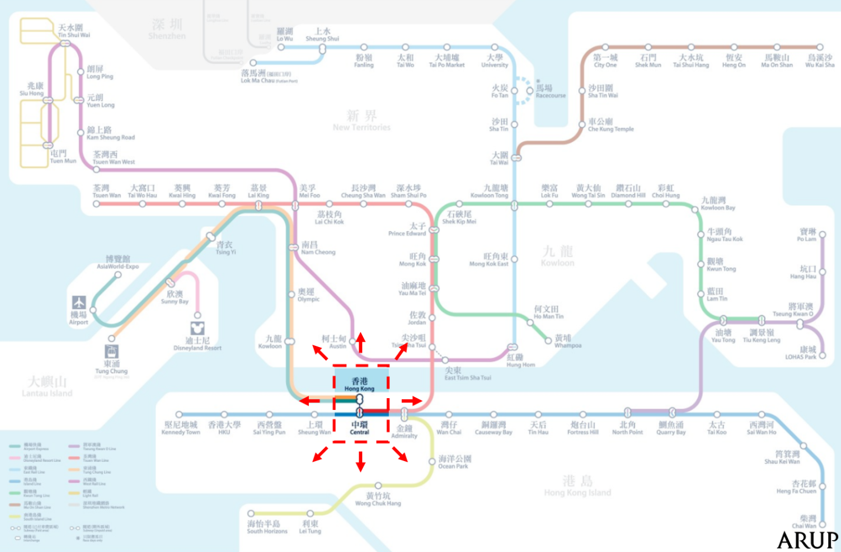

C.2.1 Daily Variation in MTR Ridership at MTR Central and Hong Kong Stations
Overall, the total daily rail passenger boardings and alightings at MTR Central and Hong Kong Stations on an average weekday and weekend/holiday in May 2019 are summarised in Table 7. Analysed by days as shown in Figure 12, the weekday and weekend/holiday ridership patterns were consistent, with high ridership during the weekdays, peaking on Fridays, followed by lower ridership on weekends and holidays. The number of Octopus Cards used throughout the month followed the same pattern as well.
Table 7: Total Daily Rail Passenger Boardings and Alightings at MTR Central and Hong Kong Stations
 | Average Weekday | Average Weekend/Holiday
Daily Rail Boarding | 185,000 | 127,000
Daily Rail Alighting | 174,000 | 126,000
Daily Rail 2-way | 359,000 | 252,000

Figure 12: Ridership and Number of Distinct Octopus Card used at MTR Central/Hong Kong Stations
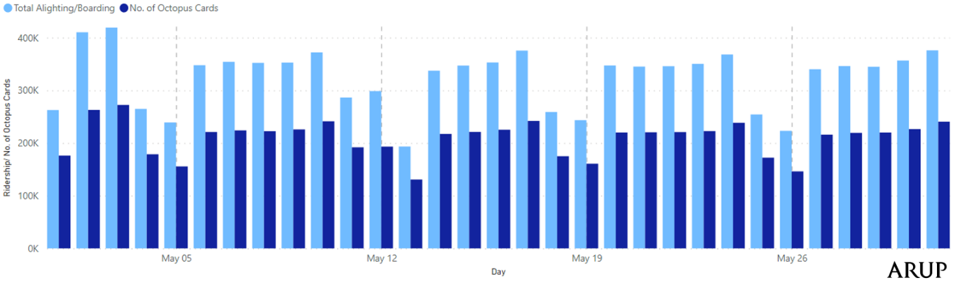
Compared to the daily trend of bus passengers, rail passengers were more likely to make more trips by rail within the same day. As shown in Figure 13, about half of rail passengers took the MTR once a day on an average weekday (49.9%), while the remaining half are “loyal” rail passengers that took the metro more than once a day (including the return journey by rail) on an average weekday (50.1%). Similar trends were observed from average figures for weekends/holidays.

Figure 13: Frequency of Daily Rail Rides per Octopus Card at MTR Central/Hong Kong Station
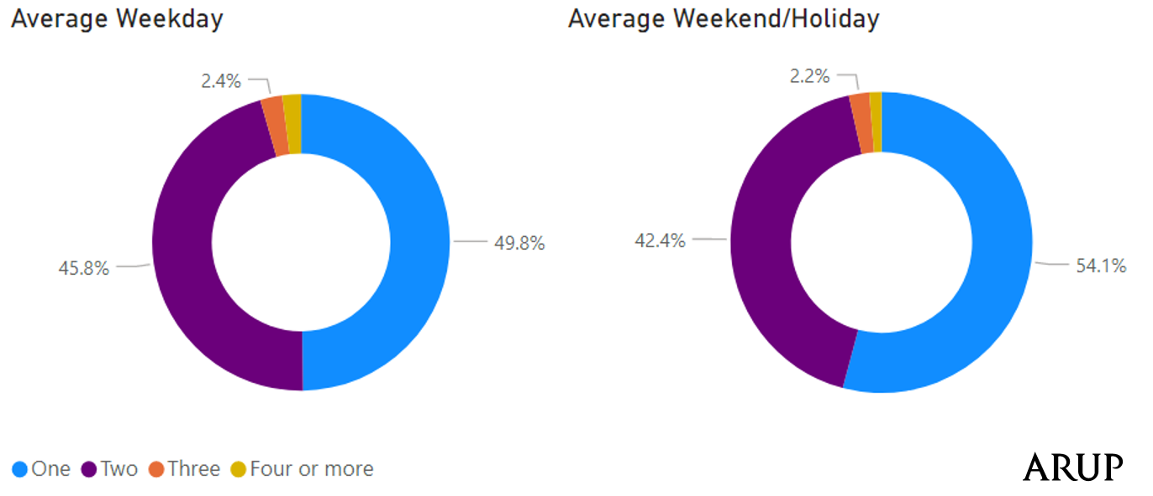
Regarding the top 5 Origin-Destination in form of station-to-station rail passenger movements from/to MTR Central and Hong Kong Stations on a daily average, as shown in Table 8, Central station mainly served stations at Yau Tsim Mong and Hong Kong Island North representing the business activities between Victoria Harbour, while Hong Kong Station mainly served stations along Tung Chung Line representing the passenger travels between residential districts along Tung Chung Line and Central.
Table 8: Top 5 Origin/Destination Stations to/from MTR Central and Hong Kong Stations
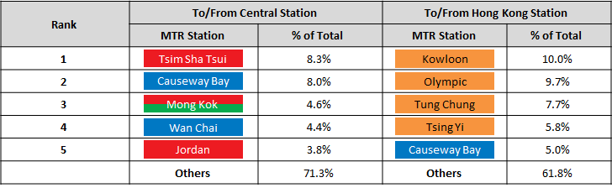
*Blue stations are on the Island Line, red stations are on the Tsuen Wan Line, red/green station is on both Tsuen Wan Line and Kwun Tong Line, while orange stations are on the Tung Chung Line
The station-to-station movements also allowed for some inference of rail passenger movements on the travelator link between MTR Central and Hong Kong stations. By assuming that passengers took the most optimal route as suggested by MTR, it could be deducted that about only 17% and 19% of boardings and alightings at both Central and Hong Kong stations traversed the link on weekdays and weekends/holidays respectively. However, the actual volume of people crossing the travelator link and its hourly variation would require further data, such as the entry or entrance by gate, specific lines taken by the passenger, and all station-to-station volumes to estimate rail interchanges at MTR Central and Hong Kong stations.

C.2.2 Hourly Variation in MTR Ridership at MTR Central and Hong Kong Stations
Figures 14 and 15 show the hourly variation of rail passenger alightings and boardings at MTR Central and Hong Kong Stations on an average weekday and weekend/holiday respectively. Especially of interest is the tidal flow pattern reflected by the business activities during weekday in Central. It was observed that there were two commuting peak periods (8:13 - 9:37 AM for rail passenger alighting during morning peak period and 6:04 - 7:16 PM for rail passenger boarding during evening peak period) throughout an average weekday, accounting for about 27% and 24% of the total daily rail passenger alightings and boardings respectively. Similar to the bus datasets, weekends/holidays had moderate inter peak periods covering approximately 9:00 AM - 6:00 PM, accounting for less than 10% of the total daily.
Figure 14: Hourly Variation of Average Weekday Alighting and Boarding Passengers at MTR Central/Hong Kong Station
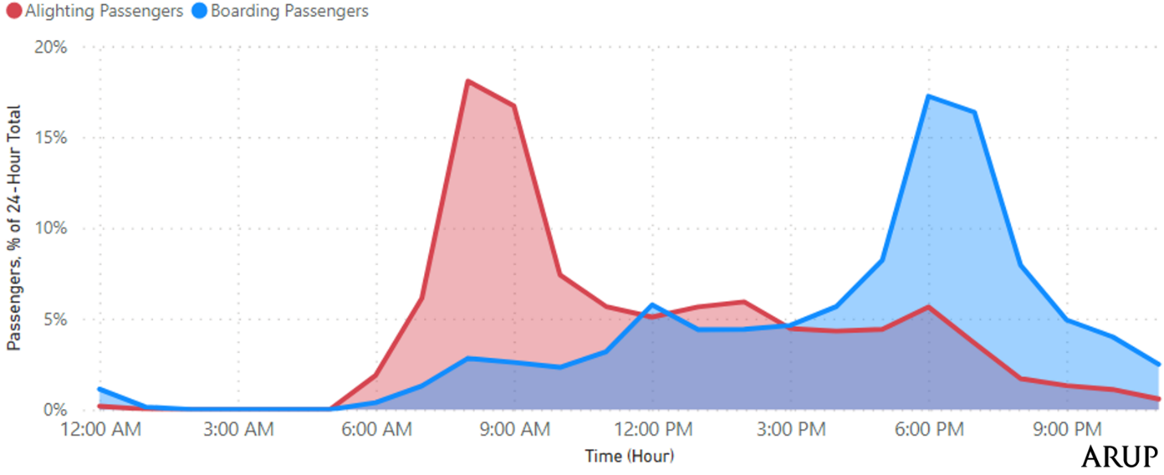
*Hourly volumes are the number of passengers between the beginning and end of an hour (e.g., 08:00:00 – 08:59:59)

Figure 15: Hourly Variation of Average Weekend or Holiday Alighting and Boarding Passengers at MTR Central/Hong Kong Station
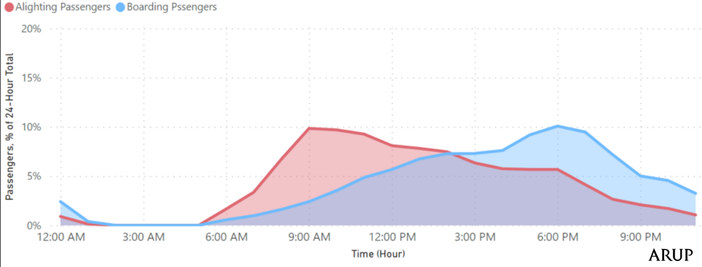
*Hourly volumes are the number of passengers between the beginning and end of an hour (e.g. 08:00:00 – 08:59:59)

Although the rail data was more comprehensive than the bus data, it is important to remember that it only represented a segment of an individual’s journey. Consequently, within the scope of the data sets provided within the defined area of interest, the analysis gave very limited insight short of understanding of rail interaction with other modes to create smarter and more efficient movement. With both rail and bus data available, the next section gives insight into how more details in a person’s itinerary or travelling behaviour can be calculated or inferred by performing inter-modal analysis with both rail and bus data.

D: Inter-modal Analysis

D.1 Interchange (rail and bus) analysis
To begin the integration of bus and rail data, matching of hashed IDs among all datasets (incl. NWFB, KMB and MTR) was initially attempted. However, for reasons that were outside of the control of the project team, it was only possible to match the hashed IDs between KMB and MTR datasets. Hence, analysis of interchanges between bus and rail could be performed as planned but noting that the “buses” refers to the 3 KMB routes (with origins/destinations from/to Shatin, Tseung Kwan O and Kwun Tong) only.
Requirements were set to define an “interchange” between two modes of transport and how hashed IDs can be matched between the KMB and MTR datasets. They also acted as underlying assumptions to overcome Octopus Card data insufficiencies, especially missing bus tap-off record. Generally, these requirements were:
- KMB and MTR as the two transport modes involved in a mechanised trip
- Time limitations between bus and rail rides
- Bus boardings and calculated alightings at bus stops within 500-metre walking distance of MTR Central and Hong Kong stations as shown in Figure 16.
In view of limited data availability for interchange, additional requirements for bus-to-rail and rail-to-bus interchanges were specified. Overall, around 2,700 valid matches for interchange between rail and bus were identified in May 2019. Interchanges amounted to around 2% of bus rides on the three KMB bus routes. Analysis together with preliminary results were discussed in detail in the following sub-sections.
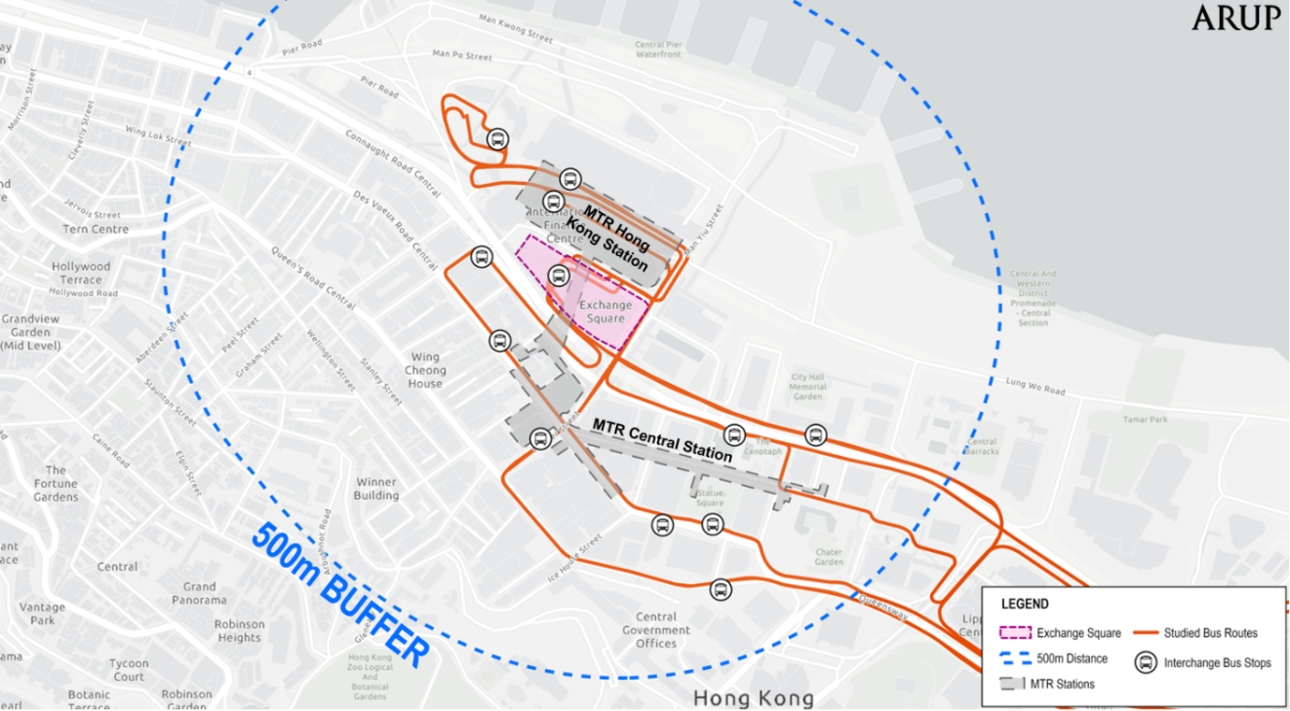
Figure 16: Bus Stops within Walking Distance of Exchange Square for Interchange Data Analysis

D.1.1 Rail-to-bus Interchanges
Rail-to-bus transfers were determined with specific requirements of Octopus Card record chains. The requirements included:
- The alighting station must be at either MTR Central or Hong Kong Station.
- Bus boarding must be within the 500m rail catchment from the MTR Central or Hong Kong Station.
- The difference in time between rail alighting and bus boarding must be less than 60 minutes.
Figure 17 illustrates the chain of rail-to-bus interchanges in form of a flow diagram. Data insights generated from top to bottom covering (i) MTR Ride Station Entry, (ii) Interchange Time, (iii) Interchange Location and (iv) Bus Route and Bus Passenger Alighting are provided.
Figure 17: Rail-to-Bus (KMB) Interchange Flow Diagram*
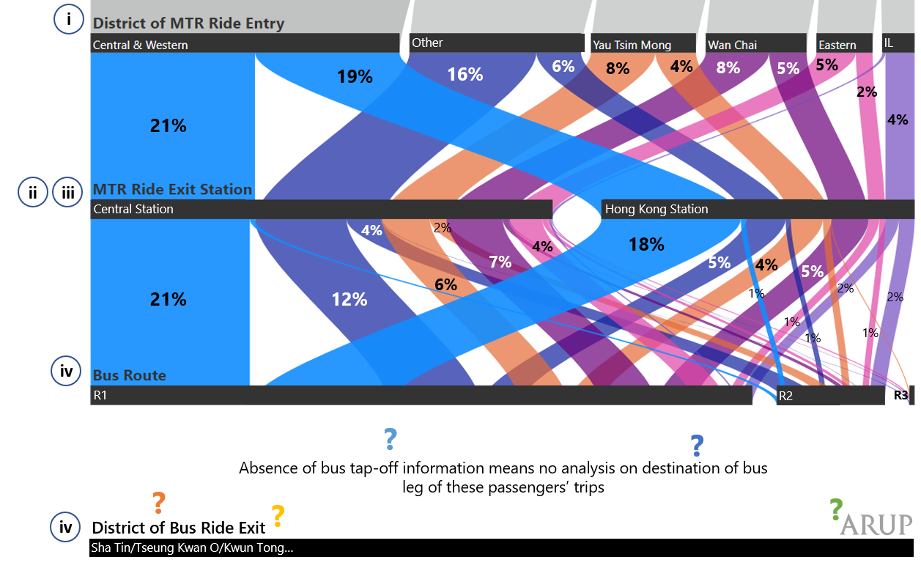
*Abbreviations for districts: IL = Islands
(i) MTR Ride Station Entry
A large proportion of rail-to-bus transfers (about 40%) started their rail trip leg at Central and Western district, entering the MTR from Kennedy Town, Sai Ying Pun, and HKU Stations. Interchanges starting from other districts, including Yau Tsim Mong, Wan Chai, and Eastern districts, etc., accounted for the remaining 60%. Of particular interest were the analysis between these two groups in terms of mode choices (by two modes with interchange or one mode direct) to/from Shatin, Tseung Kwan O and Kwun Tong, such as transfer time which will be discussed in the following sub-sections.

(ii) Interchange time
Figure 18 shows the distribution of transfer time for rail-to-bus interchanges. For rail-to-bus interchanges that started at stations within the Central & Western District, over 80% of the transfers were done within 20 minutes. In particular, transfer time within 5-10 minutes had the largest proportion (35%). The proportions dwindled down with longer transfer times after 30 minutes, the maximum bus headway that acted as a benchmark for maximum transfer time. However, the proportions remained stagnant even as transfer times increased, meaning that some rail-to-bus “interchanges” with long transfer time were not necessarily a transfer within one single trip, but could be an activity near Exchange Square between two trips. In fact, for rail-to-bus interchanges that started from districts other than Central & Western district, the transfer times for rail-to-bus interchange were found to be uniformly distributed at all time lengths. Thus, it could be inferred that while interchanges starting from Central & Western MTR stations were made by time-conscious travellers, interchanges from other MTR stations were most likely a stop for an activity within the passengers’ day, or a leisurely non-business trip.
Figure 18: Distribution of Transfer Time for Rail-to-Bus Interchanges
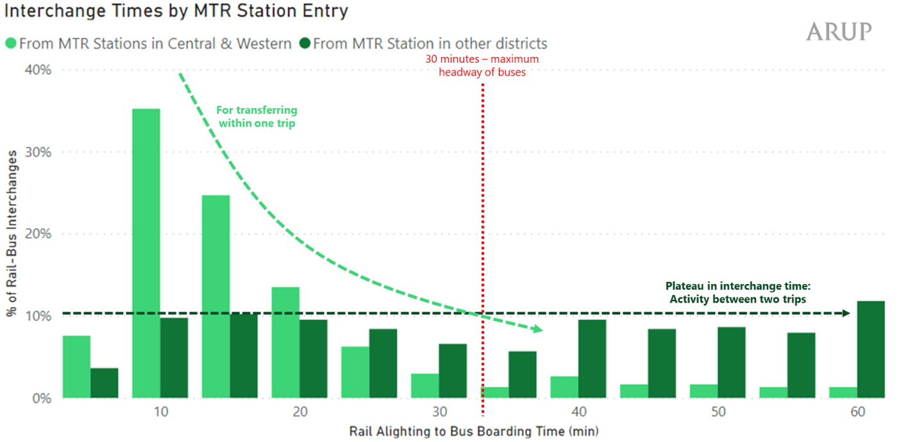
(iii) Interchange Location
Figure 17 shows a split of about 6:4 for MTR Central and Hong Kong Stations as exit station for rail-to-bus interchanges, whereas the spatial distribution of bus passenger boardings shown in Figure 19 reveals that a majority of bus boardings (over 65%) for rail-to-bus interchanges were clustered at bus stops near MTR Hong Kong Station. These data can give an insight into the strong interaction of pedestrian movements between two stations, particularly the walk trip legs either at the travellators within MTR internal walkway system or interlinked at-grade/grade-separated pedestrian walkways in the vicinity.

Figure 19: Proportion of Bus Boarding of Rail-to-Bus Transfers by Location for an average day
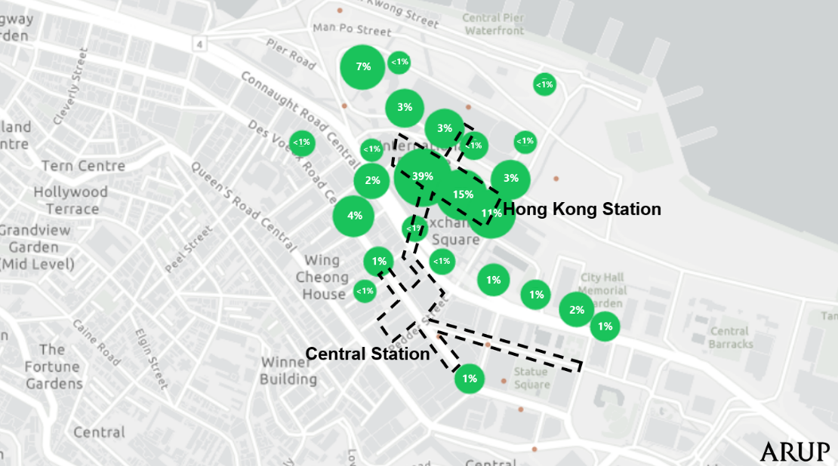

(iv) Bus Route and Bus Alighting
As shown in Figure 17, about 85% of the studied rail-to-bus interchanges involved the bus route to Shatin District (i.e., R1). Since there was no tap-off data, it is currently impossible to figure out where the interchanging passengers finally alighted on their second bus trip leg.

D.1.2 Bus-to-rail Interchanges
Bus-to-rail transfers were determined by specific requirements of Octopus Card record chains. The requirements included:
- The boarding station must be at either Central or Hong Kong Station.
- Bus boarding must be within 500m rail catchment from the MTR Central or Hong Kong stations.
- The difference in time between bus boarding and rail boarding must be less than 90 minutes.
- The difference in time between bus alighting and rail boarding must be less than 60 minutes.
To overcome the obstacle of missing bus tap-off data, the validity of a bus-to-rail interchange required a bus boarding to rail boarding time restriction. Nonetheless, the interchange time could also be determined using back-calculation with tap-off data only. Figure 20a and 20b provide illustrative examples, with explanatory notes below:
- Each bus within the KMB dataset can be identified by routes and vehicle IDs. Hence, bus locations, and arrival time of stops such as Stop 1, 2, 4, and 7 in Figure 20a and 20b can be identified only when passenger taps on a certain bus vehicle.
- However, if there are no passengers tapping on when buses arrive at a bus stop, it is impossible to know at what time the bus arrives at stops such as Stop 3, and 5 in Figure 20a and 20b.
- Base on (a) and (b), the arrival time of an interchanging passenger could only be identified when
passenger tapped onto the bus at a stop. In the case of Figure 20a, the closest to MTR station transaction were detected at Stop 6 at 10:43. To this end, the bus-to-rail passengers on that bus were assumed to have alighted at Stop 6 at 10:43. If the interchanging passengers boarded on the MTR at 10:50, it would also be assumed that their interchange time was 7 minutes.
- Similar to (c), when there were occasions that no passenger tapped onto the bus at stops within 500 metres of Exchange Square, denoted as Stop 6 in Figure 20b. The interchange time cannot be calculated since it is impossible to confidently calculate the bus arrival time to Stop 6. These interchanging trips could also not be used for interchange time analysis but was considered for geographical analysis.
Figure 20a: Illustration for Bus Tracking Method – Example 1
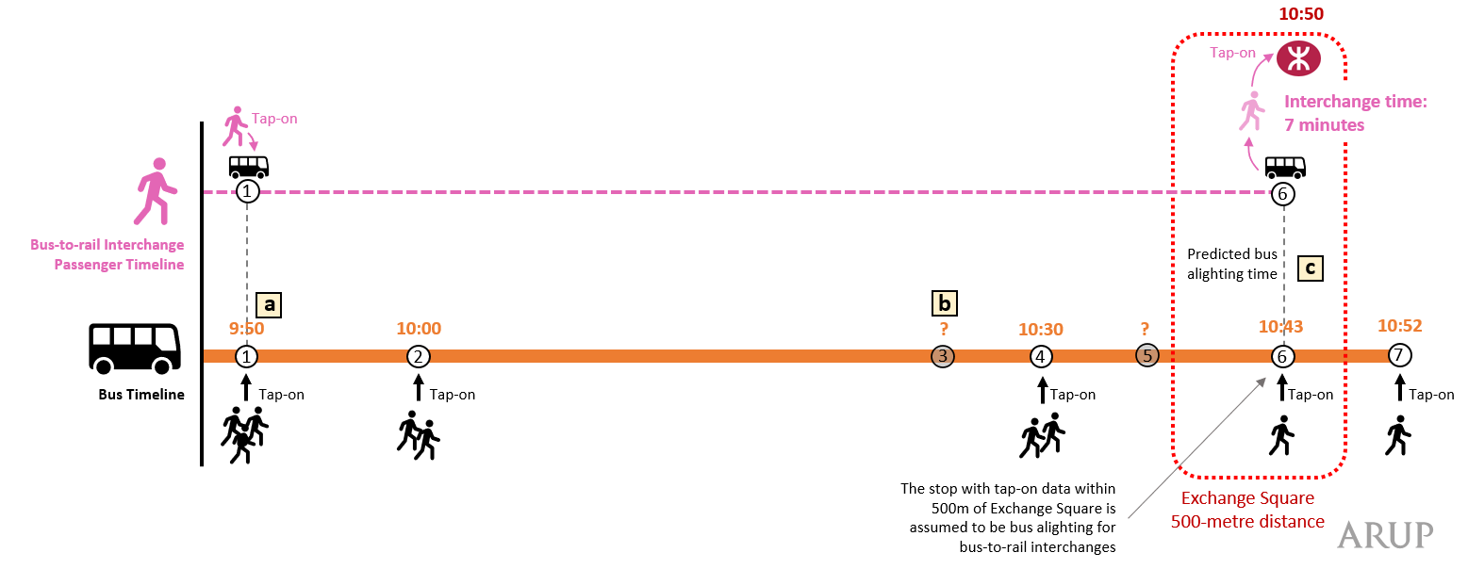
Figure 20b: Illustration for Bus Tracking Method – Example 2
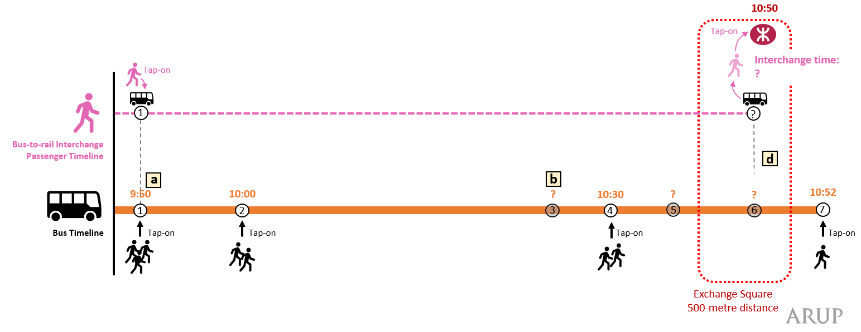

Figure 21 illustrates the chain of bus-to-rail interchanges in form of a flow diagram. Data insights generated from top to bottom cover (i) Bus Ride Boarding, (ii) Interchange Time, (iii) Interchange Location, and (iv) MTR Station Exit.

Figure 21: Bus-to-Rail Interchange Flow Diagram
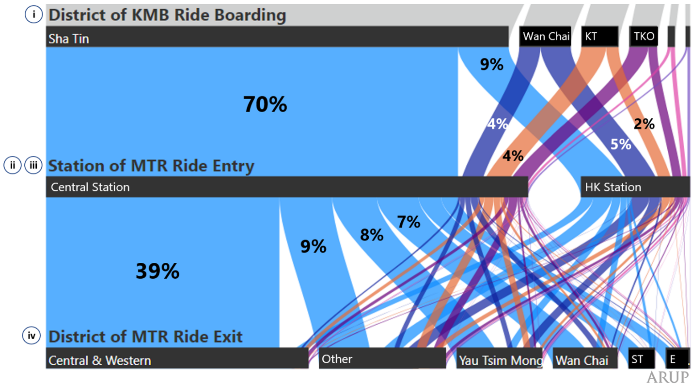
*Abbreviations for districts: KT = Kwun Tong, TKO = Tseung Kwan O, ST = Sha Tin, E = Eastern

(i) Bus Ride Boarding
A majority of the studied bus-to-rail interchanges (about 79%) boarded the bus at Sha Tin District. This was attributed to the large passenger demand attracted by a direct long-haul bus route operating between Sha Tin and Exchange Square.
(ii) Interchange Time
Figure 22 shows the distribution of calculable transfer time for bus-to-rail interchange. About 60% of said transfers were done within 10 minutes, the benchmark for maximum transfer time calculated by adding 6 minutes of non-peak headway of MTR trains and few minutes of walking time together. In particular, a transfer time within 5 minutes represented the largest proportion (40%). The proportions of transfer times dwindled down with longer transfer times after 10 minutes but were still significant 40% of all recognized transfers. This signifies that some bus-to-rail “interchanges” with long transfer time were not necessarily a transfer within one single trip but could be an activity near Exchange Square sandwiched between two trips.

Figure 22: Distribution of Transfer Time for Bus-to-rail Interchanges *
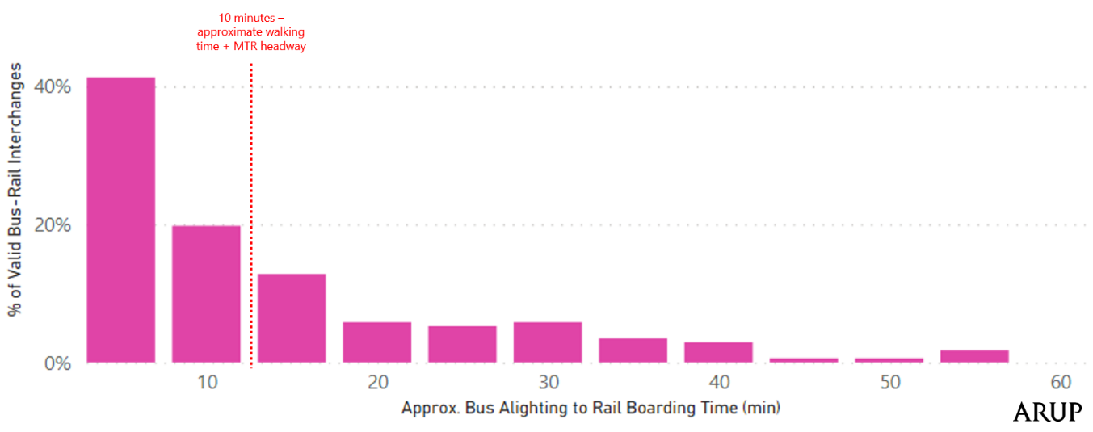*The records distributed by rail alighting to bus boarding time only include interchanges that could back-calculate bus alighting time near Exchange Square as illustrated in Figure 21a and 21b.

(iii) Interchange Location
As shown in Figure 21, a majority of bus-to-rail interchange passengers entered the MTR via Central Station. Nevertheless, we are not able to identify the exact walkways passengers used for interchanging, since they could walk outside the MTR internal walkway system to get to Central station platforms to reach their rail destination. In addition, since the exact bus passenger alighting location of interchanging passengers could not be captured, it is uncertain how passengers travelled between bus alighting and MTR station entry.
(iv) MTR Station Exit
As shown in Figure 21, about 39% of the bus-to-rail interchanges ended their second rail trip leg at MTR stations at Central and Western District, accounting for a short distance rail trip leg, while the remaining would end at MTR stations at other districts.

D.2 Opportunities for future research
Despite the limited amount of data available for this inter-modal analysis exercise, it provided an excellent opportunity to explore the potential of integrating transport datasets from different modes/operators with an aim of replicating a more “complete” travel pattern of people in the territory. It is believed that this may the first time that this has been performed in Hong Kong, and was aimed at informing discussion on how the performance of Hong Kong’s multi-modal transport network could be improved. Attempts were made to establish the principles and requirements for relevant data analysis, ideally highlighting the scaleability to larger data sets reflecting travel behaviour for more routes, ideally for the whole of Hong Kong.
We can envision that an even more insightful tool can be developed for key transport stakeholders including policymakers, developers, as well as the public for multimodal transport coordination with more comprehensive Octopus Card and other big data made available in the near future. Few examples for dataset requirements with key highlights are provided below for paving the way for significantly valuable future research projects:
Octopus Card Data
- Transport data of all modes:
  - Full picture on interchange activities between modes
  - Comprehensive dataset for defining an “interchange” between modes
  - An analysis of journey variability to see if there was a day-to-day variation at the same time every day that warranted a passenger leaving more time to travel to be confident of on-time arrival; compare bus and MTR to see if bus passengers are disadvantaged more than MTR passengers due to traffic congestion.
- MTR data by station entry and exits by gates
  - Better understanding on the walk time of travellers, the interchange time and distance by walk between rail station to bus stop
  - Potential interface with a 3D pedestrian network for detailed pedestrian modelling for public transport node
  - More in-depth analysis on the pedestrian movement across the travellator link between MTR Central and Hong Kong Stations
- MTR train departure and arrival times
  - Comprehensive understanding of the walk time, transfer time, etc. within MTR system
- Time series bus GPS locations throughout its operation
  - Accurate estimate of the bus journey time by route by time by road corridor
  - Improved derivation of the expected time and distance of an interchange walk leg
- Changing travel behaviour and pattern over time
  - Longitudinal and comparative analyses on travel patterns, e.g., how MTR riders’ travel frequency, destination and departure/arrival time change ex ante and ex post COVID-19, how MTR-bus, bus-bus and bus-MTR transfers perform to some pre-set benchmarks across month of a year, week of a month, and day of a week. They would generate useful results for public transport operations in terms of managing daily passenger demand and movement pattern.
Other Big Data
- On-board bus passenger boarding and alighting survey data by route by direction
  - Representative sample to verify and validate the bus passenger boarding and alighting by route, by stop, and by time
- Mobility data of collected from the building’s owner
  - E.g., qualitative data for people’s movement at Exchange Square can be provided from Hongkong Land through either face-to-face interview or mobile application

E: Summary & Conclusions
Smart card data can provide rich information about the trip, user, route characteristics. Records, even if anonymous, allow for a better understanding of passengers' travel behaviours as the early results show. Continuous sharing of the full dataset provides potential not only for academic research but also for better services planning and coordination across different public transit operators.

Suggestions
Hong Kong government and stakeholders consider adopting the HKU Data Trust data-sharing model for wider applications in integrated transport and other smart city planning activities.

Future opportunities
Under the government’s Open and Big Data Blueprints, more datasets have been/will be released to the public. By incorporating those datasets, for instance, the 3-D pedestrian network from the Lands Department, several directions are worth to be explored:
- Pedestrian flow estimation using public transit usage data from Octopus card and land use (POI) data from Lands Department.
- A follow-up walkability/accessibility evaluation for public transit (interchange) stations.

Annex
The MOU template: Data Controller and TDASP is available upon request
Use cases developed prior to the start of the programme are available in Annex 2

ENDNOTE

The insight that may be gained by the data at the Data Trust is limited by the diversity of data sources, the granularity of each source, and where data is not readily available, proxy data may suffice. At the time of writing, the research team at HKU was focused on data quality assurance and preparing the data sets from at least 3 Data Controllers for Aggregation, and this process will continue until early February for data received and so any results presented herein are provisional.

The analytics process will also include the identification of trips that span the route of two or more Transport Service Providers (TSP). Initial inspection of data from bus operations only shows no transfer between TSPs at the ESPTI although transit trips are likely to be detected as data from other TSPs is included in the Aggregated Data, which would allow us to create an Origin-Destination matrix for trips that include a transfer. Demand profiles were typical for May 2019 and significant diversity in the number of payment events for routes that originate and terminate at the ESPTI was also observed. With the benefit of meta data, such as payment event location, fares, the entry location to each TSP’s service, plus map data relating to pedestrian access and travel routes in the area, it should be possible to provide greater levels of insight into travel behaviour and mode split at ESPTI.

We will be looking for transit times between services, differences in demand profiles between service types and variation in any of the indicators in travel behaviour between peak and off-peak periods. The application of machine learning could reveal correlations that would not be obvious using conventional manually driven analytics, and for this, we will rely on the support our Transport data Analytics Service Providers (TDASP) that have expressed an interest in joining the programme.

Chapter 2 – Smart City Data, Policies & Regulations for Integrated Transport Systems

Introduction
This chapter addresses the increasing need for integrated transport planning and development as a core pillar for Hong Kong’s smart city evolution - by comparing the scope of Hong Kong’s Smart City Blueprint and related initiatives, such as open data and data-sharing, against relevant learnings from the global cities research to provide recommendations for adjustments in Hong Kong’s long-term planning for sustainability.
The concept of a smart city varies widely globally. For the purposes of this chapter a smart city is seen as embracing at least the following practices:
- ‘Datafication’ or the use of data from numerous sources (human- and machine generated) to support evidence-based policy-making
- The application of digital technologies such as sensors, the Internet-of-Things, AI, which are themselves sources of Big Data, that create city-wide interconnected networks of inter-operable applications and services underpinned by a solid data governance framework
- A holistic outreach across departments and communities to achieve a shift from a predominantly supply-side approach to city services towards more of a focus on demand-led services
- A city that prioritizes citizen welfare that includes all environmental issues including climate change policies

A: Hong Kong’s Smart City Initiatives
In Hong Kong, the 2016 Policy Address announced that the Innovation & Technology Bureau (ITB) will study the development of a “Smart City” in collaboration with research institutions, public and private organisations. The ITB established the Steering Committee on Innovation & Technology (I&T) chaired by the Chief Executive in December 2017 to steer Hong Kong’s I&T and smart city development. Since then, two iterations of the Smart City Blueprint for Hong Kong have been published.
The first Smart City Blueprint for Hong Kong appeared in December 2017, with over 70 initiatives in six smart areas, namely: “Smart Mobility”, “Smart Living”, “Smart Environment”, “Smart People”, “Smart Government” and “Smart Economy”. With regards to “Smart Mobility”, a series of development plans were mapped out, the proposed major developments relevant to the transport sector include:
- Encouraging public transport operators to open up their data
- Launch the all-in-one “HKeMobility” mobile application for the public to acquire real-time traffic and transport information
- Establishing “bicycle-friendly” new towns and new development areas
- Promoting “Walk in HK” as a means to encourage people to walk more.
High level plans for each of these were developed and published by Government lead departments/agencies, and a select few have been subject to pilot testing. However, the detailed implementation plans, activities and timelines for these initiatives were not widely published or made available to stakeholders and the general public. Some reporting of progress can be observed in the Legco Questions and Answers sessions.
The Smart City Blueprint 2.0 for Hong Kong was published in December 2020, with over 130 initiatives seeking to “enhance and expand existing city management measures and services” such that “residents can better perceive the benefits from smart city and innovation and technology in their daily lives”. Three years on, the goals under “Smart Mobility” remain the same, while the progress and results of how the first set of initiatives under the 2017 Blueprint have met these goals have not been reported. Particularly for those initiatives that are being continued under the latest blueprint, it is unclear what impact has been achieved to date and what impact will be delivered going forward.
Inadequate feedback loop
In April 2018, ITB established the Smart City Office to coordinate the policies and measures set out in the Smart City Blueprint for Hong Kong and to provide secretariat support for the Steering Committee on Innovation and Technology. However, since the release of the first Smart City Blueprint in 2017, the Government had not made any notable progress in evaluating the effectiveness and impact of the Smart City initiatives and the extent to which they support sustainable development of the city. The last update before the 2020’s Policy Address was provided in June, where comments were raised by the Legco Panel on Information Technology and Broadcasting concerning the implementation initiatives and performance compared with other regional cities. The Government’s response was that Hong Kong’s progress in smart city development vis-à-vis other major cities would be reflected in the performance indicators published by the International Organization for Standardization or the indicators provided under the Global Goals. This response suggests not only an inadequate or ineffective feedback loop, but these indicators still have not been published by Government for the purposes of public reporting or service monitoring.
To address this problem the Government has committed to a Smart City portal as a bridge of communication to members of the public on release of the Smart City Blueprint 2.0. Smart city initiative updates and real-time city data dashboards will be available, and members of the public can submit their views and suggestions on different initiatives and subjects.
A siloed approach to transport planning and development
The lack of motivation for Government to monitor and evaluate the effectiveness of its Smart City initiatives and their impacts on the city’s development and its citizens may be attributed to the way the Government has traditionally governed its transport ecosystem - specifically, it uses a ‘siloed’ approach to planning and development.
Public interventions in the Hong Kong transport domain are many but dispersed, and not transparently coordinated if at all. Transport competencies are spread over different administrations. For example, the Lands Department oversees Common Spatial Data Infrastructure, while the Innovation and Technology Bureau is responsible for the Smart City Blueprint. The Transport and Housing Bureau provides oversight on transport infrastructure and public transport services, while it is the Transport Department that manages the implementation. Each government department focuses its development strategy on data they collect, manage, and analyse in isolation unless under a highly specific single-purpose inter-departmental structure. In such a fragmented institutional landscape, there is an inherited siloed approach to transport planning and development within Hong Kong. In a digital age of increasing inter-operability across systems this analogue age approach is a drawback to innovation in infrastructure, services, booking and payment systems, and one that raises very significant costs and time-loaded bureaucratic barriers to projects requiring approvals, contracts and licences from an array of different bodies.
Global Cities Research: London’s integrated policy and effective governance approach
London exemplifies an integrated model – the Mayor has policy-setting capability, with Transport for London (‘TfL’) acting as the client and integrator of services (and direct provider in some instances). This has enabled clear investment decisions and a strong client function to set standards and approaches in relation to smart technologies and integration across the network.
The Mayor publishes a Transport Strategy which sets out a programme to improve transport and the wider quality of life of Londoners over the next 25 years. There is an annual publication that summarises trends and developments relating to travel and transport in London, acting as a periodic ‘health check’ to review the progress and, if necessary, revise the future planning to ensure meeting the target.
For example, in the ‘Healthy streets and people’ theme, Transport for London measures whether London residents are accumulating a total of 20 minutes of active travel per day. This is a more whole of system measure across all transport modes to drive holistic planning and development.

Policy - a One Trick Pony?
Hong Kong’s public transport is run by private companies on a commercial basis with occasional Government support. Historically the Government has chosen to rely on the market, which while it offers agility, it also limits policies and initiatives to those that largely ignore commercial externalities, such as congestion and air pollutants, or in some cases services to more remote areas. This represents a ‘one trick pony’ as it limits what is possible and achievable. A more mixed-market approach is certainly required with Governments becoming partners with the private sector and with local communities, offering incentives and other encouragements to achieve a public good, if the challenges of the Climate Change era are to be met and if vested interests in the private sector are not to be brakes upon progress. (See Chapter 4).
For example, certain demand-responsive transport services embracing new technologies to respond to changing social needs have emerged within regulatory grey areas in Hong Kong, yet the Government still has no plans to legalise ride-hailing services, despite operating in the city for six years, and the firms involved faced strong resistance from the taxi industry. Such a static and hands-off approach from the Government is the antithesis of a smart city approach and of a shift towards demand-led innovations but would be avoidable with a greater focus on new business models, including private-public partnerships, which offer incentives for the taxi industry to modernise.

Global Cities Research: The role of the United Nation’s Sustainability Development Goals in Copenhagen’s city planning
Copenhagen widely uses SDG framework in formulating its city’s action plans, the key targets related to transport are developed from the perspective of the citizens:
- 75% of all trips are on foot, by bike or public transport
- 50% of trips to work or school are by bike
- 20% more passengers for public transport
- Public transport is carbon neutral
- Improve traffic synergies
- Decrease overall travel time for citizens

The subsequent strategies and initiatives adhere to the holistic view across the transport ecosystem. In reviewing the implementation status of the goals, the Government measures the outcomes such as the passengers’ satisfaction level with public transport and overall travel time.

A more integrated and collaborative approach to planning and development
Investment in and the integration of smart mobility infrastructure and services calls for an overarching transport and mobility governance framework, one that takes into account the whole-of-city impacts of adjustments to separate transport ecosystems such as the re-routing of public transport, the redesign of street layouts to encourage walking and cycling, low-emission zones for motorised transport, and the interconnectivity of buildings and the creation of green spaces, etc.
This requires a fundamental shift in the way Government is currently approaching smart city planning and development and the cascading effect it has across various domains and related ecosystems (including transport). Key governance attributes that could facilitate a more integrated and whole-of-system approach to city planning include:
Suggestions for Hong Kong’s transport and mobility planning
- The government should take on the role as facilitator across all agencies and the wider community to engage in a collaborative and coordinated approach to sustainable smart city development. This requires strategic direction for planning and development, with both the mission for each agency clearly stated and the means to achieve it, in conjunction with cross-agency collaboration
- Agencies should be transparently accountable and performance frameworks should be results or outcomes oriented, rather than activity based. Results or outcomes are invariably macro, beyond the boundaries of single agencies, so these frameworks need to incentivise whole-of-system outcomes. City governments and leading international organisations around the world have already adopted this approach. Taking this a step further, the mechanisms for public participation could also be changed from the current consultation practices to co-responsibility, giving citizens and businesses a much greater stake in policy making, sharing ownership of policy decisions with the community that is most affected by them.
Putting the user – the citizen – at the centre
Everyday mobility of citizens should be the starting point of any city planning and design process. A thorough understanding of people’s behaviour, and how policy can drive real impact, will be the cornerstone of mobility policy, and that above all else requires well-grounded data As individuals are becoming increasingly hyper-connected through social and digital channels, data should become a two-way street as citizens use and control their own data to live intuitive and spontaneous lives based upon inter-action with their fellows, and with their surroundings including different modes of mobility.

Transport Customer Satisfaction Index
In Australia, Transport for New South Wales (‘NSW’) is tasked with putting the customer at the centre of the decision making to boost customer satisfaction with public transport.
The Customer Satisfaction Index demonstrates current satisfaction levels of customers across five transport modes: train, bus, ferry, light rail and metro. Transport for NSW openly publishes Customer Satisfaction reports to drive continual improvement across the transport network annually — making customers experience a priority.

Actively engage with key stakeholders
The major stakeholder groups in public transport are citizens as users, commercial operators as service providers and governments as policy-makers and regulators. Demand-responsive services require the operators to be innovative in meeting the changing needs of citizens, policies to be forward-looking and regulations to be flexible. A smart city is one that measures itself against these criteria and Hong Kong should do so consciously.

Global Cities Research: London’s extensive public engagement practices
Engagement and consultation with stakeholders and passengers are central to the development of smart transport planning. Key stakeholders are identified, and meetings are held routinely with the local authorities. The other way to gather frequent feedback is through online questionnaires on the consultation hubs, the following are some examples of the consultation topics:
- New guidance, policy updates and amendments
- Changes to bus services
- Relocation of bus stops and shelters
- Design and management of London roads
- Major transport projects and developments

In addition, TfL’s vision for Equality and Inclusion is that every person matters in keeping London moving, working and growing. Therefore, the stakeholder engagement exercise also includes disabled people, elderly, people with learning difficulties, and young Londoners to discuss travel and transport issues.

Transport and mobility sandboxes  Transport policymakers do not need to look far for ways to explore innovations in transport services. They just need to look at the approach to FinTech innovation by the Hong Kong Monetary Authority (HKMA) which established a Financial Supervisory Sandbox. This allows banks and their partnering technology firms to conduct pilot trials of their fintech initiatives involving a limited number of participating customers without the need to achieve full compliance with the HKMA’s supervisory requirements. Examples include Singapore which has adopted progressive regulations for the testing of self-driving vehicles, in 2017 modifying its major road traffic law to accommodate ‘automated motor vehicles’ and ‘automated systems’. To ensure that regulations remain agile and adaptable to changing technology, existing rules remain in effect for only five years, and the government has the option to revise them. Around the world, these tools are being implemented by government and public sector bodies to help various industries to develop and flourish - the transportation sector in Hong Kong is no different. | Policy Lab  There is a growing trend to establish labs that promote innovations using design thinking techniques to inject citizen perspectives in policy design and to facilitate interagency collaboration for creating new and responsive public services. The Policy Lab in the UK has been a testing ground for policymakers, people seconded to departments and experts from across Government to trial and test new ways of working. They advocate and innovate projects to develop policy in more open, data-driven, digital and user-centric ways. Success projects have included Police Digitalisation in England and Wales, saving GBP 3.7 million.

B: Data Transport and Mobility Policies and Regulations in Hong Kong
Data sharing and governance – principal laws, regulations and practices
As stated in the 2020 Open Data Index of the Internet Society of Hong Kong, open data enables “smart governance” and “smart operation”, achieving which would make Hong Kong a “truly smart city”. Seamless integration of data across sectors can facilitate solutions responding to social issues if the data is maintained and released to a uniform standard to enhance interoperability. Apart from strengthening the supply side of data by improving accessibility and transparency of public data assets, it is equally important to build the demand side to create a dynamic market for data. The discovery and utility of data for transport and mobility is currently limited by access, degrees of accessibility, re-use limitations and fair conditions.
Public information and data sharing started as a global policy initiative following the financial crisis in 2008, when governments around the world discovered the untapped value of data that is routinely produced by public sector organisations. Opening up this data for multiple forms of “re-use” promised to build the foundations for data economies. The OECD defines Public Sector Information (PSI) as “information, including information products and services, generated, created, collected, processed, preserved, maintained, disseminated, or funded by or for Government or public institutions.” The definition of Open Data is broader, and includes any type of data that is free to use, re-use and redistribute without any legal, technological or social restrictions. Public Sector Information/Open Data is not a standalone action item as part of a government’s ICT strategy, but is embedded in socio-economic strategies, policies, practices, and cultures. Open Data can be considered a reflection of the overall knowledge society and internet economy maturity of a city or country.
As one of the most advanced internet economies in the world, Hong Kong scores high in most technical and infrastructure readiness and rankings and was one of the early adopters of this global development. The government set up the Data.One portal as a pilot in 2011 where data from different agencies were freely available for third party use. Transport data, in particular real time data on cross-harbour congestion data, was the most sought-after data from the beginning of the portal.
Developing a data policy
The Data.one portal was set up and managed by the Office of the Chief Information Officer (OGCIO) which is under the ITB (Innovation and Technology Bureau). The objective of Data.one is to provide “the PSI in a form or on terms that facilitates its wider dissemination and re-use [which] will increase the value that the community realizes from the use of such information.” (Quote from Data.one website). OGCIO later adopted the international naming standard www.data.gov.hk for a site using public data sets.
Between 2011 and 2013, the government ran various apps competitions with the ICT community to encourage the development of ideas and solutions based on the published datasets, of which 22% were based on using traffic data sets, followed by weather (16 %) and air pollution (12%). However, while promoting apps development is a form of developing demand for public data, it is not enough to create a dynamic demand and supply data eco-system.
In the fourth update of the Digital 21 Strategy (Budget 2014-15) the government proposed a series of initiatives under the theme of "Smarter Hong Kong, Smarter Living", and announced that it will make “all government information released for public consumption machine-readable in digital formats from next year onwards to provide more opportunities for the business sector.” In 2018 the government announced its Open Data Policy, “by promulgating the opening up of data by B/Ds, public and private organisations in machine-readable format via the PPSI Portal.” According to OGCIO, up to 700 new open datasets were released by B/Ds in 2019. As at end-April 2020, the PSI Portal contains about 4,000 different datasets, including the real-time data from franchised bus companies and the MTR Corporation Limited, and provides around 1,380 application programming interfaces (APIs). But is asking bureaux and departments to publish data set on the portal enough to be considered a policy?
While OGCIO is managing the process of getting data sets from 94+ public agencies and releasing it in an open format and an interoperability framework it is less clear who oversees the overall information policy of the government. Data management is a part of public information management, which includes records management, information laws, copyright and IP, data formats and standards, privacy and security. In Hong Kong different agencies are dealing with different aspects of information which may explain why inter-agency collaboration as suggested in the Smart City Blueprint has yet to be conceptualised.
On the regulatory side, Hong Kong’s public data initiative did not lead to an update of relevant information laws. The HKSAR lacks laws giving comprehensive access to information as well as copyright regulations that would provide users a sound basis for businesses built on public data including public-private data sharing agreements. A revision of information laws has been discussed by the Law Reform Commission since 2013, following a request by the Ombudsman. The Ombudsman also maintains a list of information requests to government agencies based on the Code on Access to Information, with numerous examples of denied access to transport-related information. Yet Hong Kong’s information policy and laws have not been updated since 1995. The Law Reform Commission started to investigate the situation in 2013 and published a consultation paper in 2019. As of December 2020, there has been no update about the outcome of the consultation.
Data for the transport and mobility sector
Data related to transport and mobility resides in different government agencies, apart from the Transport Department, data from the Lands Department, Environmental Department, Census and Statistics Department, and others hold relevant data. As things stand and in the absence of a comprehensive data asset map, transport and mobility stakeholders can only operate on a case-by-case basis assessing their data needs and existing supply. The Open Data Index 2019/2020, published by the Internet Society of Hong Kong, compares Hong Kong with international good practice with 12 indicators across different categories. The index assesses the overall quality and supply of data in different sectors. Transport data achieved a score of 77 out of 100, with a notable low score on licensing. This issue has been mentioned by a number of private operators as one of the drawbacks of the current public data regime.
In 2019, three bus companies started releasing their real-time arrival data through APIs, as well as four rail lines of the MTR. “This is a breakthrough after years of advocacy from civil society and business start-ups, as well as the government’s coordination. In addition, real-time data also fulfils the criteria set out by the indicator of “primary”, which advocates that data should be published in its original and unmodified form without aggregation. In the event that aggregation is inevitable - e.g., for privacy and confidentiality concerns—the data should be disaggregated at the finest level of granularity when possible”.
Types of data sets on transport that are available:
- Public transport timetables (real-time)
- Public transportation statistics
- Parking lots & Charge stations
- Traffic flow (road, highways, tunnels, etc.)
Recommended and/or under development
- Real time bus services, real-time traffic status, cargo flow
- Usage of kerbside loading/unloading bay
- Deployment status of emergency vehicles
- Data on public transportation (e.g. journey time, schedules and passenger capacity of buses and trains in operation)
- Travel related statistics in the city (e.g. number of passenger entering / exiting in each MTR exit using Octopus card for MTR travel, which can help predict mobility bottlenecks and travel time
Source: Hong Kong Open Data Index 2019/20 p 63 https://opendata.isoc.hk/en/index/

Realizing the value of public data begins with involving everyone interested in working with that data and requires a cumulative shift in policy and practice. All examples of dynamic data markets begin with defining new relationships between the government and the public.
Suggestions for Hong Kong’s data practices and reforms
- Update the Information laws/Code in Access to Information
- Make evidence-based policy making the cornerstone of smart city integrated transport planning based upon well-grounded and regularly-updated data, but ensure the data is truly reflective of the needs and aspirations of all sectors of the community
- Make smart city transport planning a whole-of-government process not on a contingent basis but in a permanent basis
- Think beyond data: the value of good policy-making lies beyond the mere management of data; it needs to be focused upon the welfare of citizens and a recognition of the diversity of citizenry. This can include an urban data lab involving all sectors of society
- Experiment with the use of regulatory sandboxes for innovative transport services that integrate different modes of mobility, of payments and of booking regimes
- Further develop trusted third party models to improve business to government data-sharing

Annex: Examples of Public Engagement from Global Cities Research
Copenhagen – Measuring Citizen’s Perceptions for Effective Policy Making
Government measures the outcomes such as the passengers’ satisfaction level with public transport and overall travel time.
Smart Citizen Borgerpanel - allows citizens to participate in testing and developing new innovative solutions and digital technologies. Citizens in the panel can stay informed about new Smart City developments.
Street Lab - is a testbed area at the heart of the city for public showcase of smart city initiatives. Various departments of the City of Copenhagen are involved, and they are inviting business sectors together to provide their specialist knowledge in qualifying, selecting and evaluating the solutions to be tested. The use cases include: smart parking, waste management, air quality and noise monitoring, water management, mobility monitoring, city WiFi for tourists, and data offloading
Bicycle Track Priority Plan for Copenhagen - citizens were invited to mark an interactive map where Copenhageners believed bicycle tracks were needed, where they should be wider and where the crossings are very busy. Around 10,000 dots were put on the map in 10 days, resulting in a detailed plan of how the bicycle track network in Copenhagen should be expanded. The input from citizens and local groups have been a prominent source in refining the municipality’s Bicycle Track Priority Plan.
Also see Chapter 5

London – Exercises in public engagement
TfL’s vision for Equality and Inclusion is that every person matters in keeping London moving, working and growing. Therefore, the stakeholder engagement exercise also includes disabled people, elderly, people with learning difficulties, and young Londoners to discuss travel and transport issues. Listed below are some of the stakeholder organisations with which TfL engages on a regular basis:
- Independent Disability Advisory Group – to involve in the development of policy and strategy through Accessibility Stakeholder Forum
- Youth Panel for TfL – to submit formal consultation responses, and taking part in some of TfL’s campaigns
- Young Londoner’s priorities for a sustainable city – to participate in interviews, round-table focus groups with the Greater London Authority
See also Chapter 5

Chapter 3 – Demand Responsive Transport and Flexible Regulation in Hong Kong

This chapter is a summary of principles and case studies relating to the potential to improve the ability of Hong Kong’s transport system to respond to changes in demand and improve its resilience, informed by the views of the programme’s On Demand Interest Group (ODIG).
Introduction
Broadly, any definition of Demand Responsive Transport (DRT) reflects the provision of transport that is able to respond to demand in time and place, either in aggregate based on long-term forecasts for demand, or to meet an individual’s immediate needs. It could be argued that the most demand-responsive mode of travel is walking and the least demand responsive mode being long-distance rail. However, even the latter demonstrates flexibility in timing, although any changes in route and increases in capacity (e.g. by adding more carriages and extending platforms) may take many years to come to fruition. On the other hand, buses can be rerouted quickly, whilst the flexibility of the time of pickup by a taxi depends on its availability and the time of day. Finally, to emphasise the relationship between modes, one may partially substitute another to collectively improve the performance of the whole transport system.
The advent of data analytics, low cost vehicle telematics, interoperable ticketing systems, mobile app-enabled customer relationship management and other digital innovations, allows user behaviour to be better understood – and served – represent some of the enablers of a demand responsive system to exploit flexibility where it exists and is feasible.
The competition between business models for new and improved modes globally, has been evident in novel shared bike, scooter and vehicle schemes and the advent of subscription-based travel products. Automotive OEMs (Original Equipment Manufacturers) have been pushing the boundaries of automation (at least in low risk, low conflict environments) with low capacity shuttles, and adding increasing levels of automation to cars and buses. However, it is not just about seamless (or ‘frictionless’) access to new forms of mobility and services through digital platforms but about the better utilization of existing infrastructure, resources and assets through smarter data-driven operational strategies and finding new ways of balancing supply and demand in ways that are sustainable. Delivering higher levels of convenience and quality at reduced cost to users through improved operations may appear to be defensible objectives but when the performance of one mode is improved above all others, it can lead to an imbalance of demand between modes, as evident in queues, crowding, worsening congestion and user dissatisfaction. For example, the convenience of app-based point-to-point taxi hailing schemes and cashless payment has been shown to increase the number of trips more than any reduction in vehicles, the result being increased congestion.
Transport systems are complex, and Hong Kong’s is no exception. However, Hong Kong’s headline global leadership in public transport mode share of 90% does not provide any insight into the service efficiency of any one mode, the quality of service provision or whether users’ end-to-end needs are being adequately met. It is the latter that is the focus of this section – improving the end-to-end customer experience, enabled through the improved visibility of short-term demand and, where feasible and sustainable, improved flexibility in capacity provision by time and location.
Throughout the programme, it has become evident that the level of flexibility that is possible varies through the day. Peak hour demand generally means that services operate close to capacity (which presents its own challenges to maintaining service quality), whilst off-peak period presents opportunities for one Transport Service Provider (TSP) to redistribute demand on a route, or in an area, to another TSP in real-time, assuming sufficient regulatory support for this (see Chapter 2). This potentially reduces total operating costs without reducing the quality of service delivered.
Throughout the programme and its numerous interviews conducted amongst TSPs in particular, it has been evident that continuing the ‘siloed’ approach to transport – from service design to its governance – is questionable.
Coordinated or integrated?
A user-centric, end-to-end, multi-modal view of transport has stimulated pilots and trials of demand-responsive transport largely within the constraints of existing transport policy in Australia, US and several member states of the EU. Terms such as Mobility as a Service (MaaS, a generally subscription-based, intermodal transport) and Mobility on Demand (bookable, usually limited to one mode) have arisen.
Demonstrated successes for on-demand services have been compensated by notable failures or pilots that have since been abandoned where financial sustainability was insufficient (e.g. Kutsuplus flexible microtransit, Helsinki), where scalability was constrained (e.g. Slide’s bookable minibus, Bristol) or where regulation was not supportive (e.g. Citymapper’s circular shuttle services, London – see Chapter 5). These isolated examples and related reports generally suggest that service innovation needs to consider integration of low volume services with other modes in the ‘transport hierarchy’ (Figure 15) whilst ensuring alignment with prevailing transport policy. However, this does not mean that transport policy should not be changed but instead, as we argue here, that it should enable and anticipate service innovations. Also, innovations in transport and related policy should consider gender and social inclusion to improve equity, in particular recognising the “greater gender sensitivity in urban transport analysis, planning and practice”.
As components of Hong Kong’s transport strategy, modes are generally individually regulated (see Chapter 2) resulting in a ‘coordinated’ rather than ‘integrated’ transport. Although there is extensive evidence of physical integration such as Public Transport Interchanges (PTIs) and payment integration through the ubiquitous Octopus card scheme, there is limited evidence of fare policy integration, operational integration or the harmonisation of signage for pedestrians or ensuring common quality of the environments between (for example) MTR station and Public Transport Interchanges (PTI). Potentially, this presents challenges to deliver homogenous end-to-end services and improvements in inter-modal connectivity, as researched by the Data Trust (Chapter 1). This challenge has been faced (and addressed) in Hong Kong before. From the seed of a common stored value card adopted for payment in 1979 by MTR, the result was a private-sector led effort amongst all major TSPs to create the Octopus Card scheme that became a global best practice example of multi-party collaborative success stories, underpinned by trust amongst founder members, a common purpose and a validated business case that would benefit TSPs and passengers.
The Data Trust aims to highlight evidence for the potential for further collaboration amongst TSPs to use operational flexibility where it could exist, to enable capacity to be better matched to demand through optimising the timing and location of capacity where possible and feasible. The management of demand (e.g. through pricing) was not within the scope of this study although there have been other mode-specific studies that have focused on the impact of discounts, such as MTR’s Early Bird Discount, for example.
There are likely to be many factors that would underpin a more demand-responsive multi-modal transport scheme in Hong Kong, but the study team identified a majority view that TSPs should be allowed more discretion on timing and capacity. However, this would require regulation, for example to vary departure times of franchised buses or enabling one TSP to transfer aggregate or individual trip demand to another. Consultation revealed that whilst flexibility could benefit TSPs, any changes should not impact the safety and quality of the service delivered to passengers – ideally it would need to improve both – and of course any changes would need a valid business case. In general, without data sharing, innovations in services are more likely to lie within each mode ‘silo’ and this has been adequately demonstrated in Hong Kong. However, with data sharing and trust, external innovation becomes possible and the potential and spark for multi-party collaboration could be re-ignited – using the creation of Octopus as an example. Exploring end-to-end journeys (rather than a focus on one mode) could also help discover new service opportunities, enabled through the analysis of historic data across modes - one of the purposes of the Data Trust.

Figure 15: Hong Kong mode choices - from fixed to flexible
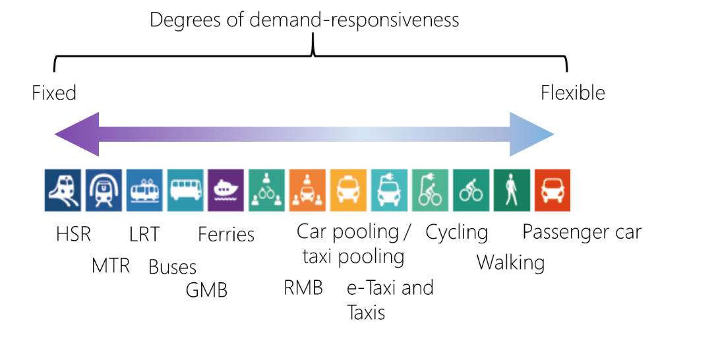

There are many examples of demand-responsive transport in the US and Australia, usually referenced by the term Mobility on Demand (MOD), applied within a mode or route by an individual TSP. However, the ‘on-demand’ component of transport is one of the steps towards MaaS. The Data Trust that was established at HKU as part of this study aims to provide some of the necessary evidence to stimulate transport policy reform, in a wholly Hong Kong context, where needed. On-demand transport can enable higher levels of multi-modal service integration and reflects a ‘whole of transport system’ approach. Arguably, this could improve the resilience of the transport network to planned or unplanned service disruption also. In the longer-term, reducing the contribution of transport to climate change through decarbonisation (e.g. improve capacity utilisation) represents an imperative that cannot be ignored.

Modes and their Differences
1. The Transport Hierarchy
Figure 1 highlights the continuum between capacity and flexibility. In general, a mode that has a higher capacity, such as MTR and franchised buses enjoy less flexibility. For instance, a franchised bus has high capacity yet is regulated by the Public Bus Services Ordinance (Cap 230) to operate on specific routes and to maintain proper service frequency. Whilst Green Mini Buses (GMB) have some flexibility in pickup and drop off, Red minibuses enjoy more flexibility in routing.
Being able to better match demand with capacity applies during peak and off-peak periods, in the former case to spread demand where possible and in the latter case to improve utilisation for transport resources at low levels of demand. However, it was emphasised during an Advisory Group meeting of 26 November 2020 that management of expectations of passengers is essential. Changing the time of a scheduled bus service during off-peak hours could be unpopular, for example, but changes in capacity, routing and connectivity with other TSPs could be beneficial to all stakeholders whilst improving vehicle asset utilisation. To help assess the opportunities, the characteristics of each mode are explained below.
2. MTR
Described as “the backbone of Hong Kong's public transport system” the MTR network accounts for about 41% of all daily trips made on public transport. As of September 2020, there were 95 stations, one high-speed rail station and 2 new stations to be opened. Some of these stations could be regarded as ‘mobility hubs’ given their physical integration with bus, public light buses (PLBs) and taxi stands as well as pedestrian infrastructure. The quality of the environment for buses and PLBs is invariably poorer than for MTR and pedestrian wayfinding signs are almost non-existent within PTIs.
Any harmonisation or alignment amongst modes that would allow for better operational alignment must also reflect the intrinsic respective commercial interests of TSPs. Within the confines of existing regulation and intra-modal service cross-subsidisation, in the end any collaboration would be a commercially driven decision, as highlighted in the data sharing framework established at HKU for the Data Trust. Conversely, since the establishment of Octopus, a lack of intermodal collaboration in Hong Kong has not only had roots in prevailing regulatory and institutional structures but appears to reflect a lack of trust between different parties – each with different levels of passenger capacity, technical capacity and financial capacity – therefore limiting any scope for bilateral (P2P) relationships that would be needed for intermodal collaboration.
One hypothetical example would be enabling MTR to optimise its maintenance regime and reduce the costs of operation by closing some of its more remote low volume stations at 11pm, earlier than scheduled. A bus (or Public Light Bus, PLB) replacement service that operates on a non-fixed route could drop off (or pickup) passengers closer to their destination. In this example, area-based on-demand services that are integrated with selected MTR stations could become more than just a replacement service but an expansion of the core proposition itself, otherwise known as a Value Added Service (VAS). Who could drive this opportunity though? Would it be the Transport Department (TD) in its role as regulator, or one or more TSPs? In Berlin, for example, the Berliner Verkehrsbetriebe (BVG) manages all surface modes and implemented the Jelbi MaaS app allowing planning and payment of multi-modal trips improving mode connectivity and emphasising its user-centric focus on urban travel.
However, without evidence to support transport policy change, any generalisations will be risky although the HKU-led study team uncovered capacity imbalances in intermodal transfers at some MTR stations and PTIs. Even though the MTR network is extensive there are areas in HK that are not so well connected by MTR or franchised buses. The study team identified a means of accessibility rating known as the Public Transport Accessibility Level (PTAL), developed by Transport for London. Given sufficient data points, the Data Trust would have the capability to generate a PTAL map and conduct travel time mapping for every location in Hong Kong to identify spatial and time-based weaknesses prioritised by local population figures.
3. Franchised buses
Allowing a TSP to re-provision an under-utilised and under-performing fixed route during off-peak hours could reduce its operating costs. However, it could also reduce the quality of service unless a replacement was offered at an increased benefit to passengers. There is evidence that on certain routes a switch from a fixed timetabled service and Key Performance Indicators (KPIs) that emphasise punctuality to one that enables flexibility in timing and capacity could result in an increase in ridership and a reduction in costs. It could be argued that implementation of this in Hong Kong is already possible, but what may be missing is enabling regulation, uniformity in the publication of machine-readable timetables, the provision of real-time data on service availability and vehicle occupancy (as a minimum banded). Regulation in the UK, Finland and Australia are some examples where statutory regulation and operating concessions require the provision of data (e.g. historic or real-time ETA) which help stimulate external innovation and service discovery. The standard BS 8477:2014 Smart City Framework – Guide to Establishing strategies for smart cities and communities and its successor ISO 37106: Guide to establishing strategies for smart cities and communities emphasise the use of shared data, and the need for a new organisation structure and information architecture to “drive city and (site-wide) change rapidly”. There are other standards that have been developed or are in development within ISO, IEC (International Electrotechnical Commission) and ITU-T that relate to geocoding of bus stops, data dictionaries, messaging and timetable formatting that could add value to future public transport data strategies in Hong Kong as part of its smart city aspirations.
Franchised bus services in Hong Kong are highly regulated and TSPs cannot freely change the routing and timetable, and any proposal depends on a manually-driven application process. This process presents a major constraint for bus operators to introduce on-demand services as part of their services proposition or to enable further integration with other transport mode (e.g., between bus and ferry). For these TSPs, their interest resides in seeing how the regulatory framework can be changed, such that underutilised trips could be replaced by other modes such as PLB or otherwise converted to on-demand service. Any trips that are loss-making from the perspective of a TSP rely on cross subsidization by other bus trips within a franchise. When data and technology drives a dynamic redistribution of demand onto different transport modes, the above-mentioned ecology will likely fall apart if there is not a corresponding change in regulatory framework. The situation will be even worse than the disruption of online air-ticket booking platforms made to the airlines which can freely suspend a route and cancel a flight.
4. Public Light Buses – Green Mini Bus and Red Mini Bus Services
PLBs are split into Green Mini Buses (GMB) and Red minibuses. GMBs generally operate on fixed routes, accept Octopus as payment and drivers are employed by GMB fleet operators. By comparison, Red minibuses mostly only accept cash, have drivers that rent the vehicle (like many taxi drivers), are limited to operate within defined areas, excluded from others, may not travel on many major highways and face disincentives through regulation to their continued sustainability. On the other hand, Red minibuses exhibit high levels of flexibility and potentially fill a viable gap in the transport hierarchy that is neither satisfied by GMBs nor taxis.
Introducing First Mile Last Mile (FMLM) services to MTR stations using Red minibuses is unlikely to be an option, although the existing regulatory framework has enabled at least one example of demand-responsive MOD service in Hong Kong
Mobility on Demand in Hong Kong: Auf Nachfrage Bus (AN BUS)
AN Bus commenced operations with a fleet of four vehicles in 2020. Its proprietor confirmed that “Peak hour demand is not [an] ideal [application] for on-demand bus” but instead it could be seen as a shared taxi service and could suit commuting by hospital workers and school trips, reflecting one mode operation of MOD in Hong Kong, namely a ‘many-to-one service (i.e. serving one location from many). In summary, “there’s no fixed route, no fixed fares, no fixed timetable … [but] when we talk about on-demand buses, it’s matching between one bus and multiple passengers and in real time, so it’s a little complicated.” Innovations include e-hailing, mobile payment and use of the driver’s mobile phone for real-time tracking of participating vehicles, demonstrating what may be achieved with the currently regulatory environment.
Sources: Ockenden, J. (TransitJam June 2020) Reinventing “Flying Cars of Death into a Premium On-demand Bus Services https://transitjam.com/2020/06/11/reinventing-flying-cars-of-death-into-a-premium-on-demand-bus-service and Li, Franki (TRPC website) On-Demand Bus in Hong Kong by Red Minibus https://trpc.biz/wp-content/uploads/2020/09/On-demand-bus-in-hong-kong-by-red-minibus.pdf presentation 29 Sep 2020

There are over 4,300 licensed minibuses in Hong Kong, of which about 3,500 are GMBs operated by more than 160 companies. To enable improvements to GMB services, vehicle telematics systems including Global Navigation Satellite System (GNSS) are being installed in the complete fleet from 4Q2020 onwards. Notably, Red minibuses amounting to 25% of the total population of minibuses, are not included in this roll-out.
The stated aim of the investment applied to all GMBs is for “[the] management, operation and maintenance of real-time arrival information system” which effectively represents a common standard of data collection and reporting for an otherwise fragmented industry. A test launch took place 31 December 2020. The benefits are nuanced: an accurate prediction of the Estimated Time of Arrival (ETA) of a GMB based on its location and historic data applying to the route, does not mean that there any spare seats and therefore optimising capacity utilisation will continue to depend on periodic assessments, informed by translation reports generated by an on-board validator as each passenger boards the vehicle, plus driver reports. Consultation with TSPs as part of the programme revealed a general concern on how data reported to Government would be used, potentially to enforce Quality of Service (QoS) provisions, whilst providing data to the public may inform the public of an alternative mode choice. The disclosure of data that has commercial value would always be sensitive, which is why the concept of ‘trust’ represented by the HKU-managed Data Trust was considered to be important. The data collected can allow different levels of occupancy to be reported or, as a minimum, a record of the driver-operated “full” indicator to be captured.
Red minibuses represent a substantial minority of PLB capacity and enjoy the flexibility in routes and timetable under the current legal system that does not apply to GMBs. AN Bus (see box) has already demonstrated that within the existing regulatory framework it is possible to offer limited low-capacity demand-responsive operations and its scalability and sustainability could be assessed, potentially to provide FMLM support for franchised buses or MTR also. The example of Slide and Kutsuplus in the UK and Finland respectively demonstrate the benefits derived from maintaining sufficient QoS, informed by the waiting time for a PLB and the maximum walking distance to a pre-planned pickup point which could be any Point of Interest (POI). Spreading the available vehicles over a larger area would reduce the QoS and could render the service infeasible.
During the Via Transportation demonstration on 29 September 2020 (see Annex 2), it was argued that on-demand transport (whether this connects with other modes or not) cannot survive on the income from the fare box alone. The recent experience from New South Wales (NSW) suggests that the implementation of on-demand transport for a minority of services may have some merit. “Learnings to date indicate that on-demand public transport will be an important feature of future networks across NSW and are already influencing current contracts. On-demand service contract components have been introduced in four contract areas including Sydney’s Inner West and Newcastle.” For stand-alone operators such as AN Bus, the challenge may be geographic scalability into areas that may already be adequately served by TSPs, particularly during off-peak hours.
Following a 6-month trial of an On Demand Bus Service (ODBS) in 3 areas of Singapore in 2019, it was concluded that “Compared to fixed and schedule[d] bus services, [the] operated mileage in the same area was 18 per cent lower during the trial, meaning fewer bus resources were needed” but the high cost of technology limited its scalability and following the trial, the data collected enabled scheduled services to be revised. Following this, a 3-month trial of autonomous public shuttles was launched in Sentosa, Singapore. The investment in Hong Kong in developing the ETA platform for GMBs and the precedence of AN Bus could be used to assess the current operating efficiencies of GMB and the potential for demand-responsive operations for both types red and green, whilst recognising the different regulation between the two types. Ensuring a common QoS between the two types would also suggest, as a minimum, that contactless payment systems should also be made available for all licensed mini buses.
5. Licenced Taxis
There are over 18,100 licensed taxis in Hong Kong, a number that is limited by quota rather than demand, split into 3 operating areas, urban areas, New Territories and Lantau. As an indication of the short-term decline in attractiveness in retaining a (tradeable) taxi license, its value has dropped from HKD7m to HKD4m since February 2020, reflecting a (potentially) short-term decline in ridership. Until recently, innovations in taxi services have been limited, whist despatching remains primarily manual and cash payments continue to dominate. However, the introduction of the Stored Value Facility (SVF) scheme in 2016 to promote diversity in payment options, coupled with private sector-led e-hailing services such as eTaxi and HKTaxi, have improved convenience and service predictability. The operation of the HKTaxi service is funded by applying a small surcharge on fares and it demonstrates the benefits of economies of scale of mobile app-enabled planning, booking and payment platforms for taxis, not yet available for public transport in Hong Kong where such platforms are currently limited to planning only. The underlying technologies for these innovations have already been proven – the business cases for them in Hong Kong have not.
However, except for a limited number of collaborations, e-hailing services generally remain focused on end-to-end trips, leaving it up to the user to plan for connecting with other modes. Interchange discounts could incentivise multi-modal trips, but currently these are negotiated on a bi-lateral basis (e.g., between GMB operators and MTR). One of the challenges is that whereas some larger operators, such as MTR, are well equipped technically to become interoperable with other service providers, others such as individual taxi drivers, are often not and this makes it difficult to establish a trusted commercial relationship. Yet trust is essential if it involves ceding control of the customer and of ticketing and other revenue sources to be balanced by gains from new sources of revenue, new types of customer interactions and lowering operational costs. Trust and regulatory compliance lie “at the core of the relationship between a ride-hailing business and its customers”.
While taxi and hire-car e-hailing does not necessarily involve multi-modal transport, it is often associated with arrivals and departures by other modes, such as trains or planes. Within the EU where e-hailing is widely used and covered by the General Data Protection Regulation (GDPR) there have been no noticeable concerns relating to the protection of personal data. App-based e-hailing has also shown how quickly drivers are willing to adapt to new means of payment, despite previous mostly unsuccessful efforts to focus only on contactless payment within Hong Kong taxis. Bundling functions appears to have been the breakthrough and the next logical step would be to combine two or more individual payments into one digital ticket, including interchange discounts. However, any attempts at integrated fares have not been evident to date, and the reasons for this need to be examined including the opportunities for new token-based and account-based ticketing schemes.
As an example of e-hailing, the HKTaxi app also provides the predictability for users that taxi operations have lacked to date, highlighting that (yet again) a suitable starting point was innovation within a ‘regulatory silo’ and using this as a market and a data platform for collaboration across silos. It is suggested that other historically data-rich transport operations in Hong Kong could scale their operations to benefit users in the same way. The establishment of HKU as a trusted party and the sole Data Processor for the programme has already highlighted a multi-party arrangement for non-real time data sharing is already possible.
6. First Mile Last Mile
First Mile Last Mile (FMLM) includes active mobility (walking and cycling) and mechanised modes that are suitable for short distances, and suitable for providing access to other modes. Currently, no Electric Mobility Devices have been licensed in Hong Kong although the Electrical & Mechanical Services Department (EMSD) are conducting trials on e-scooters and Transport Department recently concluded an a comprehensive, but as yet unpublished, study into walkability that “aims to formulate planning and design standards based on pedestrian-first principles for developing Hong Kong into a more walkable city“.
Cycling accounted for 0.5% of daily weekday mechanised trips, 97% of which were made in the New Territories, but as the Travel Characteristics Survey (TCS) of 2002 showed weekday cycle trips were “mainly for functional purposes and that 60% of the trips were related to work or school.” Another survey in 2011 found that 20% of cycling trips involved interchange with another mode of mobility. (See also ‘Decarbonising Public Transport in Hong Kong; Working Paper 2’). ‘Other Cyclist Facilities’ of the Transport Planning Design Manual (TPDM) introduces cycle facilities that could be used but advises that these are not generally applicable, notwithstanding that cycling is largely promoted as a recreational and leisure pursuit rather than a recognised mode of transport. MTR and services formerly provided by KCRC started to permit carriage of bikes on trains unofficially around December 2012 although there has been no large-scale deployment of buses with bike racks to the front or rear of a bus to permit the transport of full-sized bikes. Strict limits on total dimensions and a volume of 0.1 cubic metres for cycles on public transport effectively excludes them from carriage. Not all ferries allow cycles and opportunities for improving connectivity between ferries and bikes should be subject to further study. The impact of the Covid-19 pandemic has enabled many transport authorities to convert measures that promote active mobility above public and private car transport to a permanent feature. In general, since 2019 there appears to have been a global trend to reallocate resources from enforcement towards the promotion of walking and cycling – either to replace part of a public transport trip to prioritise capacity for key workers or to maintain low density, socially-distant travel.
Opportunities
Some modes exhibit more flexibility than others but within the transport hierarchy a ‘whole of network’ view could be adopted to improve the experience of passengers from one end of the trip to the other by improving the operational relationship between such modes and improving accessibility of all modes through static improvements (e.g. improving signing, waypoints) and more dynamic measures aimed at either reallocating demand during peak periods and improving utilisation during off-peak periods.
It could be argued that changing the time of scheduled services would be disruptive to some passengers but this misses the larger point: informed passengers, ensuring a common QoS across all modes, and recognising where flexibility is needed could reduce journey times and reduce journey time variability. Conducting surveys of those that use – and do not use – public transport would help define priorities on all measures that impact QoS including queue length, and the number of passengers ‘left behind’ at stops and platforms. An operational focus on punctuality won’t be applicable where this would not be a reliable proxy for QoS, as revealed in consultation with TSPs that participate in bus-to-ferry connections. For a TSP, the benefits could be improved utilisation of available capacity, even if it means using the capacity of another TSP to conclude a journey. The opportunity for this depends on partial substitution between modes but the constraint is that preservation (or ideally enhancement) of user experience is paramount. An MTR services that terminates early and hands over to area-based on-demand shuttles would be one example of this. The Data Trust was established in part to explore a subset of the Use Cases (Annex 1) and to generate the evidence to support and prioritise potential investment areas. The outcome could be one or more time-limited on-street Proofs of Concept to prove the business cases, operational collaboration, business case and passenger feedback.
The programme included a Global Cities Research element that identified good practice that could be considered, as a minimum as the basis for pilots in Hong Kong. Wholesale conversion of all modes to include demand-responsive operations is unlikely to be justified and opportunities to introduce more demand responsive operations will apply differently to peak and off-peak periods.
The Exchange Square PTI was employed as an initial focus for the Data Trust as described in Chapter 1. The difference in quality of the public realm, revealed in signing (or lack of), safety to pedestrians, ambience and lighting levels is clear. All of these could be improved, led by a user focus on commencing a PT trip at the PT of transiting from one mode to another.
The key enablers of a ‘whole of network’ improvements include willingness for collaboration between TSPs, improved use of data outside each mode ‘silo’, and regulations that enable innovation as explored in Chapter 2. The programme revealed data that was subject to fragmented ownership and, whilst this is to be expected given its commercial value and (in some cases) would have included personal data, standardisation can facilitate its analysis, additional data collection points (e.g. pedestrian counting), and greater focus on understanding FMLM preferences.
The programme revealed significant differences in technical and financial capacity, and modes such as Red minibuses that were not benefitting from technological investments afforded to GMBs, leaving Red minibuses at disadvantage to improve passenger QoS. Given their distinct position in the transport hierarchy and opportunities to provide shared FMLM services (e.g. from selected MTR stations), this differential treatment warrants further investigation and justification.
A Regulatory Sandbox for Shared Services in HK?
Regulatory flexibility often involves a trade-off between the established and entrenched interests of existing service providers and new entrants with innovative service proposals. The ideal way forward is to create a regulatory space within which the current regulatory regime can prosper alongside a new regime: existing service providers can choose to continue or adapt to new ways of operating, new entrants by looking for ways to complement existing services, and/or to create a new market to meet an unmet demand. The market for shared transport is a good example, and a policy framework that allows this to happen is the regulatory sandbox.
A sandbox provides a protected environment that does not threaten existing approaches to transport and would enable companies to try new things like an on-street Proof of Concept (POC) of Demand Responsive Transport (DRT) and it is recommended this be tried. However, sometimes initial success may run into structural barriers such as an inability to scale geographically. Whilst it is expected that existing requirements for shared services to be licensed will be enforced, HK Taxi has demonstrated the business case for a geographically scalable e-hailing service, making use of data analytics to improve quality of service for users and benefit drivers. It is arguable that stakeholder pressures to preserve the value of a taxi operating license has influenced taxi operators in Hong Kong, innovation in app-based e-hailing is clearly the future.
By ensuring that a regulator has sufficient power to effect and implement change, if needed through experimentation, benefits to users and other stakeholders can be delivered; for example, by granting a short-term waiver of existing regulations to enable a DRT POC and permitting licensed services to have some flexibility in scheduling and route planning. This would appear to be a more attractive option, compared with introducing and ratifying new laws (see the Bus Ordinance). In some cases the social benefits may justify government compensating existing service providers, either directly for any loss of franchised business or as an incentive to adopt new technologies and standards of service delivery. As a result, DRT services, such as first mile, last mile or vehicle hailing apps, would add to the innovation of Hong Kong’s transport network.
Suggestions
- In recognition of the essential role of verifiable data, Government undertake a survey across the whole-of-network to identify ways in which inter-model demand-responsive services could enhance the operational efficiencies of existing services, for example, in First Mile, Last Mile (FMLM) services
- Use the Data Trust at the HKU to generate evidence-based policies to support demand-responsive services where they would clearly enhance the quality of public transport services
- Review regulatory innovations in the capture and publication of data sharing by TSPs as they apply to demand-responsive services
- Consider extend the technical investments in providing an ETA service for GMBs to Red minibuses, to ensure a harmonised approach to PLBs in general, and to reflect the flexibility afforded to Red minibuses
- Encourage data-sharing between TSPs, making use of the Data Trust model, to prioritise and facilitate commercially-viable solutions
- Experiment with the use of a regulatory sandbox approach to allow for regulatory flexibility in the trial of demand-responsive services, and conduct on-street POCs where feasible and likely to benefit TSPs and passengers
- Policy-wise Government can be a supportive partner in incentivising demand-responsive services where there are clearly identified gains to under-served sections of the travelling public, such as FMLM services in outlying areas

Comparison and Insights from DRT Services in London and Sydney
The similarity in objectives and technologies
DRT services in both cities occur in suburban areas with low accessibility to public transport and are aimed to decrease local private vehicle ridership by providing users with a viable on-demand alternative. Both cities have adopted the approach of picking up passengers at ‘virtual’ bus stops to cover the FMLM gaps. In the context of Hong Kong, such DRT trials could potentially be considered in new towns with high private vehicle ridership.
Different level of legal restrictions
The government's level of regulation as a form of restriction, as opposed to regulation as an enabler, is a critical factor that influences the potential for DRT – and its profitability and business sustainability. Each city has demonstrated a pathway for on-demand business models within different regulatory regimes. In London, the application of strict regulations to protect the traditional transport industry, regulation poses challenges for innovative technology company-led DRT services. Under such a legal framework, the responsiveness and flexibility of services are likely to be undermined. However, with a cautious mindset, government-led DRT services in London have nevertheless embarked on a thorough pre-trial consultation process to vet the rationale for the continuation of the DRT trials.
In comparison, Sydney's case shows a more open market where the government encourages fair competition between traditional transport industry and DRT services, including a compensation mechanism to mitigate the impact on taxi drivers. DRT services have taken various forms in this open market, with some more successful and some less successful. This trial-and-error method has provided the city with more data and experience in testing different service propositions leading to different outcomes.
In Hong Kong, it is still early to say which level of regulatory regime is more suitable and therefore it is recommended that trials and Proofs of Concept are conducted, complemented by a transparent consultation process and provision for compensation where applicable, particularly for the taxi industry.
On-demand Mobility vs traditional Mobility
In both cities, one of the primary challenges DRT services face is that increasing use of DRT results in an increase in trips and therefore increased costs, while potentially decreasing the patronage of traditional public transport. Thus, the key questions underlying the promotion of DRT services in a city is the degree to which innovative on-demand services should be integrated into the existing transport hierarchy and how on-demand mobility could complement traditional mobility solutions, including allowing on-demand services to be provided as part of existing franchised operators’ operations.
On-demand mobility is not only a matter for the private sector. For Sydney, attempts to collaborate with public transport companies to complement traditional public transport to improve overall transport efficiency can be seen. And for London, Citymapper's newest service demonstrates how on-demand transport solutions can be provided through a journey planning app.
As the traditional taxi industry can be seen as an obstruction for promoting on-demand service, through this kind of integrated Mobility as a Service (MaaS) platform, we can see the potential of cooperation between traditional taxi industries and MaaS platform operators. The conventional taxi company will still own and operate their fleets. Simultaneously, the MaaS platform can provide the services around it, such as a better payment and demand-supply matching system, with feedback and business intelligence to all stakeholders.

Payment Integration as an Enabler
Although there is evidence of payment integration through the Octopus card scheme in Hong Kong, there is limited fare policy integration. The most prominent intermodal fare policy offered for daily commuters is 0.3 HKD discount between MTR and Green Minibus and 1 HKD discount between MTR and Franchised Bus. In relation to this, Seoul’s example of using an integrated electronic payment system (T-money) across different modes with the adoption of an intermodal distance-based fare charging policy could be a reference. The T-money system is managed by Tmoney Co., Ltd., which was established by the Seoul Metropolitan Government. Together with other government initiatives such as the establishment of an integrated data hub for smart mobility management (TOPIS) and smart Bus Management System under the reform led by strong political willingness of Mayor Lee, the T-money system aims to address air pollution contributed by heavy usage of private vehicles by increasing the efficiency and usage of public transportation.

Chapter 4 – Decarbonising Public Transport in Hong Kong

This chapter is an executive summary of Decarbonising Public Transport in Hong Kong: Working Paper 3 (January 2021) produced after discussions with and feedback from the programme’s Environmental Interest Group (EIG).
The Health Costs of Public Transport Emissions
Two studies involving a Health Impact Assessment (HIA) and an Economic Impact Assessment (EIA) of pollutants from all sources in Hong Kong have been undertaken, measuring the Value of Statistical Life (VOSL) of annual premature deaths resulting from pollution-related respiratory and cardiac illnesses, the costs of visits to doctors and stays in hospitals, and the resulting losses of productivity. The first study is by the School of Public Health, the University of Hong Kong (HKU) published in the Open Epidemiology Journal (2011) and the second from the School of Health and Primary Care, Chinese University of Hong Kong (CUHK) and posted on the website of the Environmental Protection Department (2016). They use different methodologies and come to widely different estimates.
The Working Paper uses the higher estimate of the CUHK study to isolate the costs attributable exclusively to tailpipe emissions from buses and green and red public light mini-buses (PLBs) at HKD 800 million per annum, including over 6,000 premature deaths. Removing tailpipe emissions could prevent these deaths and save this money, hypothetically overnight if all buses and PLBs converted to electricity, although these savings would only be met in full if the pollution associated with producing the electricity was also tackled. Against these savings there is an estimated capital cost of HKD 24 billion.
Environmental issues are central to smart city transport planning and data-sharing that can identify the points of pollution and help, for example, in the optimum locational design of electricity recharging points and hydrogen cell refueling stations when hybrid vehicles are used. The Data Trust at the HKU is a facility that could be used for these purposes.

A: Taxis, Trams and Ferries
Taxis
The Working Paper does not examine trains and aircraft, but it does look at taxis, ferries and trams as well as buses and PLBs. There are over 18,000 licensed taxis in Hong Kong, 98% of them using fossil fuel either as diesel or in the form of liquefied petroleum gas (LPG). The rest, around 1,200, are LPG-electricity hydrogen hybrids introduced from 2019 onwards. A major factor holding back the introduction of e-taxis seems to be the time it takes to recharge batteries as drivers are then unable to pick up passengers. The new hybrids will cut fuel costs by half using a combination of hydrogen fuel cell electricity while driving in densely built-up urban areas and LPG in more open environments thereby achieving just under 20km per litre of LPG compared to just under 10km for older taxis.
To suggestions that Government should consider incentives to drivers to switch to hydrogen hybrids the government response is to consult on a road map to be introduced in 2021 under the city’s Clean Air Plan. Most taxis in Hong Kong are made by Toyota who seems to have no plans to introduce pure battery electric vehicles (BEVs) before 2025.
Trams
Technology is allowing emission-free trams and trolley buses to become ‘trackless’, called Autonomous Rail Rapid Transit (ART), substituting optical guidance system for rails embedded in roads, replacing steel wheels with rubber tyres (see video) and replacing catenary overhead wires with pantographs. They run entirely on batteries that can be recharged at stations in 30 seconds or at terminals in 10 minutes, but the most likely application in Hong Kong is in new towns connecting to outer districts where spatial planning is more flexible. Application to older crowded urban areas would call for a redevelopment of roadways to car-free zones devoted to pedestrian piazzas and public transport vehicles. In Australia the costs of trackless trams works out at between AUD6-8 million (HKD34-45 million) per kilometre compared with conventional light rail at between AUD80-120 million (HKD450-680 million).
Ferries
Pollution from ferries is at last being addressed by trials of in-harbour electric ferries and hybrid diesel-electric propulsion ferries to the outer islands. The trials are not scheduled until 2022-23 and by that time feasible alternatives to diesel may be available. Ferries offer an especially attractive mode of transport but their inter-connects with other modes – taxis, PLBs, MTR, franchised buses – could be upgraded, for example, by extending the Exchange Square catchment area down to the harbour front as a pedestrian landscape with improved walkability. A Report in 2017 estimated e-ferries could reduce in-harbour pollutants SO₂, NO_{X}, PM₁₀, PM_{2.5}, HC and CO by 1.3 tonnes, 79.4 tonnes, 1.6 tonnes, 1.5 tonnes, 1.1 tonnes, and 14.3 tonnes, respectively. Replacing outer island ferries with hybrid electric ferries would further reduce these pollutants by 8.2 tonnes, 485.9 tonnes, 9.2 tonnes, 8.4 tonnes, 6.8 tonnes and 87.1 tonnes respectively.

Suggestions for Taxis, Trams and Ferries
Taxis
- A plan for e-recharging/hydrogen refuelling stations for e-taxis is urgently needed, especially if designed to allow facilities-sharing with other forms of public transport to spread costs and optimise the use of locations. The Data Trust at the HKU could be used for logistical analysis.
- A Well-to-wheel supply chain for hydrogen production, storage and pumps needs to be mapped out and acted upon.
- The business case for creating third party ready-to-go recharged batteries for taxis and other public service vehicles should be fully explored.

Trams
- There seems to be a strong case for adopting zero emission trackless trams/trolleys for flexible routing in new towns, in the New Territories and in other relatively open areas as a low-cost alternative to public light rail.
- In heavily congested urban areas trackless trams/trolleys would only be suitable if there were a wholesale re-planning of streets to provide a ribbon of connected pedestrian-only areas inclusive of cycling and e-vehicles for the handicapped.
- Creating ribbons of connected pedestrian-only piazzas would not require wholesale redevelopment but rather a redesign of street and walkways. These spaces could adopt a tiered system of access by vehicles:
Level 1 allow emergency vehicles, public transport vehicles and taxis
Level 2 allow delivery vehicles, restricted by time of day/night and by weight/emission ratings
Level 3 allow private e-vehicles to restricted areas where vertical parking and recharging facilities would be available
Level 4 allow other vehicles with appropriate restrictions and a road pricing scheme.

Ferries
- Ferry terminals in the Hong Kong harbour could be upgraded to airport standards, making them more than just travel terminals. As they are privately run this would of necessity require public funding.
- Extending the Exchange Square catchment area down to the ferry piers by creating an attractive environment to replace the unattractive long walkway bridge to shops and transport hub at Exchange Square and upgrading the current taxi and PLB space adjacent to the piers. It would be ideal for a trackless tram/trolley service (see above).

B: PLBs and Franchised Single/Double Decker Buses
Public Light Buses
Over 4,000 PLBs using LPG are responsible for 8% of respirable suspended particulates and 4% of nitrogen oxides emitted. The technical details of changing them to an all-electric fleet, which will require a change in design with rails on their roof to sync their batteries with a pantograph recharging mechanism, maybe more straightforward than the approvals process for trials.
Government established an interdepartmental e-PLB Task Force in 2019 consisting of nine government agencies plus advisory groups, an indication of two things: first, many of these agencies need to be involved in an approval process for tests to be implemented in public spaces, including the Buildings Department which is not actually a member of the committee; second, the apparent complexity of what is, in principle, a fairly straightforward pilot project, yet one that involves several crucial parties, such as the maker of the buses, the bus operators, the supplier of the charging apparatus, the construction site such as a terminal or depot or on-route bus stop, the supplier of the power, the management, monitoring and data-recording of the pilot, a series of planning approvals and business contracts, for example covering equipment failure and liability issues. Unless a process such as this is given priority status across all the departments concerned, which would require an overarching coordinating authority, the bureaucratic process is bound to be slow. There would seem to be an argument for bringing transport and environmental issues under one authority where data sharing and planning are complementary.

The first trial of e-PLBs is delayed until mid-2023 by which time PLBs with pantographs designed and manufactured by the Hong Kong Productivity Council (HKPC) should be available. A tender for the pantograph and back-up plug-in chargers for installation at the new Kwun Tong PTI which is due to open early 2021 was issued by the EPD in October 2020. However, Green Mobility Innovations Ltd (GMI) a Hong Kong-registered manufacturer of PLBs is already collaborating with Siemens and the Hong Kong Science & Technology Park (HKSTP) to run tests.  There are several manufacturers of Pantographs (see Diagram 1) using a common OppCharge standard, such as TGood and Siemens. A word of warning is that methods of ‘fast charging’ may more rapidly degrade the charging components on the bus adding to the lifetime costs. | Diagram 1    Source: TRANSIT JAM

Trials will tell how viable the pantograph solution is, with the question of land and space to locate them at points along the numerous LPB routes perhaps being the major challenge. This is where the Data Trust at the HKU could play a role.
Suggestions for PLBs
- Data and spatial analysis of bus routes, times and passenger requirements using the HKU Data Trust or some similar facility should be used to identify ideal locations for recharging points, which wherever possible should offer opportunities for sharing to spread costs.
- A standing committee rather than select or ad hoc inter-departmental committees embracing at least Transport, Housing, Environment, Highways, Planning, Development and the OGCIO would serve the long-term interests of Hong Kong meeting its climate change objectives and promoting inter-modal transport data sharing policies as an essential component of smart city planning and development.
Franchised Single and Double Decker Buses
It is estimated that 95% of road pollutants arise from commercial traffic such as buses and heavy trucks. A report by the EPD in 2018 noted of the few suitable models of double-decker BEBs buses available “their passenger carrying capacity and operational efficiency still fail to fulfil the local operational needs.” In the meantime, Government policy is to upgrade (retrofit) diesel buses to Euro V and Euro VI standards and, for example, limit the Franchised Bus Low Emission Zones (FBLEZs) in Central, Causeway Bay and Prince Edward Road to these models. All the evidence suggests that double-decker battery electric buses (BEB) suitable for Hong Kong’s terrain, climate and typical route distances won’t become widely available until post-2024. Only then will their purchase price also become competitive with diesel or hybrid buses. The estimated price is around HKD4 million per bus and with over 6,000 buses a total replacement would cost not less than HKD24 billion. Single-decker BEBs are close to being available today, subject to a supply of batteries that are of the right quality. A caveat is if the transition to e-buses requires a higher ratio of e-bus: diesel than 1:1 due to the fact that e-buses may have distance restrictions arising from the limits of recharging that pose the need for more buses and therefore more drivers over the lifetime of the buses. For example, In Berlin it is estimated their additional lifetime costs could be the equivalent of HKD20 billion. Commenting on the conversion to e-buses in Shenzhen, a Legco paper in 2019 notes that the ratio of bus replacement was 1.2 electric for 1 diesel. The ultimate cost comparison is the total lifetime cost of a bus, including maintenance and replacement of batteries, etc. Although projections vary according to source, most suggest that BEBs will have lower total lifetime costs by the 2030s.
In all cases the availability of an adequate recharging infrastructure, or refuelling infrastructure in the case of hydrogen fuel cell powered e-buses, is a constraint, but not an insurmountable one. Problematic is the time to recharge the batteries. Fast charging for around 5-to-10 minutes using pantographs located at selected bus stops could be manageable for single-decker e-buses travelling shorter routes using smaller batteries that do not eat into passenger space on the buses. Equally 5-to-10 minute refuelling for hydrogen fuel cell hybrid double-decker buses at bus terminals or shared petrol stations is feasible, possibility using much larger batteries supported by conventional batteries for periods of acceleration or when additional power is needed. Otherwise, the options seem to be either 3-to-4 hours overnight plug-in charging of BEBs which may not be sufficient to manage the longer routes in which case either hydrogen fuel cell e-buses may be needed, or shorter bus routings introduced, or third-party battery recharging companies could be employed to provide fully powered-up battery replacements at strategic points along bus routes.
The comparative total lifetime costs of BEBs and FCEVs (Fuel Cell Electric Vehicles) have been variously estimated with one report from Deloitte forecasting that FCEVs will be “less than BEVs by 2026… overall, we estimate that the TCO of FCEVs will decline by almost 50% in the next 10 years.” Part of the forecasting problem lies in the fact that manufacturers will price above marginal costs until the market becomes fully competitive.
Suggestions for e-Buses
- A more developed manufacturing supply chain for e-buses and batteries is needed
- An urgent focus upon reduced carbon or carbon-free supplies of electric power and/or hydrogen fuel
- Opportunities should be brought forward for business models based upon third-party supply of battery recharging and hydrogen refuelling facilities
- An accelerated replacement of all Euro IV buses by the mid-2020s in light of the health benefits
- A more pro-active approach towards building the recharging/refuelling infrastructure, to enable the development of station hydrogen refuelling facilities that can be used by taxis, HFC buses and other heavy commercial vehicles including delivery services such as FedEx, DHL and UPS and cross-border trucks and coaches.
- Consider making such refuelling and recharging stations also transit points for passengers switching modes of transport, including public transport interchanges, together with vehicle diagnostic services
- Empower Hong Kong’s two power companies to offer recharging services as well as providing opportunities for new entrants specialising in off-grid and renewable energy storage systems.

C: Walking and Cycling
Walking
Walking is the mode of mobility for all but the disabled, and transport and environmental policies need to give far more prominence to both. Walking for leisure has received recent policy focus with ‘Walk in Hong Kong’ but walking the first and last miles to work, school, shops, etc., has been under-reported and under-represented.
As much walking involves some degree of inter-modal transport, a good starting point would be gathering reliable data which has been sadly lacking over the years as the emphasis has been far more on motorised forms of mobility. The evidence that does exist suggests that more covered walkways connecting to MTR and bus stops through interconnected buildings allowing the sharing of air con at zero marginal costs and offering landscaped surroundings, shops and other facilities would be environmentally friendly and could encourage reduced use of private vehicles. A good framework has been set out by Civic Exchange. The NGO DesigningHongKong has produced interesting proposals for connecting overhead walkways in crowded urban districts to create a latticework of skywalks, in districts such as Tsim Sha Tsui and Admiralty/Wan Chai, albeit still open to the elements. Most recently, some tentative steps have been taken by government to experiment with street improvement for pedestrians as part of an as yet unpublished report commissioned from Mott MacDonald, and an important aid to planning is the release by the Lands Department of 3D visualization of pedestrian walkways and by the Transport Department of topographical features such as terrains and infrastructures. However, there appears as yet to be no systematic pedestrianization nor introducing a tiered approach to motorized transport that favours public vehicles and e-vehicles over others.
Cycling
There is a chronic shortage of data on cycling in Hong Kong, so transport policies have been less evidence-based and more assumption-based. But even the scant data that does exist suggests that ‘functional’ cycling to work, to school, to shops, etc., is more prevalent that often assumed, and frequently it involves inter-change with other modes of travel. Further, that even in urban areas there is an, albeit small, under-estimated demand for cycling and that going forward the redesign of streets and walkways as part of a strategy to reduce air pollution and the use of private cars should see cycling as an important part of that strategy, following the lead of other global cities.
Suggestions for Walking and Cycling
- Hong Kong needs better and more up-to-date information on both walking and cycling preferences and options for citizens.
- Hong Kong would do well to firm up its programmes to encourage walking and cycling by creating more opportunities for both, creating more space for both at the expense of polluting vehicles, and by facilitating and encouraging multi-modal mobility, for example, providing storage for bikes in trains and buses.
- A survey showing over 50% population satisfied with pedestrian walkways still leaves many who may be expecting improvements; the suggestions of Civic Exchange are a good starting point.
- Much greater recognition of the needs of the physically disabled in the design and redesign of walkways is needed, with conveniently-placed braille signage and well-paved sheltered connected walkways with lifts and chairlifts for wheelchairs.
- Redesigning walkways is needed which goes beyond cleanliness and the removal of footpath obstacles to create spaces and ways to accommodate different modes of mobility – pedestrians, cyclists and less polluting forms of motorised transport, possibly even trackless trans/trolleys at district levels.
- More shopping precincts adjacent to MTR stations and bus interchanges to encourage the use of public transport to minimise carbon emissions as recommended in a report for the World Resources Institute (2020) by Civic Exchange Pathways to Net Zero Carbon Emissions by 2050.
- In a cleaner, greener Hong Kong cycling in urban areas should be facilitated and no longer sacrificed to motorised vehicles.
- There needs to be far more inter-agency urgency and planning given to these programmes with a significant reduction in the red tape of permissions and licencing that may be required.
- Consideration should be given to an ombudsman with ‘mayor-like’ powers of coordination of Hong Kong’s response to climate change, and the cleaning and greening of Hong Kong
- Hong Kong should replicate the best practices that are to be found in many other global cities
- These change will take time, so let the journey begin.
Also, see Bikenomics: How to Get Cycling on the Agenda https://www.youtube.com/watch?v=vcIXgwzfXpY&feature=youtu.be

Annex: Examples of Public Transport and the Environment from Global Cities Research
Transport for London (TfL) provides good standards for Hong Kong to follow
For example in London by 2019 there were 200 electric buses, a mix of battery and hydrogen buses, the largest fleet in Europe and with the aim of having all 9,200 buses electric by 2037. In London by October 2020, where fifty percent of all air pollution arises from road transport, all buses were required to meet the Low Emissions Bus Zone (LEBZ) requirements of a 90% reduction in NO₂ emissions compared with 2016. An Automatic Number Plate Recognition (ANPR) camera system will monitor traffic replacing the Vehicle Registration Mark (VRM) with an alternative set of numbers and letters (‘pseudonymisation’) to comply with privacy regulations. An Atmospheric Emissions Inventory is being managed and updated by King’s College, University of London.

London sets standards that Hong Kong could follow, including regular and up-to-date data on cycling and walking. The long term objectives of the Mayor of London is to have 80% of all journeys made on foot, by cycling or by public transport by 2041. Cycling data is collected on behalf of Transport-for London (TfL) by Santander Cycle Hire. Since 2010 London has produced a Pedestrian Comfort Guidance for street planners. London also has an Independent Disability Advisory Group (IDAG).
Source: Global cities research by RAs Valerie Pang Chor Kiu and Leslie Lei Shuyu

In the UK, Leicester’s New Bus Station
Bus passengers will benefit from a completely redesigned and improved internal layout with a new café, better seating and real time digital passenger information. There will also be increased capacity for national and regional bus services, with the number of bays increased from 18 to 24.Electric bus charging points will be installed, and the new building will feature secure storage for up to 150 bikes. Improvements to footpaths and roads immediately surrounding the bus station are also proposed, with better facilities for pedestrians and cyclists, new landscaping and tree planting, and better and safer crossings to soften the impact of the ring road. This will help strengthen and improve links between key development sites and the city centre.
Source: Leicester City Council (October 2020) https://news.leicester.gov.uk/news-articles/2020/october/designs-revealed-for-leicester-s-new-carbon-neutral-bus-station/

Paris – A City encouraging walking and cycling

Paris is a compact city ideal for cycling, but with dense traffic congestion caused by private cars. Led by an energetic mayor, and as part of its own effort to meet the climate accords, Paris has a programme to encourage both walking (the Paris Pietons programme) and cycling (the Paris cycling plan 2015-2020). Seven city squares have been redesigned to shift space from vehicles to people with cars banned from long stretches of the riverside and 50% more space give over to walkers and cyclists. The plan aims to give 15% modal share of traffic to cycling, with bike parking at all Parisian railway stations, 10,000 new parking spaces by removing them from private cars, a real-time cycling app for routes, and buses will be required to provide storage spaces for bikes. The result is that by 2020 there has been over 40% increase in bike traffic since 2015.
Clean Air and Buses
The Paris Climate Action Plan is a major effort to bring green transport to the city. For example, all diesels will be banned by 2024 (petrol cars by 2030) and public transport operators are required to develop digital platforms and data-sharing solutions enabling regulation for optimised traffic management. RATP, the City’s transport authority, in 2019 placed an order for 800 new zero-emission e-buses to combat the city’s smog problem ahead of the Olympic Games in 2024. By 2025 all buses will be zero-emissions, 4/5ths will be electric and 1/5th biogas powered. A night-time depot recharging infrastructure will cost around €400 million (HKD3.8 million) divided equally between bus manufacturers Heuliez Bus, Bolloré and Alstom.
Source: Global cities research by RAs Valerie Pang Chor Kiu and Leslie Lei Shuyu

Copenhagen
Copenhagen with a population of 600,000 is far less crowded than Hong Kong easy for cycling but this does not mean that Copenhagen’s green innovations cannot hold lessons for Hong Kong. Perhaps the most important is the City’s 2025 Climate Plan which has 8 goals including: to achieve 75% of all trips by walking, cycling or on public transport, including 50% of journeys to work or to school by bicycle or walking, 18% of passengers by public transport an increase of 20% compared to 2009, carbon neutral public transport, 30-40% of all heavy vehicles and 20-30% of light vehicles on new fuels such as hydrogen or biomass. For road improvements, since 2015 the city required all public motorised transport in Low Emission Zones to be electric or hydrogen, with new LEZs for other vehicles from July 2020 enforced by cameras. The Bicycle Strategy 2011-2025 involves PLUSnet, as system of regional Bicycle Superhighways with 3 lanes for cycles in either direction on 80% of the network. Sensors embedded in roads detect clusters of cyclists and can change traffic lights green accordingly.

Copenhagen is therefore utilising digital technologies quite successfully but is not immune from anti-social behaviour such as vandalism and in 2019 up to 75% of the bikes rented out by Bycyklen ended up in their workshops, but with the help of IoT companies such as VanMoof that provides bike tracking and alarm systems, together with an online VIN cycle database of stolen bikes, bicycle thefts are down in numbers.
Source: Global cities research by RAs Valerie Pang Chor Kiu and Leslie Lei Shuyu

Sydney
Buses
Australia has taken only tentative steps towards phasing out diesel buses and changing its fleets to BEBs, although in principle Sydney targets all of its fleet of 8,000 buses to become zero emission with 14 e-buses under trial in 2020 and a further 13 service contracts due by 2022.
Data on Walking and Cycling
Australia carries out video surveys on walking twice a year using 100 locations based on the liveable green network. A national cycling participation survey (NCPS) carried out every two years for each state and territory and the capital cities and non-capital areas within each state and territory. Sydney is building a 200km cycling network including 55km of separated cycleways, including new pop-up cycleway connections introduced as part of the response to the Covid-19 pandemic in 2020. A target of 10% of trips in the city by bike.
Source: Global cities research by RAs Valerie Pang Chor Kiu and Leslie Lei Shuyu

Chapter 5 – Global Cities Research Extracts

The following accounts cover issues where Hong Kong could learn something from the inter-modal transport and data-sharing policies and practices of other selected cities from around the world.

Copenhagen
As stated in the 2030+ Strategy, Hong Kong plans to promote active mobility including the expansion of the cycling infrastructure in the New Territories. However, the potential of using on-demand shared bikes to complement other transportation modes has not been fully explored. Although Copenhagen is unlike Hong Kong, for example bikes enjoy a higher modal share than private cars, its proactive record in promoting active mobility – such as the smarter usage of shared bike services for “last mile” transport – holds useful lessons for Hong Kong.
As laid out in the Copenhagen Bicycle Strategy 2022-2025, and actualized by the plan, the cycling infrastructure in Copenhagen is characterised by extensive cycling lanes and strategically positioned shared bike stations to facilitate intermodal journeys. Extensive cycling networks help connect citizens from their place of residence to key transportation modes and hubs, such as trains and buses. Docks for Bycyklen, the main operator of the bike-sharing scheme, are available at 46 train and metro stations which facilitates the parking of bikes. Similar to Copenhagen, Hong Kong also has extensive cycling lanes and once had several dockless bike-sharing companies competing in the New Territories. However the issue of indiscriminate parking, especially near MTR stations, was and is cause for complaint. The Hong Kong government may explore options, as Copenhagen has done, to establish docked shared bike spaces and ventures. The placement of docking stations near transit interchanges and residential areas in the New Territories could promote cycling as a viable option for last-mile transportation. Copenhagen has also managed to avoid the race to the bottom of cost competition which results in the de-valuing of the asset and its mistreatment, introduced innovation in tracking bikes, as well as the practice of geo-fencing and geo-location to save space and improve security of parked bikes from vandalism. Fleet management is enhanced through the development of a geospatial analytics system that provides an actual and historical view of the number of assets needed in a particular station and in a specific period and a diagnostic tool allows for the continual documentation and monitoring of docking stations and bikes. These enhancements have been designed and developed with forethought to provide the digital infrastructure for the integration of the cycling infrastructure in the city’s transportation network through on-demand shared bike services.
Policy and regulation-wise, Copenhagen has defined shared bikes as the “fourth” major transportation mode. As stated in the city’s Bicycle Strategy 2011-2025, “a bike share system is an integral part of the public transport system in the capital region and enjoys an equal footing with buses, trains and metro.” The system intends to promote green and healthy transport, reduce congestion and curb CO₂ emissions, contributing to the city's vision to become the world’s first carbon neutral capital by 2025. Associated governmental strategies include modernising the bike share system through an app-based system (MinRejseplan) integrating smart payments, operations and marketing. Funding is by the government through an annual grant of 12 million Danish Krones (approximately 15 million HKD) while all profits are reinvested in the shared bike system enhancements through Bycyklen. The Hong Kong government responses mostly categorize cycling in the New Territories as a recreational activity – but see chapter 4. The government also views bike sharing essentially the same as bike rental services, thus it has not seen the importance to set up a specific policy and regulation for it. Borrowing from Copenhagen, bike-sharing services in Hong Kong could be reassessed regarding their potential to fill the gap of last-mile transportation in the New Towns – see chapter 4 for arguments to reassess older urban areas – and additional government resources and funding assigned to support them possibly through a non-profit Cycling Foundation leveraging off cooperation between the government and the multiple local cycling associations already in existence.
In terms of data sharing Copenhagen has integrated shared bike transport data into the multimodal journey planner MinRejseplan, which means “My Journey Planner”. The journey planner is managed under the company Rejseplanen A/S, founded by all the regional transport authorities in Denmark with the total budget of 10 million Danish Krones (12.7 million HKD). Following the launch, the company owns and operates the application with an aim to make MinRejseplan available across all of Denmark. The mobile application can suggest the fastest routes with consideration of the real-time bicycle availability, location and traffic conditions. Real-time cycling counting data are also collected through cyclemeters and sensors and published on roadside display boards to aid in the commute. In Hong Kong, real-time data on shared bike availability and location is only reflected in a service provider’s own application. Real cycle counts are not collected by the government showing a paucity and dearth of reliable data on cycling in Hong Kong – in itself a major problem as cycling like walking often goes under-reported. The government could seek to facilitate the integration of shared bike data, availability and location in addition to cycling counting data in an intermodal journey planner, but in order to be effective the data should be collected and integrated with a clear policy objective and aimed at changing the way HK wants to approach bicycling as a part of intermodal journeys, as illustrated by the example of Copenhagen.
For payment, MinRejseplan allows booking and payment for intermodal journeys, including shared bike trips. The app was developed under the partnership between the Public Transport Authority of North Denmark Nordjyllands Trafikselskab and the software developer HaCon, a member of the Siemens Company. The app provides travelers with an electronic ticket granting access to all public transport modes in Copenhagen and includes special discounts for sharing services and taxis. Payment (credit) cards and local travel smartcards can be used as a means for in-app payment. For shared bikes in Hong Kong payment is limited and restricted to bank payment cards stored in the operator’s application. Shared bike users cannot enjoy an intermodal discount as provided by Octopus related to transport service purchases. The government could work with shared bike operators and the Octopus company to explore the use of a digital Octopus card as an alternative means of payment providing an interchange discount for shared bikes. In the long run, the government could take the lead and collaborate with software companies to explore the integration of an e-ticketing system across public and private modes.
Most importantly Copenhagen provides an example of public participation and engagement in transport and cycle planning and the testing of new technologies through the principle of building the public space together. The municipality invited citizens to mark on an interactive map where they believed bicycle tracks were needed and adjusted its Bicycle Track Priority Plan 2017-2025 based on citizens’ input. Also, Copenhagen set up the Street Lab in 2018 as a testbed and public showcase of smart city initiatives. Hong Kong may refer to this innovative approach to create cycling infrastructure and smart city initiatives that are more user-centric and user friendly.

London
Demand-Responsive services in London have involved both public and private transport initiatives, with mixed results.
Public Initiatives
From 2000 to 2015 London increased the mode share for active, efficient and sustainable mobility such as walking, cycling and public transport from 53% to 64%, but there was a decline in daily bus journeys and a significant growth in low-occupancy trips by car-sharing and private hire vehicles, threatening a decline in demand for public transport in the future. Facing these trends, proposal 104 of the Mayor's Transport Strategy stated the need to explore new opportunities through Demand-Responsive bus services to reduce car-based trips and complement conventional bus services, in support of the objectives of reducing congestion and achieving a target of 80% of all journeys by public transport, cycling or walking by 2041.
In response the transport authority Transport for London (TfL) launched a series of trials of Demand Responsive bus services in the outer areas of London in 2019 over a 12-month period. According to the TfL, demand responsive bus services can proportionally benefit areas in outer London as those places tend to have higher private car ownership and dependency, limited conventional public transport availability and underserved travel needs. The trials aimed to collect relevant data and estimate the level of demand and therefore the financial viability for on-demand services and whether they can meet the desired outcomes, viz: complement the public transport network, improve accessibility, reduce car dependency and improve air quality. The trial services ran flexible routes and schedules using mobile app technology-based booking in advance with in-app-based payments to respond to a request for a pickup and calculate time windows. Shared rides were run within defined zones taking at most ten passengers in the same direction with pickup and drop-off done at 'virtual bus stops'. The new vehicles met low emission standards and were accessible to wheelchair users. Through technology, bus delays would be kept to a minimum, thereby reducing unnecessary pollution. COVID-19 intervened to end an extension of the trials. The final report is awaited but should provide answers to the key questions asked by TfL with regards the benefits.
As a good example of the process, TfL worked closely with the boroughs of London and other relevant stakeholders to achieve agreement and consensus on appropriate operation areas for the trials. Before contracting the trials out to private technology companies such as ViaVan and MOIA, TfL conducted a survey to collect views and opinions, including those of youth panels, taxi associations and local boroughs and councils. The public expressed concern regarding payment schemes through apps instead of using the existing and popular integrated smart card, higher fares and limited-service areas. Nevertheless, TfL decided not to make any major amendment but to try out the services first so that the public could begin to experience Demand Responsive services, with any smaller change or adjustment meant to come during the trials according to actual demands.
The TfL instituted a precise structure in responding to and delivering on one of the Mayor's top strategies and priorities. In Hong Kong, the Chief Executive (CE) at the moment lacks such a dominant mayoral (executive-led) power for administering smart city strategies or establishing the set of clear policy directives for the Transport Department in turn to provide flexible policies such as Demand Responsive trials. However, the public consultation process of engaging different stakeholders can equip the government with sufficient knowledge of the public's needs and demands to identify critical service details like service areas and a mission statement that resonates with the public.
Private Initiatives
Most of the efforts by the private sector have ended in failure. Regulatory restrictions have been a significant factor, notably those placing a cap on passenger numbers to reduce competition with public services. Uber's licence was turned down in 2017 and again in 2019 as the city started to impose stricter regulations on e-hailing services leading to a loss of interest by private companies and an exodus from the market. Citymapper's SmartBus was a successful service run in two London districts in 2017. Citymapper, a trip-planning app possessing multimodal transport data, selected routes by analysing the recorded data to address inadequate late-night mobility offerings. However, due to a government policy constraining the number of seats, the long timespan for route approval and not being allowed to provide services with flexible time schedules, Citymapper dropped SmartBus and turned to SmartRide in 2018, a kind of 'Uber' type point-to-point service, which itself was ended by Citymapper in 2019. The SmartBus private trial initially showed promise and that there was latent demand for such a service but the imposition by government of strict regulations reduced the service to operating as low-capacity cabs. Citymapper repositioned itself in terms of outsourcing risk by becoming a booking service and no longer investing in depreciable and capital-intensive assets and operational costs such as new vehicles, maintenance, storage, fuel, driver salaries, etc. In a similar vein, the Ford company also shut down in 2019 its Demand Responsive service comprised of a 12-seat commuter minibus that transported people from homes to transit hubs with a fixed route, due to falling ridership numbers.
While TfL wanted to encourage knowledge transfer and partnership between the public and private sector through new service discovery without adding unnecessary complexity, in the end found itself trying to strike a balance between guaranteeing conventional public transport ridership and supporting innovative Demand Responsive services. By comparison, a regulatory framework that provides a certain degree of flexibility could contribute to more successful Demand Responsive services in Hong Kong and lead to an optimization of user benefits. However, without support at the district level, and with delays in approving licences and new routes and a failure to adjust routes to meet demand timely can lead to a loss in ridership and cause service collapse. An ideal trial service might resemble Citymapper's SmartBus initiative to analyse real-time multimodal trip planning data and provide bus-based services in underserved travel demand areas with conventional transportation. Such services cannot exist in the long run without the support of government regulations.
Such a two-pronged approach for Demand Responsive services could be applicable in Hong Kong. For one thing, the government can invest in trials of minibuses in rural areas (e.g., new towns in the New Territories) with a high mode share of private vehicles, poor access to public transport and high travelling demand. Potentially, assistance from technology companies will be needed to improve the smart governance and user experience of minibuses. For another thing, the government can encourage the public transport operators who have the resources and expertise such as MTR and KMB to carry out their own trials in areas identified to have underserved travel demands. In complementing conventional transportation, a two-pronged approach of public and private Demand Responsive service trials should be adopted under a holistic framework to allow for data sharing and interoperability. It is essential for the government to cooperate with the private sector that possesses rich data and permit the privately led trials to adjust services according to the demand in order to have the best chance at being successful in meeting community needs, public policy goals and where possible shareholder returns.

Paris
The Red Minibuses (RMB) in Hong Kong has potential in providing On Demand services as it enjoys flexibility in timetable, price and range setting. Yet it has difficulty in integrating with other transportation modes and has limited government policy support as an On Demand service. In contrast, Paris has shown strong leadership and policies in promoting new and innovative On Demand options. In the face of serious smog and poor air quality generated mainly by road transport in recent years, the mayor of Paris Anne Hidalgo decided to prioritize tackling pollution and congestion when she entered office. The Paris Climate Action Plan was adopted by the city in 2018 and includes the “Paris Respire” (Paris Breathes) anti-pollution programme reserving space for pedestrians and bicycles and promoting the use of shared mobility through data-driven innovation. One of the outcomes was the On Demand minibus service Flexigo developed and invested in by the Île-de-France Mobilité, the public transport authority managing the transport network in the Île-de-France region which contains Paris.
In terms of infrastructure and policy, Flexigo is not dissimilar to the RMB in that both use vehicles with a capacity of 10 to 19 passengers and can change their routes on the fly according to where demand is situated. However, in Paris Flexigo buses are planned with main stops near transit interchanges connecting users in hard-to-reach areas to regional trains and buses. This and other adjustments to spatial policies play an important role in the ability of Flexigo to integrate operationally with other transport modes. The routing of Flexigo buses is modified by an algorithm and machine learning routines developed by the start-up Padam to match capacity (Flexigo buses) with demand (requests from users through the mobile application TàD Île-de-France Mobilités) in an adaptive and responsive fashion. "Buses no longer navigate by following lines, but by connecting points, at the request of the user". Flexigo also uses a payment interface built to facilitate intermodal travel. The local travel card Navigo used by other transportation services and the single-way intermodal transport ticket t+ are both accepted by Flexigo. It is reported that the Flexigo service has reached 7000 trips per month and 97% of trip reservations are done through the dedicated app. The mix of spatial policies, a government embracing innovation in response to societal challenges and the wide usage of intermodal travel cards has provided conditions for Flexigo to take off.
In 2019 the French Mobility Orientation Law (LOM – Loi d'Orientation des Mobilités) was enacted to mandate and facilitate the integration and sharing of data and payments between new and traditional transport modes in the country. In conjunction with the Digital Republic Act (2016) and the Macron Law on Open Data (2015) LOM is part of a shift in thinking in a government historically beholden to a policy of dirigisme around state regulation and administration of the economy. Under the LOM all transportation operators including Flexigo are required to share information on stops, timetables, fares, and to electronically publish integrated ticketing information to the users and operators. The data from transport operators will be coordinated by Authorities of Mobility (AOMs), which are a new governance structure established under the LOM, to form a multimodal calculator that allows users to access all transport public or private and ultimately to a MaaS platform. Companies are also enabled to sell mobility services apart from their own modal offering and to provide an integrated journey planning experience to users in the future. The LOM, while still under implementation and subject to amendments in France, could serve as a reference for Hong Kong in developing its own requirements for an intermodal data sharing and payment platform. In Paris a municipal and central government that begins to understand the value of data and the importance of innovation is showing a capability to adapt and drive a competitive market and the creation of new services such as Flexigo.
Additionally, to encourage public participation and garner public support, the Etalab in Paris has used the means of public sessions to enhance the French Open Data platform Data.gouv.fr and foster a mindset and culture of sharing. It recognised that it is not efficient to force other entities to share the maximum amount of data and opted to organize and participate in brainstorming sessions and hackathons specific to understanding what data people want to access and utilise on Data.gouv.fr from government agencies, civil society organisations (CSOs), businesses and citizen scientists. In Hong Kong there is a lack of questioning what data is needed on the government’s open data portal while the process of seeking greater questioning and wider input is not transparent nor articulated. Etalab’s practice of a laboratory that brings together the general public, entrepreneurs, government officials and data scientists to work together on what actually can be done with data could serve as an example for the Hong Kong Science Park and its Hong Kong Data Studio to further enhance the quality of the open data platform in the future.

Sydney NSW
Demand Responsive Services Trials in Sydney
The level of interest in demand-responsive transportation services is being tested in Australia’s state of New South Wales (NSW). As with many jurisdictions, regulations had not changed for years despite rising competition between ridesharing services, including taxis, and the increasing pressure to enforce standards on drivers and companies. Following a report from the independent Point to Point Taskforce in 2015, the government of NSW accepted its recommendations that it was time to update the 'outdated transport regulations to give customers the services they're calling for.' A new Point to Point Transport Commissioner was created to govern the industry, including managing licensing, education and enforcing the companies' compliance with safety standards.
After the legalisation, Transport for NSW (TfNSW) highlighted in its Future Transport 2056 plan and Sustainable Sydney 2030 the need for on-demand services to increase people's accessibility to transport services. It is estimated that a population of 3,500 carshare vehicles in Sydney by 2036 could remove 35,000 private cars from the road network. The on-demand services are expected to provide alternatives to private vehicle use and fill the mobility gap between scheduled mass public transport services such as trains and buses.
Since 2016, TfNSW has launched 22 on-demand trials across Sydney and the state regarding opportunities to test and learn about the technical feasibility, review customer behavioural changes, and confirm the scope of services. Each trial has unique characteristics, including a focus on either different urban and rural areas and partnerships between various private companies (e.g., SaaS platform company BRIDJ, public transport operators like Keolis Downer and technology companies like Via Mobility). Currently, 6 DRT trials are under way in Sydney's suburban areas , some testing First Mile Last Mile (FMLM) services, and others serving specific areas comparable to a bus service – See Annex Table 5.
COVID-19
TfNSW responded to the Covid-19 pandemic by adding more weekly services to increase capacity in line with social distancing measures and introduced additional stops on several routes to serve other points of interest such as pharmacies, hospitals and shopping centres, which the on-demand services were able to accommodate through their flexibility in add and rerouting vehicles. TfNSW also highlighted the importance of flexibility of DRT when faced with the re-emergence of congestion and mobility pattern shifts as the Covid-19 restrictions were eased.
Fares, Financial Assistance and the Role of Government
TfNSW is responsible for researching fare structures, vehicle types and defining operational areas and parameters before contracting DRT trials to private operators, although unlike the case of London, no public consultation process was conducted nor reports were made available in Sydney.
Taxis
The NSW government set aside AUD250 million (HKD1.51 billion) as a structural assistance fund for licenced taxi drivers to cushion the blow and let them adapt to the more competitive environment brought by legalising e-hailing services. The fund's cost was met through consolidated revenue and a temporary tax on all point-to-point transport operators for a maximum of five years. Additionally, during the downturn of the COVID-19 outbreak, the NSW government provided a support package of AUD12.6 million (HKD76 million) for the survival of the taxi industry to reduce the financial burden of taxi operators and drivers. Meanwhile, the government reduced taxi licence fees and removed other cost-heavy regulations and burdens for the taxi industry as further compensation.
As part of the government's Point to Point Transport Independent Review 2020, it was concluded that the taxi industry requires an 'on request' model for issuing licences to increase the vehicle numbers and meet growing demand, instead of setting a cap on the size of the taxi population. To establish an even playing field, it also suggested that taxi companies should not face any restrictions in adding vehicles, compared to ride-hailing services, thereby leading to an increase in service flexibility to meet operators’ business needs.
Private e-Hailing Operators and Intermodal Fare Discounts
TfNSW also continues to monitor and review the performance and monthly summaries of private e-hailing operators through a data disclosure agreement as part of their franchise obligations, and requiring monthly patronage data to be made available on the state's Open Data platform. To determine whether to terminate or continue pilot schemes, TfNSW routinely conducts reviews of impacts and outcomes by analysing the tap-on and tap-off smart card payment event data of traditional transport. In addition, the reliability, on-time running, and impact on reduced travel time are suggested to enable performance to be measured and assessed.
Payment for DRT services is dependent on each operator's own mobile application, rather than being integrated into the overall Opal smart card automated fare collection scheme for public transport in Sydney. This continued focus on the independent app development poses a challenge to the evaluation and opportunity for intermodal connectivity between traditional transport and DRT. What remains missing is evidence of multimodal data sharing between transport services or how the on-demand services may impact or complement existing franchise services. According to the Rail, Tram and Bus Union divisional secretary, Sydney's on-demand services are regarded as monomodal propositions that compete with existing services instead of functioning as a complementary or integrated part of the transport network hierarchy. It was also pointed out that there is a great need for a comprehensive survey to identify areas where demand is underserved before introducing any new trials. In response, TfNSW implemented the Opal Connect digital payment platform in late 2019 and since then, DRT operators have slowly agreed to participate. This data connectivity between DRT and the Opal Connect platform enables customers to book and pay for the trips via the operators' own apps with one single Opal account. As a lack of transfer discounts can impede DRT ridership, Opal Connect has offered up to AUD2 travel credit for commuters who transfer between traditional services and DRT services within 60 minutes. More multimodal journeys are expected to be encouraged with these intermodal transfer discounts.

Trial Results
- Some trials have failed due to low patronage, high cost, network-specific issues, lack of user awareness and limited running time. It was identified that DRT services tend to have high operational costs due to the deployment of new vehicles with smaller seating capacity, thereby requiring more drivers than traditional buses with large seating capacity, if the service is run in a more traditional fashion. Although DRT schemes in Sydney operate by matching customers traveling in the same direction with one shared vehicle, the vehicles are often far from full during off-peak hours for some routes, resulting in low patronage and raising questions over scope and technology.
- Several trials were successful and extended for several months. For example, ‘The Ponds’ DRT service launched in 2019 to provide FMLM services to three train stations in suburban Sydney. Rapid growth in ridership has already resulted in a reduction in carbon emissions and generated socio-economic benefits to the community. Fifty-five per cent of The Ponds passengers used to make the same journey by private cars thereby confirming that DRT in this case was able to substitute for private car usage. Four structural factors support the use case for DRT in this example, including the previous lack of feeder services between stations, existing high private vehicle mode share for such trips, lack of parking capacity near the stations, high-density housing development, and roads too narrow for conventional buses. Passenger surveys performed to understand transport patterns, gaps and alternatives reflected how the local factors and social sentiment are supportive of the chosen use case and the customer narrative of "Replace your car for a faster ride to the station" represents an attractive and undeniable proposition.
Lessons learned from the DRT trials
- For services that operate in areas with low levels of accessibility yet low patronage, it becomes inevitable that the government needs to pay a subsidy to keep fares to a standard Adult Opal single trip bus ticket, and that becomes financially unsustainable over time. However, for services that are seen to be serving a collective community purpose, such as FMLM services to remote locations, or special services for schools or the handicapped, the sustainability issue could be seen more in terms of social welfare and less in terms of the financial subsidies required. Who could or should provide the DRT in such cases is a mor open question. Where DRT falls more into the category akin to a luxury cab service the fare structure should at least aim to breakeven.
- Carrying out consultations and surveys to define demand in the planned area of operation before designing service routes is essential in determining a successful outcome, followed by permitting the flexibility to make fare and route adjustments. The DRT trials in Sydney were given this degree of flexibility. Avoiding direct competition with existing public transport services is also of importance when designing the service area. The offering of a tailored subsidy to the industry most affected by the new entrants can be considered. For example, such compensation could be explored in Hong Kong, where DRT proposals have faced objection from the Hong Kong Taxi Owners Association over profit-taking.
- Previously, the DRT operators in Sydney all use their own apps for advanced booking, which can inconvenience passengers. Ideally, DRT payment methods would be integrated with the local smart card payment system, Opal, to provide concessions to vulnerable passengers. However, given the nature of getting temporary trials up and running for a short period to test outcomes, it is understandable that operators used their own apps to lower technical and economic costs even though doing so might have defeated other aims. And the newly established Opal Connect payment system has opened the window for all the operators to join and manage transactions in the future.
- The four factors for assessing DRT services' feasibility are highly applicable to Hong Kong, for example, DRT serving new development areas, school shuttle services, late-night services, and hospital patient transportation. Currently, on-demand hospital patient transportation services are provided in Hong Kong through Rehab Bus in collaboration with the Hospital Authority in 2001 and 2017 for the elderly and the disabled, respectively.

Annex
Currently, 6 DRT trials are under way in Sydney's suburban areas and can be categorised into two types in 2021 (Table 5).
Table 5. On-going DRT Trials in Sydney Till Jan 2021 (Source: TfNSW)
Region | DRT service | Start  Dates | Type | Operator | Category | Aims and Responsiveness | Remarks
Bays Precinct | On Demand Ferry | October 2019 | Ferry trial | Transit Systems' BRIDJ | Type 2.  Fixed routes | Improve connections to transport hubs and popular destinations. | The six months' trial is currently on hold under review and will restart as soon as possible.
Inner West | Inner West | July 2018  (Contracted in alignment with the traditional bus) | Bus trial | Transit Systems' BRIDJ | Type 1.  Virtual stops | Filling the first and last-mile gap. | BRIDJ's parent company Transit Systems is the bus operator of Region 6 in Inner-West Sydney.
North West | Norwest | 2019 | Bus trial | CDC Hillsbus' MetroConnect | Type 1.  Virtual stops | Filling the first and last-mile gap.  Connecting with Sydney Metro stations  In response to COVID-19:  add a private hospital and shopping centre to the route. | Travel Credit with Opal Connect:  Passengers can earn up to $2 travel credit every time transferring between Opal and On Demand services in Norwest within 60 minutes.
North West | The Ponds | May 2019  (To coincide with the opening of Sydney Metro Northwest) | Bus trial | Cooee Busways | Type 1.  Virtual stops | Filling the first and last-mile gap.  Connecting with three Sydney Metro stations  In response to COVID-19:  add a shopping centre to the route. | Travel Credit with Opal Connect:  Passengers can earn up to $2 travel credit every time transferring between Opal and On Demand services in Norwest within 60 minutes.
South and South West | Edmondson Park | January 2018 | Bus trial | Interline Bus Services | Type 2.  Fixed routes | Several locations from parks to the station.  In response to COVID-19:  add shopping centres to the route and extend running time. | Travel Credit with Opal Connect:  Passengers can earn up to $2 travel credit every time transferring between Opal and On Demand services in Norwest within 60 minutes.
Northern Beaches | Northern Beaches | November 2017 | Bus trial | Keolis Downer | Type 2.  Fixed routes | Filling the first and last-mile gap.  In response to COVID-19:  add a pharmacy, a hospital, a park and several hubs to the route. | Travel Credit with Opal Connect:  From December 2020, passengers can earn up to $2 travel credit every time transferring between Opal and On Demand services within 60 minutes.

DRT services in the North West were launched in specified divisions along the metro line, aligned with the newly built metro stations to enhance the bus connectivity for local residence. The Inner West DRT service is a unique case as the operator was awarded an integrated contract in the Inner-West region for traditional bus services and DRT at the same time in 2018. DRT services were introduced as feeder services into transport hubs with more user-friendly services to cover the FMLM gaps. With integrated planning, larger buses will be allocated to trunk corridors while DRT services can efficiently facilitate the bus network operating in the secondary road levels, contributing to the alleviation of the overall transportation network's traffic burden.
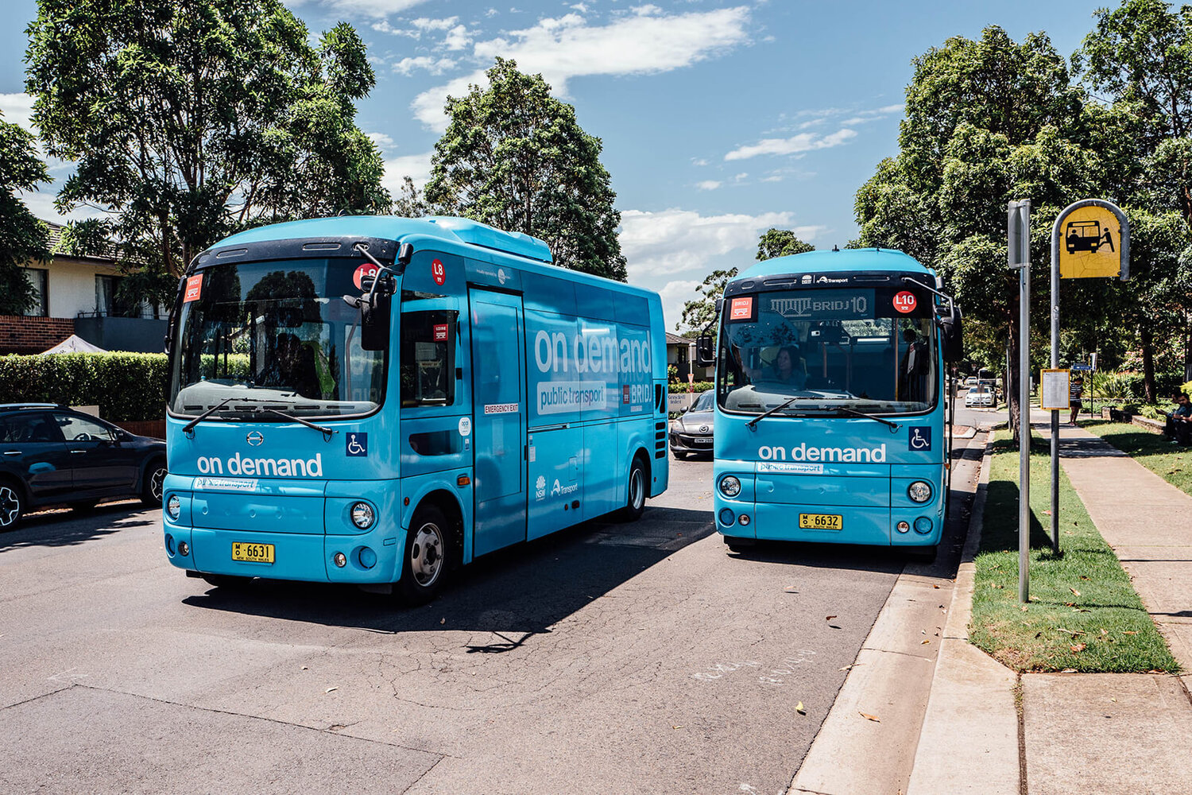
Source: On demand bus in Sydney, Bridj.com, https://bridj.com/

Seoul
The Intermodal Fare Policy
In 2004, the Seoul Public Transport Reform introduced in 2004, involved a large-scale restructuring of Seoul’s bus routes and numbering system together with a complementary intermodal fare system using a T-money smart card system (“T” represents “tech, transport, and touch”). This was the first time any attempt had been made to fully integrate the metro services and bus fares; previously separate fare systems caused passengers to choose sub-optimal routes to avoid transfers. From 2004 onwards an entire trip is calculated as one fare based on the travelled distance. Up to four free transfers between different modes of transportation and vehicles are allowed.
For commuters travelling long distances with multiple transfers, the system was designed to charge less than the original pricing for each ride. Upon the introduction of distance‐based fare charging policy, the traveller can pay approximately 40% (equivalent to HKD10) less on average for using public transportation service. By giving passengers an incentive to minimise travel time, reducing the strain on the public transportation system while at the same time encouraging its greater use, the government’s intermodal distance-based charging policy also helps to ‘nudge’ citizens away from the use of private vehicles and to address the problem of harmful emissions from heavy usage of private vehicles.
How the T-money System Works
T-money is used for unified fare collection and settlement among operators. Citizens can use the T-money card to pay at the entry to or different transportation mode by tapping the T-money card on the card validator or alternatively, to use the T-money card to book their trip through the Internet or mobile ticketing app in advance. A “post-paid” billing service was launched in 2013 to link the T-money card to a user’s credit card which bills the monthly cumulative spending on transport at the end of each month, and eliminates the need to top up. After reconciliation, payments are made from the T-money system to the relevant public transport operators in the city.
T-money is now applicable in a variety of transportation modes, such as metro, buses and taxis across most cities and regions of the country. New micro mobility options such as the bike sharing scheme (Seoul Bike “Ddareungi”) have also adopted T-money as a payment method to enable users to enjoy intermodal discounts if a user takes a bus or train within 30 minutes after returning the bike. Other services such as car sharing and “all-you-can-ride” subscription plans also might be added to the T-money system in the future.
Data Usage and the T-money System
The T-money transaction data is one of the datasets collected by Transportation Operation and Information Service (TOPIS) system, which was established by The Seoul Metropolitan Government, to coordinate traffic volume and bus routes, as well as providing real‐time information to passengers and operators. TOPIS uses the T-money transaction data to determine the occupancy of participating buses by analysing the number of passengers boarding and exiting the bus. This information is then shown on the digital display board at the bus stops, at train stations and in the intermodal transport mobile application. The information helps users decide whether to take the bus or which bus to take, contributing to a more convenient and comfortable travel and improved compliance with bus timetables due to reduction in boarding times.

Shenzhen
Shenzhen has made impressive strides in providing DRT services since 2016. The city's franchised bus operator Shenzhen Bus Group Corporation (SBG) started working with the top car-hailing company in China - Didi Chuxing Technology (Didi) and the government-owned company Shenzhen Institute of Beidou Applied Technology. While the bus operator provides its fleet of buses and services, it lacked online operation technology and demand analysis capability. Didi provides the integrated trip planning and a payment platform and technical support by analysing big data. This includes reconfiguring and rerouting bus routes based on real-time requests as initiated by passengers. In such a collaborative manner the allocation of the conventional public transport capacity is optimised. Passengers can book the services via a Mini-program based on WeChat, the nation's most widely used social media and mobile payment app, allowing the convenient one-click trip-planning and payment experience without the need of downloading additional apps.
Shenzhen has successfully provided the customers with two kinds of DRT services with different carrying capacities.
The first is the U+ minibus DRT service with 12 seats, resembling the uber-like DRT services in other countries. It was first being trialled for three months to fill the FMLM in the Qianhai and Shekou districts, the two crucial industrial and economic development zones in Shenzhen where thousands of white-collar workers commute daily. Another use case of the U+ minibus is to provide the on-demand shuttle service for passengers at Shenzhen Bao'an International Airport. It was decided that the capacity of the previous ground-level transportation at the airport was insufficient to meet passenger demand in different periods with fixed operation schedules and fare setting. There was also a long queuing time for passengers arriving at the airport, especially at late night. Once the passengers get off the airplane and make appointments, the U+ minibus will collect all the data, match at least three passengers and optimize the operation routes within 25 minutes. U+ minibus has successfully reduced the passengers' waiting time while offering efficient and convenient services at a low cost of only 1RMB (1.25HKD) within a 10 km range and increases by 1RMB for every additional 1 km.
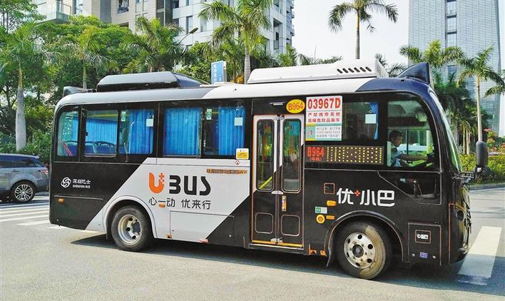
Source: https://www.sohu.com/a/256231692_100008879
The other is Udian bus DRT service, combining ride-hailing with conventional buses and optimising the travel routes, reaching a higher capacity of on-demand services at a lower fare setting comparing to other point-to-point services. The price is 2RMB(2.4HKD) within 3 km and increases by 0.5RMB(0.6HKD) for every additional 1 km. Udian bus DRT service has been extended to several major districts in Shenzhen, including Yantian, Futian and Nanshan. The DRT services have sufficiently met the travelling demand and form an on-demand bus network for the city.
The second use case of the Udian bus includes holiday buses that offer point to point services between tourist spots in the city and surrounding areas, long-distance buses connecting to adjacent cities, and customised commuting buses for companies. Customers can initiate and request for new bus routes according to different use cases on the Mini-program platform. Once at least sixty customers have supported the request, the suggested route will be taken into consideration by the company. Didi will collect three data sources for introducing new on-demand bus routes, including 1) real-time operation Origin-Destination (OD) data from its Didi ride-hailing app; 2) conventional smart card data provided by SBG; 3) travel demand data initiated by customers on the Wechat Mini-program platform.
The Udian bus service is considered successful with an average occupancy rate of more than 70% and its economic self-sufficiency without being subsidised by the government. The business model supported by big data demonstrates how conventional bus operators can upgrade their service, transform to DRT, form an integrated and efficient network and support urban commuting.
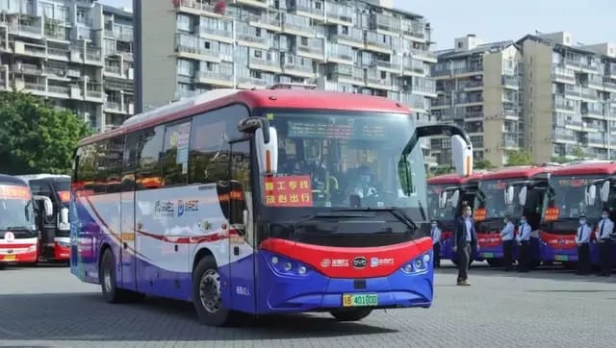
Source: https://m.sohu.com/a/376533834_626425/?pvid=000115_3w_a

Chicago
Integrated payment and trip planning
The Chicago Transit Authority (CTA), Metra, and Pace are the three leading public transport service providers serving Chicago's metropolitan area, the nation's second-largest public transportation system. As the bus and rapid transit operator in the city of Chicago and the second largest authority in the US, CTA is also an independent government agency. Metra is the suburban rail system operator and Pace the suburban bus system operator.
To increase connectivity between CTA's regional transit partners and to create a one-stop shop experience for commuters, CTA launched the Ventra app in 2015. The app allows users to pay for rides on the three systems and provides trip planning tools showing nearby buses and real-time train information. To further encourage multimodal transportation and offer First Mile, Last Mile choices, Ventra offers nearby bike-share stations and bike availability, allowing users to pay for bike share rentals with their Ventra account. Chicago has invested in extending its Divvy bike-share system and allowing Divvy connections to 75% of CTA's rail stations and nearly 50% of CTA's bus stops. Divvy is operated by Lyft for the Chicago Department of Transportation and it contributes to a seamless integration between public transportation and bike-sharing, and as a result has increased the efficiency of multimodal transit.

Data sharing but with ramifications
In 2019, the Chicago Mayor's Transportation Task Force proposed over 50 recommendations to support a reliable multimodal transportation system, including establishing a structural governance framework for data sharing and developing uniform data sharing requirements between public and private entities. Abundant transport data relating to private transport service providers is publicly available on the Chicago Data Portal, including taxi trips, bike-sharing trips and pilot e-scooter trips.
A research case study was conducted by Bestmile to test the impact and service designs of shared mobility in Chicago using taxi ride data. The research compared the performance of shared and unshared services as opposed to car hailing services and their ability to reduce congestion and pollution through using fewer vehicles to move more people over fewer kilometres driven in regard to private vehicles. By processing taxi data through dispatching and ride-matching algorithms on Bestmile's mobility services management platform, three service area scenarios in Chicago were designed and studied to represent a variety of travel demand patterns. The scenarios considered micro-transit in Lincoln Park, a shuttle service to and from O'Hare Airport; and citywide ride-sharing. From this study, it was concluded that shared mobility services have the potential to reduce the number of private vehicles on the road significantly and the number of kilometres travelled, thus reducing greenhouse gas emissions. Through such simulation, the fleet efficiency and passenger-related KPIs for the three scenarios were able to provide planners and transport service providers with more confidence and insight on how new shared mobility services might perform before launch. This example demonstrates how publicly available trip data shared by private sectors can help test future mobility services. However, by implication passenger traffic could be shifted from public to private vehicles and not just from private vehicles to privately shared vehicles with potential consequences for the economics of public transport.
Challenges brought by ride-hailing services
This dilemma also arises in the case of ride-hailing. In contrast to shared mobility, the rapid growth of ride-hailing services in Chicago was proven to have added to the level of traffic congestion. While the number of taxi licenses is limited to under 7000 per year, the number of vehicles registered for ride-hailing services grew by 271 percent in two years to 117,000 in 2017. A recent study revealed that half of all ride-hailing trips were centred in the downtown of Chicago, and 77 percent of all trips were single trips, worsening the city's congestion situation during rush hours. The data also showed that the areas with the most severe congestion were already well-served by public transport. Accordingly, the loss in CTA’s ridership corresponded to the areas that had the highest level of ride-hailing trips, indicating that the public transportation riders had turned to use ride-hailing services, thereby contributing to congestion.
To tackle the problem, Chicago enacted a congestion mitigation scheme in 2020. Ground Transportation Tax standards for all trips on ride-hailing service providers (i.e. Uber, Lyft and Via) are differentiated on whether the trip is single or shared and whether the trip is subject to a Downtown Zone Surcharge. Shared rides are intentionally designed with cheaper tax, and trips starting or ending in Special Zone (e.g. airports, Navy Pier and McCormick Place) will be subject to the higher tax. The new tax structure intends to convert solo trips to shared trips and boost CTA ridership in the meantime. Taxi owners are awarded financial assistance from lower license renewal fees from USD1,000 to USD500 (HKD7750 to HKD3975) every two years.
Private ride-hailing company: Via on-demand services
As one of the main ride-hailing companies, Via has made efforts in avoiding the mentioned problems of ride hailing services and prioritised shared trips over single ride-hailing trips and has expanded its operating zone within areas that were least served by existing public transportation in Chicago. Via's stated goal was to lower private car ownership by providing affordable and convenient on-demand shared services covering first-and-last-mile gaps and supplementing public transit. In order to offer affordable services in areas with limited access to public transit, Via intentionally set the fare as USD2.50 (19HKD) for users who order a Via ride to-or-from railway stations, which is similar to a single pass on a CTA.
Via has also partnered with Northwestern University to provide on-demand student shuttles. Students can hail a free Via vehicle during the evening hours to travel around campus safely. By examining ridership data of the university's previous Safe Ride program, the introduction of Via's matching algorithms is predicted to decrease the wait times of students significantly.
Via's DRT services in Chicago have demonstrated how a private ride-hailing company can actively engage in the public transit system and fill the gaps of unmet travelling demand without diminishing the ridership of conventional public transportation.

Public transit operator: Pace on-demand services
As the suburban transit agency, Pace Bus operates both fixed bus routes and an on-demand vehicle fleet. Due to low-ridership, some of Pace's fixed routes were identified to be economically unsustainable. However, Pace's decision to eliminate the routes with poor performance was postponed facing broad opposition from the public. To grapple with the decreasing public transit ridership and tackle traffic congestion, turning to DRT can supplement the underserved demand. Pace partnered with MobilityDR and initiated a new on-demand model that integrates fixed-route services, and demand-driven options have then become Pace's option for operating the same routes while fulfilling the demand of the public in 2018. Pace On Demand now operates DRT service in 11 designated areas throughout the Chicago suburban region. Users need to book online or call to reserve trips at least one hour (or up to 7 days) in advance and pay with Ventra or cash when boarding. Pace set the services at an affordable rate of USD2 (HKD15) per one-way ride and an on-demand trip to and from Pace's fixed-route bus service is as cheap as USD0.3 (HKD2) to support commuters' transfer.
In addition, Pace has also sought partnerships with ride-hailing companies or taxi companies after receiving funding from the Regional Transportation Agency and Cook County in 2019. Pace believed that using ride-hailing services to cover the last mile from Pace's fixed route stations, any declining public transit ridership of the struggling fixed routes could be boosted. Pace set two of its fixed routes as a part of the pilot program that subsidised ride-hailing services to support the late-night commuters. One line being tested was Pace's 24-hour bus, and another line was with limited connections to other transit services covering the last mile. The price for a ride was USD2.25(17.5HKD) in cash and USD3(HKD23) with a Ventra card, similar to a Pace bus fare.
In summary, Chicago demonstrates a variety of initiatives to address the first-and-last-mile challenges facing public transit, including provision of better access to bike-share systems and ride-hailing services. Via and public transport service providers align in their visions that, with the supplement of ride-hailing services around the least served areas by public transportation, the ridership of public transit can be boosted, and private car ownership can be lowered. The outcomes of such partnerships are still being tested at the moment, but it may be concluded that supporting multimodal transportation at a regional level can improve the commuters' travelling experience with more options being offered at affordable prices.
Pace's transition from operating traditional public transportation to providing on-demand services at routes with low ridership can be regarded as relevant precedence for Hong Kong's public transport service providers. Instead of closing unprofitable routes, turning to on-demand services can be a viable lifeline to continue serving the public efficiently and sustainably.

Chapter 6 – Conclusion

This Draft Report shows the inter-modal transport data-sharing programme is work-in-progress until the Final Report and Closing Conference, scheduled for 27th January 2021. As it stands however it offers the following conclusions:
- The Data Trust at the HKU has succeeded as a Proof-of-Concept as a trusted third party with whom transport operators are prepared to sign MOUs and share certain types of data with confidence that their commercial interests and personal privacy concerns are fully safeguarded while serving the interests of citizens and contributing to smart city governance.
- The Data Trust is therefore a legacy from this programme to Hong Kong that can be continued and applied to other sectors within and beyond transportation. It can be called Data Trust 1.0 in preparation for a Data Trust 2.0
- Through this first small step on exploring multiple transport data sources, there is clear evidence on data insight and adding values to create more effective and integrated transport systems and their associated facilities with enhance user experience and effective use of space/resources. In addition, it is essential for the Government and Data Providers as well as the Data Trust to work closely on building a trusted system that can serve the data sharing purpose, but also covering/balancing each of the Data Providers' commercial interest.
- Smart city planning for transport needs to focus on integrated and therefore multi-modal transport options for passengers at home and from abroad. To achieve this outcome there needs to be a much more holistic approach to governance in practice as well as upon paper, and one that actively involves all stakeholders, from operators to citizens, not in the traditional siloed manner but by developing policy and planning networks that engage with those stakeholders at all levels, from community and district levels up to data sharing at smart city planning levels.
- Data sharing needs to go beyond just making data sets available and in usable formats, to a full examination of what data is most useful to which stakeholders and for what purposes. Therefore in addition to databases there should be regular data forums that can assess positive outcomes of open data and data sharing and identify future needs. To facilitate this Hong Kong needs to update its pre-digital age Code of Access to Information as recommended as early as 2013 by the Law Reform Commission.
- It is proven from the inter-modal transport data-sharing programme can integrate single trip from various ‘siloed’ transport systems into a more ‘completed journey, such that journeys can be better understood. There are also travel insight has been revealed in this report that would no doubt allow transport interchange facilities can be better design with enhanced user experience.
- The success of future inter-modal transport data-sharing programme is a key stepping stone for Hong Kong in moving towards Data Driven approach for Smart City planning.
- As part of the study our Data Trust has developed an agreed common approach (hashing algorithm) to anonymise data to ensure data privacy, the hashing progress should be enhanced such that data can be combined and inter-linked. This calls for careful management of the entire data ingress process. In addition, it is essential to set up common data format that allows Data Providers to contribute partial data with ease, this can also address concerns on revealing commercial sensitive information.
- Demand-responsive transport policies and operations run along a spectrum of possibilities, from flexible scheduling of public transport to the licensing of new forms of on-demand services, to inter-modal services based upon data-sharing to serve identifiable community needs and operational efficiencies. It would serve Hong Kong well to undertake a comprehensive policy review of all forms of demand-responsive transport services together with the laws and regulations that govern them.
- The greatest single obstacle to expanding demand-responsive services seems to come from taxi associations who themselves offer on-demand services. Government needs to find pathways that compensate and/or incentivise taxi drivers to innovate and accept (and perhaps offer) new types of demand-responsive services, including acceptance of online payments and multi-modal transport bookings.
- Incentives for taxi owners to switch to non-polluting e-vehicles and the provision of electric recharging points and/or hydrogen fuel stations at locations that can facilitate sharing by vehicles, vehicle diagnostics and related information services are much needed if roadside emissions of particulate matter (PM_{2.5}) and nitrogen oxide (NO₂) are to be significantly lowered. Similarly, there are non-polluting trackless trams and trolley buses that can play a part in Hong Kong’s smart city planning, especially if street layouts are redesigned at what would be at a marginal cost to provide for cycling and pedestrian-only walkways, with green open spaces, shopping and recreational piazza even in the dense urban areas of Hong Kong. Evidence-based policy making with supporting data, much of which is sorely lacking in Hong Kong, would be the first necessary step.
- Franchised single and double-decker buses are among the major sources of public transport pollution, contributing as much as HKD800 million annually to health costs in Hong Kong and to the over 6,000 annual premature deaths due to pollution-related illnesses. To replace the entire fleet of buses with battery-electric buses (BEBs) in one go – either solely by battery or by hybrid hydrogen fuel cells – would cost around HKD24 billion suggesting a payback of around 30 years. This could start by the mid-2020s when BEBs suitable for Hong Kong are likely to be available and commercially feasible. Government subsidy or tax incentives could take into account the HKD 800 million saved each year together with lives saved.
- Each chapter contains suggestions for government action going forward. In every case this is evidence based and in full recognition that choices have to be made, but also that choices can and should be made. Moving from an age of analogue technologies to digital offers new opportunities to generate Big Data (multi-sources) for evidence-based policy with opportunities for direct engagement of citizens and commercial stakeholders. The HKU Data Trust is an example of a model for data-sharing and better informed smart city policy-making.
- Feedback on this Final Report is welcomed. Please send your comments and suggestions to jenny.wan@accesspartnership.com

Annex 1 - Use Cases Developed in Workshops during 2019

Definition:
A use case is a definition of a specific business objective that the system needs to accomplish. A use case will define this process by describing the various external actors (or entities) that exist outside of the system, together with the specific interactions they have with the system in the accomplishment of the business objective.
Source: https://www.inflectra.com/ideas/topic/use-cases.aspx

The dimensions of the use cases are:
- Mono-modal / multi-modal
- Travel during peak periods / travel during off peak periods
- Travel now / travel in the future
- Travelling through unfamiliar territory / a commuter
- A commuter that doesn’t plan
- A traveller that requires special assistance (e.g. registered disabled)
- Dealing with unplanned incidents (e.g. congestion due to an incident)
- Dealing with planned incidents (e.g. a major festival)
- A preference for active mobility – happy to walk when the air quality is OK
The above leads to many combinations below. Excluding cross-border travel, the most common intra-HK ones are listed below. The list provides a flavour of the most common challenges facing stakeholders, including the passengers themselves, and is subject to further refinement and development during the period of research.
Use case # | Use case | Additional Context.
1 | A passenger wishes to get to a nearby destination during peak period but is unfamiliar with the area. He / she wants to know what the travel options are, including walking. | Simple mono-modal planning requirement.
2 | A passenger wishes to get from A to B now and wants to know how much the total trip will cost. | Simple planning requirement but may include one or more modes
3 | A passenger wishes to get from A to B tomorrow and wants to know what the travel options are. | Simple planning requirement but may include one or more modes
4 | A passenger wishes to get from A to B tomorrow and wants to know how much the total trip will cost. | Simple planning requirement but may include one or more modes

5 | A passenger is arriving by train from the Airport by Airport Express in Central and needs a taxi to meet him / her without having to wait. Taxis are usually available but typically long queues. | The initial mode choice is known, but a connection is needed. The passenger is travelling on business and would be prepared to pay the standard booking fee of $5 (or more) to get certainty.
6 | A commuter takes the MTR and as he / she exits, if there’s a taxi then the commuter would take it, otherwise he/she would walk | Could a taxi be ready and waiting? The commuter hasn’t booked but would certainly take it.
7 | A passenger is on a bus and there’s been an accident and there’s heavy congestion ahead. The passenger needs to know what the options are to get to his / her destination and the new Estimated Time of Arrival | The passenger hasn’t booked the trip but the bus operator wishes to provide good service to every customer – but the advice needed is different for each passenger.
8 | A passenger is making his / her first visit to Chai Wan and wants to pay for a trip covering MTR and taxi to the destination. He / she has no idea when the trip will start. | The passenger has not yet entered the MTR station, but the MTR certainly knows when the passenger enters the MTR’s paid area and leaves the MTR’s paid area at the end of the trip.
9 | A passenger works 6-days per week and maintenance work is planned on the MTR. The commuter needs to be notified if there’s a risk of this – without asking. | An event that is internal to a mode that the passenger frequents. He / she would like to know – without asking.
10 | It could rain tomorrow, and the travel time could be extended. The commuter needs to be notified if there’s a risk of this – without asking. | An event that is internal to surface modes only. Historic travel patterns show that rain could impact surface transport and increase congestion. Notification to a commuter could be helpful to improve quality of service. Generally, commuters have fixed arrival times, and therefore the departure time would need to change.
11 | A traveller with impaired mobility wishes to travel door-to-door on an unfamiliar journey, probably including more than one mode. An adapted taxi and step-free access to each mode is needed. He / she can walk for sort distances unaided. | What information is known about the route, including step-free access and perhaps availability of support staff?
12 | There are lots of passenger is on a ferry from an outlying island and its likely to be few minutes late. They may miss the bus and its 30 minutes to the next one. | Can the ferry company help? This is a regular occurrence during the winter months when sea conditions vary.

Annex 2 – Demonstration Projects

Title and Date | Demo Project
A Transport Data Sharing Model for Hong Kong  3rd August 2020  Attendance: 25 | The online Knowledge Café has been created by Ms. Waltraut Ritter of the TRP-HK Team and is being used as the platform for the demo projects  The first was held in June and the second on 3rd August with Ir. Andrew Pickford of the TRP-HK Team introducing ‘A Transport Data Sharing Model for Hong Kong’  https://trpc.biz/3-august-2020-trp-mobility-futures-knowledge-cafe/
Passenger Journey Analytics Tool  28th August 2020  Attendance: 35 | Stephane Duguet, Head of Research, Technology & Innovation at Thales Transport & Security HK, introduced a big data analytics tool, Naia, for measuring passenger numbers and modelling passenger flows and making predictive analysis for operators to improve the efficiency and quality of service.  Assistant Prof. Dr Kuo Yong-Hong of the Department of Industrial and Manufacturing Systems Engineering, HKU acted as discussant, and fielding questions from the audience.  https://trpc.biz/28-august-2020-trp-knowledge-cafe-demonstration-seminar-on-passenger-journey-analytics-tool/
‘Resolving Inter-modal data transfer with issues with smart contracts’  24th September 2020  Attendance: 27 | ‘Resolving Inter-modal data transfer with issues with smart contracts’ Sabine Reppert, CEO of Deon Digital Hong Kong, showcased how these hurdles can be overcome. Deon Digital enables this breakthrough by introducing Distributed Ledger Technology and Deon Digital’s Smart Mobility Contracts into the MaaS technology stack.  Discussant: Pindar Wong, Chairman of VeriFi (Hong Kong) Ltd. https://trpc.biz/24-september-2020-trp-demonstration-seminar-on-resolving-intermodal-data-sharing-issues-with-smart-contract-technology/
‘On-demand Transit: Recent Experience and Future Promise for Improving Mobility in Hong Kong’  29th September 2020  Attendance: 22 | ‘On-demand Transit: Recent Experience and Future Promise for Improving Mobility in Hong Kong’  David Adelman, Vice President of Global Partnerships, Via discussed Via’s approach to on-demand mobility and its potential for Hong Kong. He also provided a demonstration of Via’s apps and service management tools that are now used in over 150 cities worldwide.  AN BUS aims at providing on-demand bus service by red minibus in Hong Kong. Franki Li, Founder & CEO, Auf Nachfrage Bus (AN BUS) shared his views and experience. He explained why red minibus is the ideal mode that can provide on-demand transportation service in Hong Kong.  https://trpc.biz/29-september-2020-trp-demonstration-seminar-on-demand-transit-recent-experience-and-future-promise-for-improving-mobility-in-hong-kong/

How is Hong Kong moving during the new normal? Mobility data with Teralytics’  5th November 2020  Attendance: 32 | ‘How is Hong Kong moving during the new normal? Mobility data with Teralytics’  Diana Gutierrez, Head of Business Development, Teralytics APAC, discussed how mobility data can provide Hong Kong transport operators, mobility providers and transport related government organizations with a clear and updated view of how Hong Kong is moving as events unfold. Diana provided a demonstration of its Matrix dashboard to exhibit how Hong Kong was moving during the 2nd wave of COVID-19 (July-August 2020).  https://trpc.biz/5-november-2020-trp-demonstration-seminar-how-is-hong-kong-moving-during-the-new-normal-mobility-data-with-teralytics/
‘Volumetric Urbanism, sketch tool for Multimodal Service Area: Use case: Harbourfront masterplan, pedestrian wayfinding simulation for option generation and evaluation’  12th November 2020  Attendance: 32 | ‘Volumetric Urbanism, sketch tool for Multimodal Service Area: Use case: Harbourfront masterplan, pedestrian wayfinding simulation for option generation and evaluation’ presented by Alain Chiaradia, Associate Professor, Department of Urban Planning and Design, Faculty of Architecture, University of Hong Kong.  Tony Pearce, Vice President of City Wayfinding, T-Kartor, Sweden, shared insights on city wayfinding systems which people use to navigate on foot, by bike or public transport, and encourage modal shift away from private car use. He demonstrated how multi-modal wayfinding information is produced, managed and maintained from a core data-driven production system.  https://trpc.biz/12-november-2020-trp-demonstration-seminar-volumetric-urbanism-sketch-tool-for-multimodal-service-area/
An Integrated MaaS service: insights from Berlin  10th December 2020  Attendance: 60 | ‘An Integrated MaaS service: insights from Berlin’  Trafi is a mobility-as-a-service startup which allows cities to integrate the planning and booking process for various forms of transport into a single app. In Berlin, the all-in-one transport planning and payment app runs in partnership with the public transport authority Berliner Verkehrsbetriebe (BVG).  Speaker: Christof Schminke, Managing Director Commercial at Trafi https://trpc.biz/10-december-2020-trp-demonstration-seminar-an-integrated-maas-service-insights-from-berlin/ and https://www.youtube.com/watch?v=d_8q4YTwlm0&feature=youtu.be
19th January 2021  Attendance: 43 | ‘Integrated transport data sharing for a whole country: Experience from Denmark’  A talk about Mobility-as-a-Service (MaaS) system in Denmark and a demonstration how data is retrieved and analysed. Also how the data sharing model between the different stakeholders works.  Speakers: Jens Willars, Chief Operating Officer at Rejsekort & Rejseplan and Geert Vanbeveren, Siemens Mobility  https://trpc.biz/19-january-2021-trp-demonstration-seminar-integrated-transport-data-sharing-for-a-whole-country-experience-from-denmark/
22nd January 2021  Attendance: 33 | ‘IP of Algorithms in Open Innovation’  Katherine Sheriff and Dr. Li Yahong together with her PhD student, Mr. Wang Wei, will discuss IP and innovation in the context of business-to-government data-sharing initiative with transport operators and payment providers.  https://trpc.biz/22-january-2021-trp-seminar-on-ip-of-algorithms-in-open-innovation/

The number of ITF grant received by HKU is GSP/016/19. Dr. Zhou Jiangping was the holder (principal investigator) of the grant and Drs. Li Weifeng and Liu Xing-Jian were co-investigators. Other programme team members were designated consultants for the grant.
Goetz, A. R. 2009. Intermodality International Encyclopedia of Human Geography. pg. 529–535.
European Union, Multimodal and combined transport, https://ec.europa.eu/transport/themes/logistics-and-multimodal-transport/multimodal-and-combined-transport_en#:~:text=The%20EU%20transport%20policy%20aims,greater%20use%20of%20multimodal%20solutions.&text=The%20social%20and%20environmental%20costs,with%20the%20polluter%20pays%20principle
Based on: ‘Analysis of cooperation models among public and private parties’ 30 April 2020
Compute Calcul Ontario, Building Ontario’s Next-Generation Smart Cities Through Data Governance: Part 2-Towards a Smart City, https://computeontario.ca/building-ontarios-next-generation-smart-cities-through-data-governance-part-2/
Open Data Institute (2019), UK’S First Data Trusts To Tackle Illegal Wildlife Trade And Food Waste, https://theodi.org/article/uks-first-data-trusts-to-tackle-illegal-wildlife-trade-and-food-waste/
Open Data Institute (2020), What Mobility Data Has Been Collected and Published During Covid-19, https://theodi.org/article/what-mobility-data-has-been-collected-and-published-during-covid-19/
Research Gate (2020), An integrated data platform to leverage the benefits of smart mobility, https://www.researchgate.net/publication/339002024_An_integrated_data_platform_to_leverage_the_benefits_of_smart_mobility
Hong Kong Tramways (website) Our Story https://www.hktramways.com/en/our-story/
The WGS 84 Coordinate System is a Conventional Terrestrial Reference System (CTRS) see GPS World (website) https://www.gpsworld.com/data-collection-of-wgs-84-information-or-is-it/
A common programming code, https://www.python.org/
DUPAD and FoA of the HKU are highly reputable in the field of urban planning and transport analytics research, experts in computational challenges in construction and cities, urban semantics in 3D point clouds, BIM, GIS and IoT, operations research, applied machine learning and transport/transit systems and land use connections studies have been consulted to facilitate the production of research insight with the support of the data trust.
Elastic Logstash - Centralize, transform and stash your data, https://www.elastic.co/logstash
Monthly Traffic and Transport Digest (May 2019), Transport Department, available from <https://www.td.gov.hk/en/transport_in_hong_kong/transport_figures/monthly_traffic_and_transport_digest/2019/201905/index.html>
Apart from Octopus Card and cash, more e-payment options including using QR code, mobile and contactless cards are available recently. It is expected that there will be more potential for fragmentation of data in foreseeable future in view of the increasing number of e-payment options.
Readers are referred to: - Yang, Y., Ma, H. and Zhou, J., 2020. One-sided or two-sided love? Visualizing connections between metro station pairs in Beijing. Environment and Planning A: Economy and Space, 52(4), pp.707-709. - Wang, Z., Tang, H., Wang, W. and Xi, Y., 2020. The Pattern of Non-Roundtrip Travel on Urban Rail and Its Application in Transit Improvement. Sustainability, 12(9), p.3525.
Readers are referred to: Ingvardson, J.B., Kaplan, S., e Silva, J.D.A., Di Ciommo, F., Shiftan, Y. and Nielsen, O.A., 2020. Existence, relatedness and growth needs as mediators between mode choice and travel satisfaction: evidence from Denmark. Transportation, 47(1), pp.337-358.
Time ranges with average numbers of boarding passengers per minute mostly in the 95th percentile or above were determined to be peak periods.
For instance, passengers coming from Northwest New Territories or Tsuen Wan and exiting at MTR Central Station gates are assumed to take the Tung Chung Line to arrive at Hong Kong Station platforms and traverse the travelator to Central Station, since this is the fastest route.
Time ranges with average numbers of alighting and boarding passengers per minute mostly in the 95th percentile or above were determined to be peak periods.
Thomas Menkhoff et.al. (2018) Living in Smart Cities: Innovation and Sustainability, Singapore World Scientific, p.6 ff.
The dedicated Smart City website provides no details on the progress of initiatives https://www.smartcity.gov.hk/
Panel on Information Technology and Broadcasting, Meeting on 8 June 2020, Updated background brief on smart city development (https://www.legco.gov.hk/yr19-20/english/panels/itb/papers/itb20200608cb1-710-3-e.pdf )
UN SDG Goals Monitoring https://www.unsdsn.org/sdg-index-and-monitoring
Fintech Supervisory Sandbox (FSS) (https://www.hkma.gov.hk/eng/key-functions/international-financial-centre/fintech/fintech-supervisory-sandbox-fss/)
Internet Society of Hong Kong (2020) Open Data Index 2019/2020 https://opendata.isoc.hk/en/index/
Marc de Vries (2010) Reverse engineering Europe’s PSI – towards an integrated framework for PSI re-use
OECD (2018) Open Government Data Report http://www.oecd.org/gov/open-government-data-report-9789264305847-en.htm
OECD, Recommendation of the Council for Enhanced Access and More Effective Use of Public Sector Information, OECD/LEGAL/0362 https://legalinstruments.oecd.org/public/doc/122/122.en.pdf
OGCIO 2012 Update on Provision of Public Sector Information EGTF Paper no 8 https://www.ogcio.gov.hk/en/about_us/committees/archive/d21sac/previous_terms/doc/D21SAC_paper_8-2012.pdf
Data.gov.hk (website) Frequency Asked Questions https://data.gov.hk/en/faq
OGCIO (December 2007) 2008 Digital 21 Strategy https://www.ogcio.gov.hk/en/news/publications/doc/2008D21S-booklet.pdf
CEDB September 2013 Public Consultation on 2014 Digital 21 Strategy https://www.ogcio.gov.hk/en/news/consultations/d21_submission_2013/doc/2014D21S-booklet.pdf
Legislative Council Paper LC Paper No. CB(1)710/19-20(02) Update on Smart City Development https://www.ogcio.gov.hk/en/news/legco_papers/2020/06/doc/lb_20200608_e.pdf
https://www.ogcio.gov.hk/en/our_work/infrastructure/e_government/if/interoperability_framework.htm
The Law Reform Commission of Hong Kong https://www.hkreform.gov.hk/en/docs/accesstoinfo_se.pdf
Office of the Ombudsman http://ofomb.ombudsman.hk/abc/en-us/code_informations
Hong Kong Open Data Index 2019/20 p 8 https://opendata.isoc.hk/en/index/
Graham Vickery (2011) https://ec.europa.eu/digital-single-market/en/news/review-recent-studies-psi-reuse-and-related-market-developments
International Transport Forum (ITF), “Regulating App-Based Mobility Services: Summary and Conclusions”, 27 August 2019, https://www.itf-oecd.org/regulating-app-based-mobility-services. See also Financial Times, 9 September 2020, “Uber has pledged to make all of its rides in North America and Europe fully electric by 2030, after a new report found the ride-hailing company’s operations to be more damaging to the environment than private transportation. Uber said it was ‘beginning to compete’ with personal car ownership on carbon efficiency, but added that emissions from Uber rides were still 41 per cent higher when compared with an average-occupancy vehicle — due to the time spent driving without passengers in the car, for instance when driving to pick up a client. The move follows the release of Uber’s first-ever environmental impact report, based on data from every single Uber ride taken in the US and Canada from 2017-19 — approximately 4bn trips. According to the report, emissions per ‘passenger mile’ had gone down overall, since improved algorithms had reduced passengerless travel. But based on the average vehicle occupancy rate in the US, its emissions per passenger mile still outstripped those of privately owned vehicles.”
HSL, ‘Final report on the Kutsuplus trial: work to develop ride-pooling worth continuing, June 2016 accessed at https://www.hsl.fi/en/hsl/news/news/2016/06/final-report-on-the-kutsuplus-trial-work-to-develop-ride-pooling-worth-continuing on 4 January 2020
BBC, ‘Slide Bristol shared-ride minibus scheme to close’, November 2018, https://www.bbc.com/news/uk-england-bristol-46360299 accessed on 4 January 2020
The relaunch of UbiGo’s MaaS service in Gothenburg, Sweden demonstrates the benefit of learning and adaptive transport policy.
Peters, D., “Gender and Sustainable Urban Mobility”, Global Report on Human Settlements 2013 accessed at https://civitas.eu/sites/default/files/unhabitat_gender_surbanmobilitlity_0.pdf on 4 January 2020
http://www.mtr.com.hk/en/customer/main/early_bird.html. See also Anupriya et al, “Quantifying the ex-post causal impact of differential pricing on commuter trip scheduling in Hong Kong”, Transportation Research Part A, Elsevier, 15 September 2020.
Via Transportation Inc was a consultee and provided a demonstration on 29th September 2020 during the study.
https://www.premier.sa.gov.au/news/media-releases/news/on-demand-bus-services-in-massive-demand, accessed on 31 December 2020.
Currently the major TSPs have their own mobile app requiring users to be familiar with all of them.
https://www.td.gov.hk/en/transport_in_hong_kong/public_transport/railways/index.html, on 30 December 2020.
Transit Jam, ‘Inter-Modal Mobility: Exploring the Exchange Square Public Transport Interchange ‘, https://www.youtube.com/watch?v=hj7-uzAqP84, accessed on 2 January 2021.
Ref. Trafi demonstration event on 10 December 2020, https://trpc.biz/10-december-2020-trp-demonstration-seminar-an-integrated-maas-service-insights-from-berlin/.
Anecdotal evidence.
Mayor of London/Tfl (April 2015) Assessing transport connectivity in London http://content.tfl.gov.uk/connectivity-assessment-guide.pdf; Tfl (WebCat website) Planning with WebCAT https://tfl.gov.uk/info-for/urban-planning-and-construction/planning-applications/planning-with-webcat
Meeting Notes from ODIG #1 circulated amongst ODIG Members, 08 October 2020.
A way to reveal to the user whether an incoming vehicle is fully occupied or has seats available without revealing the information in a manner that would be detrimental to the operator of said vehicle.
BSI Standard Publication (20014) Smart city framework – Guide to establishing strategies for smart cities and communities https://shop.bsigroup.com/upload/267775/PAS 181 (2014).pdf
Complemented by ISO 37105: A Descriptive Framework for Cities and Communities, that provides a consistent way of describing all the key aspects of a city.
Consultation findings between the HKU research team and TSPs, October 2020.
HKT (Sep 2020) HKT wins HK$65 million contract for procurement cum management, operation and maintenance of real-time arrival information system for green minibus http://www.pccw.com/assets/Common/files/press-release/2020/Sep/20200914e%20HKT%20TD%20green%20minibus.pdf,
HKG Press Release (Dec 2020) Test launch of Green Minibus Real-time Arrival Information System on three Hong Kong Island green minibus routes https://www.info.gov.hk/gia/general/202012/31/P2020122900495.htm
https://future.transport.nsw.gov.au/projects/on-demand-services, accessed on 16 March 2021.
CNA (May 2019) No on-demand public buses for now, as LTA cites high tech costs https://www.channelnewsasia.com/news/singapore/lta-on-demand-bus-trial-end-11583408
Intelligent Transport, (August 2019) Singapore’s first on-demand autonomous shuttle trial opens to the public https://www.intelligenttransport.com/transport-news/86331/first-on-demand-autonomous-shuttle-trial/
Transport Department (website) Role of Taxis https://www.td.gov.hk/en/transport_in_hong_kong/public_transport/taxi/
Reuters (December 2016) HKMA grants stored value licences to eight more issuers including PayPal ‘ https://www.reuters.com/article/us-hongkong-hkma-license-idUSKBN12Z0NE
Intelligent Transport, (November 2020) ‘Ride-hailing businesses should protect users from data-hungry manoeuvring‘, https://www.intelligenttransport.com/transport-articles/111299/ride-hailing-businesses-should-protect-users-from-data-hungry-manoeuvring/
Legislative Council of the Hong Kong Special Administrative Region (December 2020) ‘Regulation of e-scooters and electric mobility devices’, Legislative Council of the Hong Kong Special Administrative Region - Regulation of e-scooters and electric mobility devices (legco.gov.hk)
The Government of the Hong Kong Special Administrative Region, (December 2017) “TD commences studies on walkability and assessment mechanism to take forward "Walk in HK" initiative”, accessed at https://www.info.gov.hk/gia/general/201712/15/P2017121500603.htm#:~:text=The%20Consultancy%20Study%20on%20Enhancing,into%20a%20more%20walkable%20city.
Transport department (2004) Cycling Study: Final report https://www.td.gov.hk/filemanager/en/publication/cyclingstudy.pdf
Transport Department (February 2014) Travel Characteristics Survey 2011Final Report https://www.td.gov.hk/filemanager/en/content_4652/tcs2011_eng.pdf
TRPC (December 2020) https://trpc.biz/decarbonising-public-transport-in-hong-kong-part-2/
Section 6.6, Volume 3.
Transport Department (2011) Cycling Information Centre https://www.td.gov.hk/mini_site/cic/en/index.html
Transport Department ‘Bicycle Carriage Arrangement on Public Transport’ (2011) https://www.td.gov.hk/mini_site/cic/en/cycling-infrastructure/cycling-with-public-transport.html
Lee, A. (May2013) Cyclists blame policy for keeping bikes off public transport https://www.scmp.com/news/hong-kong/article/1231604/hong-kong-cyclists-blame-policy-keeping-bikes-public-transport (paywalled).
Block, I. (May 2020) London, New York, Paris and Milan give street to cyclists and pedestrians https://www.dezeen.com/2020/05/07/london-new-york-paris-milan-cyclists-pedestrians/
Newbart, D. (December 2020) ‘Why 2020 was such a great year for biking in Chicago https://chicago.suntimes.com/2020/12/24/22194681/2020-biking-cycling-pandemic-riding-coronavirus-covid-strava
Mancur Olson, The Logic of Collective Action: Public Goods and the Theory of Groups (Harvard: Harvard University Press, 1965). Henry Hansmann, Ronald Gilson and Mariana Pargendler ‘Regulatory Dualism as a Development Strategy: Corporate Reform in Brazil, the U.S., and the EU’ (Yale Law School 2010). Collective Action Theory first proposed by Olson in 1965 underpins ‘The Olson Problem’, namely the resistance to reform by established groups, described as ‘political and economic elites’, that wish to preserve their power. Arguably, this could be applied to any situation mentioned as regards vested interests resisting any intensification of the corporate governance regulatory environment
LegCo.(2019).MTR Fare Adjustment for 2019. https://www.legco.gov.hk/yr18-19/english/panels/tp/papers/tp20190426cb4-766-4-e.pdf
Tmoney. (n.d.). Overview. https://eng.tmoney.co.kr/en/aeb/aboutUs/overview/overview.dev;jsessionid=rvI7wuAWYZyswaa1yYYDi13RV6n3MhAHwRJZ9VC1Wq6MC10fU7uKwzAPxufdNCiz.czzw02ip_servlet_ksccweb
The Open Epidemiology Journal 2011:v4:pp.106-122 ‘Assessment of the Health Impacts and Economic Burden Arising from Proposed New Air Quality Objectives in a High Pollution Environment’ Hak-Kan Lai, Chit-Ming Wong, Sarah McGhee and Anthony Hedley. Copy available from https://benthamopen.com/ABSTRACT/TOEPIJ-4-106 or upon request Johnure@trpc.biz
EPD (2016) Developing an Instrument for Assessing the Health and Economic Impacts of Air Pollution in Hong Kong: Final Report https://www.epd.gov.hk/epd/sites/default/files/epd/english/environmentinhk/air/studyrpts/files/instrument_impacts_air_pollution.pdf
Legco Panel on Environmental Affairs (June 2013) Retrofitting Franchised Buses with Selective Catalytic Reduction Devices https://www.legco.gov.hk/yr12-13/english/panels/ea/papers/ea0614cb1-1269-1-e.pdf
Interview, Michael Chan Ting-bond COO of Inchcape, 11th December 2020
EPD (June 2021) Clean Air Plan for Hong Kong 2035 https://www.enb.gov.hk/sites/default/files/pdf/Clean_Air_Plan_2035_eng.pdf ; SCMP (July 2020) Hong Kong taxi distributor says including hybrid models in electric vehicle road map will reduce emissions in near-term https://www.scmp.com/news/hong-kong/transport/article/3094763/hong-kong-taxi-distributor-says-including-hybrid-models
S&P Global (September7 2020) Toyota plots late arrival to electric vehicle party https://www.spglobal.com/marketintelligence/en/news-insights/latest-news-headlines/toyota-plots-late-arrival-to-electric-vehicle-party-60238243
The Conversation (October 2019) Trackless trams v light rail? It’s not a contest – both can improve our cities https://theconversation.com/trackless-trams-v-light-rail-its-not-a-contest-both-can-improve-our-cities-125134
https://theconversation.com/why-trackless-trams-are-ready-to-replace-light-rail-103690
Transus Consultants (December 2017) Provision of Service to Identify Green Ferry Options that are Technically Feasible in Local Context: Summary Report https://www.epd.gov.hk/epd/sites/default/files/epd/english/environmentinhk/air/studyrpts/files/GFS_summary%20report_eng.pdf
https://www.legco.gov.hk/yr19-20/english/panels/ea/papers/ea20200122cb1-336-4-e.pdf
The Task Force comprises representatives of the EPD, Electrical and Mechanical Services Department, Government Property Agency, Housing Department, Innovation and Technology Commission, Lands Department, Transport Department, Architectural Services Department, Highways Department, representatives of the Hong Kong Institution of Engineers, as well as academics and experts of electric vehicles technologies.
The word ‘bureaucracy’ tends to be synonymous with slowness, but in the work of Max Weber (1864-1920) bureaucracies existed because they were the most efficient means of policy administration. How efficient is determined by their governance.
HKG SAR October 2020) Press Release https://www.info.gov.hk/gia/general/202010/15/P2020101500414.htm
http://www.gmi-hk.com/portfolio/gemini-public-light-bus/
Interview (15th October 2020) with Thomas Chan, Senior Manager, Green Technology Cluster, HKSTP https://www.linkedin.com/in/thomas-chan-07627559/?originalSubdomain=hk
https://www.oppcharge.org/
http://tgood.com/int/en/pages/about
https://www.eesi.org/papers/view/fact-sheet-electric-buses-benefits-outweigh-costs
Transit Jam (October 2020) Fast Chargers For Electric Minibuses To Descend On Kwun Tong https://transitjam.com/2020/10/15/fast-chargers-for-electric-minibuses-to-descend-on-kwun-tong/
https://www.legco.gov.hk/yr18-19/english/panels/ea/papers/ea20181219cb1-319-4-e.pdf
HKG Press Release ( December 2018) LCQ16: Electric buses https://www.info.gov.hk/gia/general/201812/12/P2018121200670.htm
HKG Press Release (Dec 2019) Tightened emission requirements of Franchised Bus Low Emission Zones to Euro V standard take effect today https://www.info.gov.hk/gia/general/201912/31/P2019123100268.htm
HKG Press Release ( December 2018) LCQ16: Electric buses https://www.info.gov.hk/gia/general/201812/12/P2018121200670.htm
The Berlin Spectator (May 2020) Berlin: 5 Billion Euro for the Most Elegant Electric Buses https://berlinspectator.com/2020/03/09/berlin-5-billion-euro-for-the-most-elegant-electric-buses/
Legco Panel on Environmental Affairs (January 2020) Promoting the Use of Electric Vehicles https://www.legco.gov.hk/yr18-19/english/panels/ea/papers/ea20190128cb1-487-3-e.pdf
Deloitte (January 2020) Fueling the Future of Mobility Hydrogen and fuel cell solutions for transportation https://www2.deloitte.com/content/dam/Deloitte/cn/Documents/finance/deloitte-cn-fueling-the-future-of-mobility-en-200101.pdf
Civic Exchange (December 2016) Measuring and Improving Walkability in Hong Kong: Final Report https://civic-exchange.org/wp-content/uploads/2016/12/201612URBAN_Walk2report-1.pdf
DesigningHongKong (Website) Elevated park to complete the footbridge network in Wan Chai https://www.designinghongkong.com/edm/index.php?option=com_acymailing&ctrl=archive&task=view&mailid=345&key=oltItJKr&subid=179375-XDA6YtbbOM5kny&tmpl=component
HKG Press Release (May 2020) Legco: Improvement to Pedestrian Facilities https://www.info.gov.hk/gia/general/202005/13/P2020051300347.htm
HKG Press Release (December 2020) 3D Pedestrian Network and 3D Visualisation Map datasets made free to public https://www.info.gov.hk/gia/general/202012/03/P2020120300289.htm
A major constraint on creating an inviting outdoors environment is the lack of a cohesive policy for street management, often involving multiple government agencies and red tape as highlighted by a Civic Exchange report Managing Vibrant Streets (2018) https://civic-exchange.org/wp-content/uploads/2018/08/Managing-Vibrant-Streets-for-web.pdf
Civic Exchange/World Resources Institute (June 2020) Pathways To Net Zero Carbon Emissions By 2050 https://civic-exchange.org/wp-content/uploads/2020/06/Hong-Kong-2050-policy-report_Final-20200626-1.pdf The report recommends (i) Transport Department oversight of the system should shift from decisions on matters such as specific bus routes to regulating at the whole-service level; (ii) the key service measure should be how long it takes to get from a public transport pick-up point to a destination; (iii) District councils should be provided with comparisons of actual and target service levels for their district and focus on the quality of the service level provided rather changes to individual bus routes.
https://www.bloomberg.com/news/articles/2020-06-17/the-electric-car-battery-boom-has-screeched-to-a-halt-for-now
Transport for London Cycling Infrastructure Database https://data.london.gov.uk/dataset/cycling-infrastructure-database
Transport for London (2010) Pedestrian Comfort Guidance for London https://www.cycling-embassy.org.uk/sites/cycling-embassy.org.uk/files/documents/pedestrian-comfort-guidance-technical-guide.pdf
Made by TfL (December 2020) Our Independent Disability Advisory Group https://madeby.tfl.gov.uk/2020/12/02/idag-members/
France 24 (April 2019) Paris orders 800 new electric buses to fight smog https://www.france24.com/en/20190409-paris-orders-800-new-electric-buses-fight-smog
VanMoof on YouTube (January 2019) How the Theft Defence system works https://www.youtube.com/watch?v=vP_rkokvC80
Cycling Embassy of Denmark (2018) Preventing Bicycle Theft https://cyclingsolutions.info/preventing-bicycle-theft/
Development Bureau and Planning Department, 2016. Hong Kong 2030+: Towards a Planning Vision and Strategy Transcending 2030: Public Engagement, https://www.hk2030plus.hk/document/2030+Booklet_Eng.pdf.
Cycling infrastructure and activities are mainly allowed in the New Territories as they are hard to actualise in urban areas due to spatial limitations, according to the Transport Department, 2020, Major Cycle Tracks and Parking Sites, https://www.td.gov.hk/mini_site/cic/en/cycling-infrastructure/cycle-tracks-and-parkings/index.html. This is subject to debate.
This led to enforcement actions by the government, resulting in financial losses to the operators and their eventual closing down, LegCo, 2018, Bicycle-sharing systems in selected places, https://www.legco.gov.hk/research-publications/english/1819in02-bicycle-sharing-systems-in-selected-places-20181015-e.pdf; 陳晶琦, 2020, 共享單車｜三年後剩一公司「生存」業界批政府充公單車礙發展, https://www.hk01.com/社會新聞/490527/共享單車-三年後剩一公司-生存-業界批政府充公單車礙發.
Key technological updates of the bike-sharing scheme in Copenhagen, brought by the collaboration between Bycyklen and VAIMOO, using the technology developed by SITAEL, https://www.vaimoo.com/portfolio/vaimoo-the-e-bike-sharing-platform-chosen-by-the-city-of-copenhagen/; Details of the current technology, https://www.vaimoo.com/e-bike/, https://www.sitael.com/internet-of-things/emobility/fleet-management-system/, https://www.esb.bike/bikesharing_system/.
VAIMOO, 2020, https://www.vaimoo.com/fleet-management/.
The City of Copenhagen, 2011, Bicycle Strategy 2011-2025, http://kk.sites.itera.dk/apps/kk_pub2/index.asp?mode=detalje&id=823.
Bycyklen is funded by the city and the Commuter Bike Foundation as a non-profit, https://bycyklen.dk/en/facts-about-bycyklen/.
Development Bureau, 2020, LCQ15: Cycle track networks and cycling economy, https://www.devb.gov.hk/en/sdev/press/index_id_10731.html.
LegCo, 2018, Bicycle-sharing systems in selected places, https://www.legco.gov.hk/research-publications/english/1819in02-bicycle-sharing-systems-in-selected-places-20181015-e.pdf.
Hacon Company, 2018, MinRejseplan: MaaS App for Denmark, https://www.youtube.com/watch?v=x60CCM28X8E&ab_channel=HaConCompany, Accessed 22/12/2020.
Mamba, 2018, MinRejseplan and Plustur – two ways to maximise mobility in rural, Northern Denmark, https://www.mambaproject.eu/wp-content/uploads/2018/07/WP2_good-practice-cases_-MinRejseplan-and-Plustur-FINAL.pdf.
Hacon Company, 2018 (MinRejseplan: MaaS App for Denmark, https://www.youtube.com/watch?v=x60CCM28X8E&ab_channel=HaConCompany, Accessed 22/12/2020.
Technology of Cyclemeter developed by SWARCO, 2020, Greenwave for Copenhagen/Denmark https://www.swarco.com/stories/greenwave-copenhagen-denmark; https://www.swarco.com/products/cycle-products/cyclemeter.
Locobike, 2020, https://loco.hk/bike.
Government views the collection of bike utilisation rate as not necessary, Development Bureau, 2020, LCQ15: Cycle track networks and cycling economy, https://www.devb.gov.hk/en/sdev/press/index_id_10731.html.
Https://assets.new.siemens.com/siemens/assets/public.1536909402.d3ea2f7d-2cdc-4fb4-993f-596f2759c141.mobility-marketplace-flyer-en.pdf.
Https://www.hacon.de/en/news/press/hacon-and-rejseplanen-proudly-present-maas-app-minrejseplan-for-its-world-congress-2018-and-beyond/.
Octopus intermodal discount, http://www.mtr.com.hk/en/customer/tickets/intermodal.html.
Advocacy groups in Hong Kong have commented on the lack of public involvement in open data policies and some smart city initiatives. For instance, a criticism was directed to the smart lamppost initiative. “It’s not just about the technology, it’s about the consultation. The consultation [on the smart lampposts] was very close-lipped. This made it hard to gain public support without a more collaborative culture.” Hong Kong Free Press, 2020, Open Data Index reveals how Hong Kong’s gov’t fails to meet int’l standards, https://hongkongfp.com/2020/06/01/open-data-index-reveals-how-hong-kongs-govt-fails-to-meet-intl-standards/.
Travel in London report 12, 2019, http://content.tfl.gov.uk/travel-in-london-report-12.pdf.
Mayor’s Transport Strategy, 2018, https://www.london.gov.uk/sites/default/files/mayors-transport-strategy-2018.pdf.
The two trial services were GoSutton trial run in collaboration with the vehicle hailing company ViaVan and bus operator Go-Ahead; and the Slide Ealing trial in a partnership with vehicle hailing company MOIA and the French public transport operator RATP.n; see Go Sutton and Slide Ealing, https://tfl.gov.uk/modes/buses/demand-responsive-bus-service#on-this-page-1.
TfL bus, 2020, https://www.yourlocalguardian.co.uk/news/18535698.tfl-announce-future-gosutton-bus/.
Key questions TfL wanted to answer through the trials include: Can the service model deliver a quality customer service offering that is accessible and easy to use? What are customers’ experiences of using technology to request transport services in real-time? Can the service model support mode shift away from car travel and meet the Healthy Streets principles?
The demand responsive bus trial Ealing consultation report includes an Equalities Assessment analysing the impacts of the service, https://consultations.tfl.gov.uk/buses/demand-responsive-buses/.
Issues involved car insurance and driver qualifications, safety concerns and the employment status of drivers, self-employed or employees of Uber who supply the car hailing app and share the revenue.
Ford Axes Its Chariot Shuttles, Proves Mobility Is Hard, 2019, https://www.wired.com/story/ford-axes-chariot-mobility-is-hard/,
City of Paris, 2018, Paris Climate Action Plan, https://cdn.paris.fr/paris/2019/07/24/1a706797eac9982aec6b767c56449240.pdf.
Https://www.iledefrance-mobilites.fr; https://portail-idfm.cdn.prismic.io/portail-idfm/4e240fcd-3df6-4bfa-b104-f0bd4ce3c82a_presentation+idf+mobilites+2019_EN_04-12-2019_Disclaimer.pdf.
POLIS – a network of European cities and regions on Transport Innovations, 2019, https://www.polisnetwork.eu/news/flexigo-a-new-flexible-on-demand-transport-system-available-in-ile-de-france; https://tad.idfmobilites.fr.
Cognasse, 2019, Padam takes off with Île-de-France Mobilités, https://www.usinenouvelle.com/article/padam-prend-son-envol-avec-ile-de-france-mobilites.N807925; Flexigo User Guideline, https://tad.idfmobilites.fr/wp-content/uploads/2020/08/Offre-Vall%C3%A9e-de-Chevreuse-1.pdf.
Cognasse, 2019 (Padam takes off with Île-de-France Mobilités, https://www.usinenouvelle.com/article/padam-prend-son-envol-avec-ile-de-france-mobilites.N807925); Île-de-France Mobilités , 2020 (User Guideline of Flexigo, https://tad.idfmobilites.fr/wp-content/uploads/2020/08/Offre-Vall%C3%A9e-de-Chevreuse-1.pdf)
TV78 – La chaîne des Yvelines, 2018, see video at 0:55, Flexigo : transports à la demande, https://www.youtube.com/watch?v=Dk4DOmGZw6c&ab_channel=TV78-LachaînedesYvelines.
Padam Use Cases, https://padam-mobility.com/en/successes/drt-successes-clients-use-cases/.
The Urban Mobility Daily, 2020, Your Guide to the French Mobility Orientation Law, https://urbanmobilitydaily.com/your-guide-to-the-french-mobility-orientation-law/.
Despite external views to the contrary a bureaucracy that thinks it is working efficiently and effectively will not think of change. Emmanuel Macron elected to the presidency in 2017 came in with what he perceived a mandate to change things. For more about Digital Republic Act, see French Republic, n.d., The Digital Republic bill – An Overview, https://www.republique-numerique.fr/pages/in-english. For more about the Macron Law see Juris Initiative, 2015, The «Macron Law» promotes the digital economy, http://www.juris-initiative.net/en/legal/article/the-macron-law-promotes-the-digital-economy-167.html.
“The LOM requires the open access of transport services data, both public and private”, p. 3, “Autonomy White Paper: French Mobility Orientation Law”, Urban Mobility Daily, n.d., https://bit.ly/2L6hVGm.
The LOM empowers AOMs in each region and locality around the organisation of new On Demand mobility services. These AOMs could be either a new or existing body. They are given lawful authority and are required to ensure the existence of an information system covering all modalities. Urban Mobility Daily, 2020, p. 2, “Autonomy White Paper”. viaID, 2019, Adoption of the Law of Mobility Orientation by the French Parliament, https://www.via-id.com/en/adoption-de-la-loi-dorientation-des-mobilites-par-le-parlement/.
Etalab is a start-up within the French government, with responsibilities related to enhancing the open data platform, the data sciences and Artificial Intelligence, 2020, How we helped organize the “Data Association” hackathon, https://www.etalab.gouv.fr/comment-nous-avons-aide-a-organiser-le-hackathon-a-lasso-des-donnees.
Wickberg, 2020, Independent Reporting Mechanism (IRM): France Design Report 2018– 2020, https://www.opengovpartnership.org/wp-content/uploads/2019/11/France_Design_Report_2018-2020_EN.pdf.
The government illustrates the open data plan without explaining how the plan is derived.
A new transport economy: consumer choice, competition and downward pressure on fares, 2015, https://www.transport.nsw.gov.au/news-and-events/media-releases/a-new-transport-economy-consumer-choice-competition-and-downward.
Point to Point Transport Commissioner, https://www.pointtopoint.nsw.gov.au/.
Future Transport 2056, https://future.transport.nsw.gov.au/plans/future-transport-strategy; Sustainable Sydney 2030, https://www.cityofsydney.nsw.gov.au/sustainable-sydney-2030#:~:text=Sustainable%20Sydney%202030%20will%20transform,kind%20of%20city%20they%20wanted.
Transport on demand: Accelerating Australian Cities, 2016, http://www.aecom.com/content/wpcontent/uploads/2016/10/AECOM_Transport-on-demand-accelerating-Australian-cities.pdf.
On Demand pilots enter next phase, 2019, https://www.transport.nsw.gov.au/news-and-events/media-releases/on-demand-pilots-enter-next-phase.
WA taxi industry offered help as Uber drivers to be licensed under deregulation legislation in 2016, https://www.abc.net.au/news/2016-05-18/government-moves-to-scrap-taxi-provisions-legalise-uber/7426910.
The NSW Consolidated Fund - “all public moneys … collected, received or held by any person for or on behalf of the State shall form one Consolidated Fund”, https://www.parliament.nsw.gov.au/lc/proceduralpublications/DBAssets/wppbook/14%20NSW%20LC%20Prac%20Ch13%20(press).pdf. The Consolidated Fund is the account into which the government deposits taxes, tariffs, excises, fines, fees, loans, income from Crown assets and other revenues once collected, together with transfers from the Commonwealth, and from which it withdraws the money it requires to cover its expenditure.
Point to Point Transport Commissioner’s Annual review 2019–20, https://www.pointtopoint.nsw.gov.au/sites/default/files/media/documents/2020/P2P004-Commissioners-Annual-Review-WACG.pdf.
Point to Point Transport (Taxis and Hire Vehicles) Act 2016, https://www.legislation.nsw.gov.au/view/whole/html/inforce/current/act-2016-034.
Open data platform: On Demand Pilots – Patronage, https://opendata.transport.nsw.gov.au/dataset/on-demand-pilots-patronage.
Resurgence of Demand Responsive Transit services – Insights from BRIDJ trials in Inner West of Sydney, Australia, 2019, https://kopernio.com/viewer?doi=10.1016%2Fj.retrec.2020.100904&token=WzEwODk5MjIsIjEwLjEwMTYvai5yZXRyZWMuMjAyMC4xMDA5MDQiXQ.xYRI8zSqof-8wLCbXklxRkWD-ug. NSW does not appear to use the TCSI or Transport Customer Satisfaction Index for the review. The two things will be reviewed are the patronage data collected from private operators (DRT performance) and the Opal data of public transport (DRT impact).
https://transportnsw.info/opal-connect-help.
Sydney's new on-demand buses test the public's appetite, 2018, https://www.smh.com.au/national/nsw/sydney-s-new-on-demand-buses-test-the-public-s-appetite-20180718-p4zs5d.html.
The Ponds On Demand service, https://transportnsw.info/travel-info/ways-to-get-around/on-demand/ponds-on-demand-service.
The Ponds Service Area, https://transportnsw.info/document/4194/the-ponds-on-demand-area-map.pdf.
Five Key Steps To Deliver Successful On-Demand Transport , 2020, https://www.lek.com/insights/ei/five-key-steps-deliver-successful-demand-transport.
Taxi drivers slam franchise plan at public hearing, 2020, https://www.thestandard.com.hk/section-news/section/11/215143/Taxi-drivers-slam-franchise--plan-at-public-hearing
The Hong Kong Society for Rehabilitation , 2020, https://www.rehabsociety.org.hk/portfolio-item/accessible-transport-and-travel-services/.
On Demand public transport, https://transportnsw.info/travel-info/ways-to-get-around/on-demand
On demand bus service – Cooee and Metroconnect launched, https://castlegroup.com.au/on-demand-bus-service-cooee-and-metroconnect-launched/.
Bridging the gap to Strathfield & Burwood train stations, https://bridj.com/latest/burwood-strathfield-case-study.
Innovative Governance of Large Urban Systems (IGLUS). 2017. Case study: Displaying real-time bus occupancy levels in Seoul, South Korea. https://iglus.org/case-study-displaying-real-time-bus-occupancy-levels-in-seoul-south-korea/
P. 6 of World Class Smart Mobility & Payment Service Company (Tmoney, 2019)
Innovative Governance of Large Urban Systems (IGLUS). 2017. Case study: Displaying real-time bus occupancy levels in Seoul, South Korea. https://iglus.org/case-study-displaying-real-time-bus-occupancy-levels-in-seoul-south-korea/
Tmoney. (n.d.). Seoul, Korea. https://eng.tmoney.co.kr/en/aeb/global/oNm/oNmSelKor.dev;jsessionid=rvI7wuAWYZyswaa1yYYDi13RV6n3MhAHwRJZ9VC1Wq6MC10fU7uKwzAPxufdNCiz.czzw02ip_servlet_ksccweb
Audouin, M; Razaghi, M and Finger, N. 2015. How Seoul used the 'T-Money' smart transportation card to re-plan the public transportation system of the city; implications for governance of innovation in urban public transportation systems. https://www.researchgate.net/publication/290574722_How_Seoul_used_the_'T-Money'_smart_transportation_card_to_re-plan_the_public_transportation_system_of_the_city_implications_for_governance_of_innovation_in_urban_public_transportation_systems
P. 20 of “Seoul Public Transportation” (Seoul Metropolitan Government n.d.). https://www.metropolis.org/sites/default/files/seoul_public_transportation_english.pdf
Tmoney. (n.d.). Overview. https://eng.tmoney.co.kr/en/aeb/aboutUs/overview/overview.dev;jsessionid=rvI7wuAWYZyswaa1yYYDi13RV6n3MhAHwRJZ9VC1Wq6MC10fU7uKwzAPxufdNCiz.czzw02ip_servlet_ksccweb
Unclear if integrated online payment is made online, but examples using the T-money to book and pay for taxi and bus services are detailed on p. 9-12 of “World Class Smart Mobility & Payment Service Company” (Tmoney, 2019).
Innovative Governance of Large Urban Systems (IGLUS). 2017. Case study: Displaying real-time bus occupancy levels in Seoul, South Korea. https://iglus.org/case-study-displaying-real-time-bus-occupancy-levels-in-seoul-south-korea/
P. 21 of Seoul Public Transportation. https://www.metropolis.org/sites/default/files/seoul_public_transportation_english.pdf
“If a citizen takes a bus or subway within 30 minutes of returning a Seoul Bike, he/she will receive a “mileage benefit” of 100 points (equivalent to KRW) per ride, accumulating up to 200 points a day and 15,000 points a year”, Seoul Metropolitan Government. (2016). Ring Ring! Enjoy Riding Through Seoul on a Seoul Bike!. http://english.seoul.go.kr/ring-ring-enjoy-riding-seoul-seoul-bike/
Innovative Governance of Large Urban Systems (IGLUS). (2017). Case study: Displaying real-time bus occupancy levels in Seoul, South Korea. https://iglus.org/case-study-displaying-real-time-bus-occupancy-levels-in-seoul-south-korea/
TOPIS. (2014). Topis System Service. https://topis.seoul.go.kr/eng/english.jsp
The number is recorded as passengers tap the card reader before they get on or off the bus, error may occur due to cash payments or failure to touch the transportation card. Seoul Metropolitan Government. (2017). New service allows passengers to check congestion level of buses in Seoul. http://english.seoul.go.kr/avoid-congested-buses-take-vacant-buses/?cat=29
Innovative Governance of Large Urban Systems (IGLUS). (2017). Case study: Displaying real-time bus occupancy levels in Seoul, South Korea. https://iglus.org/case-study-displaying-real-time-bus-occupancy-levels-in-seoul-south-korea/
滴滴优点“优加小巴”机场拼车项目正式上线, 2018, https://www.sohu.com/a/280034741_389742
上座率最高的定製公交「優點巴士」走向全國了, 2019, https://kknews.cc/zh-hk/society/8va89ke.html
Available at https://data.cityofchicago.org, accessed on 9 February 2021

